Horton Grange Primary Year 5 Newsletter
Autumn 1 in Year 5
Dear Parents and Carers,
Welcome to Year 5 and we hope your child is excited to start this new year. In order for this positivity to continue, please make sure they come into school on time, in full school uniform, with their book bag, and a warm, waterproof coat. Please ensure children wear their PE kits during their allocated PE days. The children will continue to receive their English and Maths homework every Wednesday, which needs to be returned by the following Monday. This is in addition to reading every night and learning spellings for the weekly spelling test on Tuesdays. Thanks again for your continued support.
Year 5 Staff
Maths  The children will start the term focussing on place value. They will extend their knowledge from Year 4 and look at numbers to a million. They will move on to addition and subtraction towards the end of the term. |  |  | English  The children will be writing a balanced argument based on the book ‘Who Let the Gods Out’. This text is related to their curriculum subject and they will be learning key language features such as, modal verbs, adverbial phrases, writing in third person and balanced opinions. In Guided Reading, the children will focus on developing their fluency and key skills on retrieval and being able to infer using a variety of texts.
Topic  This half term the children will learn all about Ground-breaking Greeks. The children will look closely at the development and changes over six periods of ancient Greek history, focussing on the city state of Athens and exploring the lasting legacy of Ancient Greece, They will learn certain skills such as, comparing periods of time using timelines, understanding the importance of democracy in Athens, the value of artefacts and deepening their understanding of Greek art and culture. This unit will cover other aspects of the curriculum including, English, Science, Geography and Art. | Autumn 1 in Year 5  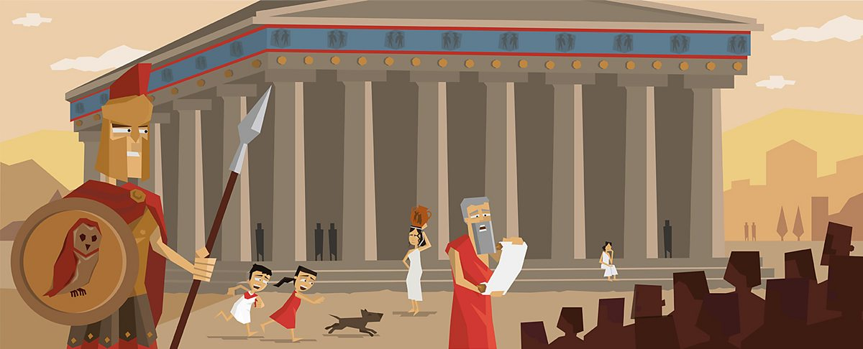 |  |  | Computing  In Autumn 1, children will be learning all about Systems including computer systems and search engines. The children will look closely at input and output systems, with a deep dive into search engines. | PSHE  In Autumn 1, children will be looking at Health and Wellbeing within the Media.
MFL
This half term the children are learning their numbers to 30 and how to spell the days of the week and months. They will also learn dates from the Spanish calendar.

Physical Education  Our topic in PE in Autumn 1 is developing ball skills. PE lessons for 5A will be on a Tuesday and Wednesday and for 5B and 5C on Wednesday and Thursday. |  | Music  In Autumn 1 of Year 5, the children will be learning about variety of musicians and composers and they will be appraising music of different genres. |  |  | RE  During the term, the children will study the faith Christianity and they will learn about forgiveness in Christianity, why forgiveness is important and why people find it hard to forgive.

