Parent guide: Using the Raving Reader journal
Pupils are expected to read for 5-10 minutes every day (this would be longer for children in KS2). Children should read with an adult or an older sibling and this should get recorded in their Raving Reader journal (see below).

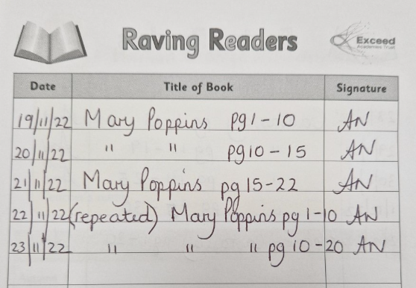
Pages read
Title of the book. This does not have to be repeated each time. Instead, these lines can be used until your child changes their book.
Parent/carer signature
Date
It is likely that sometimes the child will have to repeat their book if they are not yet fluent. This can be written like this.

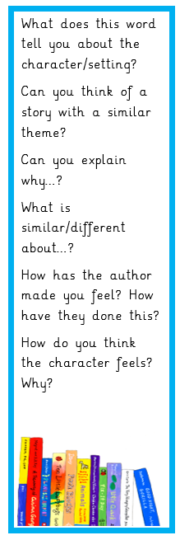
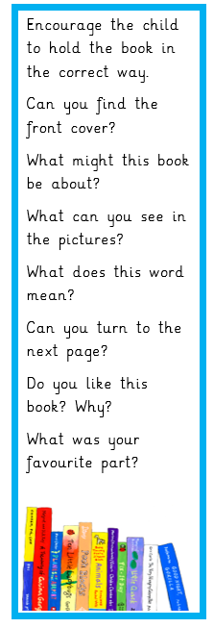
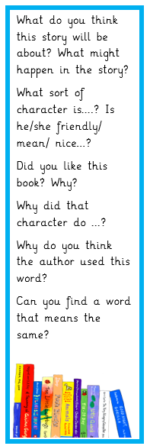
You should also ask the child questions about their book. You can use the Horton Grange Reading bookmark to help guide you with these questions.
KS2
KS1
EY

EY (Early Years) includes 2sCan, Nursery and Reception
KS1 includes Years 1 and 2
KS2 includes Years 3,4,5 and 6

