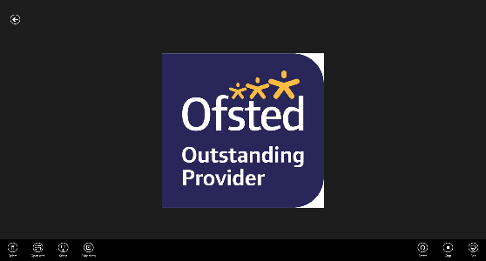

**Newsletter**

As the half-term draws to a close, I would like to thank the children and staff for their continued hard work and their families for ensuring they attend on time every day. Bonfire night is coming up and whilst we are holding assemblies in school, please ensure your children are aware of the hazards at this time of year.

Please can I ask that you are mindful of dropping litter in the local area, particularly on the school field. We are spending a considerable amount of time and money cleaning the field on a daily basis to make sure it is safe for the community to use. This is money that should be being spent on the children and their education. If you see anyone littering, fly tipping or causing damage to any part of the field, please notify school as we are working with the local police to address the issue.

Congratulations to Mr Mahmood and Mr Zaman both of whom have welcomed new babies into their respective families this half-term. We are sorry to say goodbye to Miss Ghani who is taking up a post with the council and Miss Zaman who is leaving to go travelling.

Have a lovely break, stay safe and see you back in school on 31st October.

A message from Miss Marshall

Thank you to all the children who dressed up in yellow to raise awareness for mental health. Here are some pictures from the day.

Hello Yellow Day

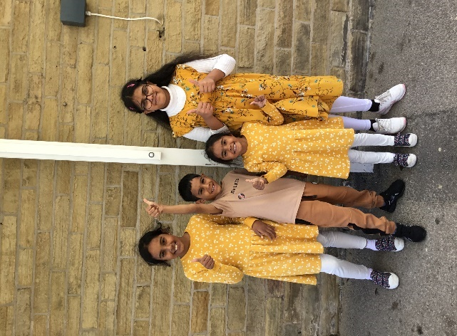

**MacMillan Coffee Morning**

Thank you to everyone who contributed to our MacMillan coffee morning. Together, we raised an amazing £267.10! Here are some pictures from the day.

Information for parents

Reading at Home

Please continue to support your child on their reading journey by taking 10 minutes a day to sit quietly and read with them. If your child is bringing picture books home, please discuss the pictures in the books and encourage your child to enter into discussions about what the book is about. Regardless of the stage of reading your child is at, spending quality time reading will significantly support them in their learning.

Raving Readers (Reception to Year 6)

Your child will be bringing home a reading fluency book and a reading for pleasure book. The reading fluency book should be read daily with your child in order to develop their ability to read a text accurately, quickly and with expression. Reading fluency is important because it bridges the gap between recognising words (word recognition) and understanding what they are reading (comprehension). Please record each time that you read with your child in their Raving Reader book. Your child will then receive Raving Reader ticks on the board in their classroom. As your child collects ticks, they will receive a number of different prizes throughout the year, which they really love receiving!

English and Maths Parent/Carer Workshops

We are excited to announce that next half-term there will be a number of parent/carer workshops taking place. During the workshops we will share with you what your child is learning in school this year and how you can support them at home. Please look out for more information coming out via text and MarvellousMe.

|  |  |
| --- | --- |
|  | **Diary Dates** |
| School re-opens | 31.10.22 |
| School photographs | Week beginning 28.11.22 |
| Whole school filming | 28.11.22 |
| Year 2 pantomime | 14.12.22 |
| Christmas break | 16.12.22 |



Children In Need will be on the 18th of November. There will be merchandise on sale, more details will be given nearer the time.

**Children In Need**

A polite reminder that school dinners are £2 per meal. If your child’s account reaches more than £4 in debit, you will be asked to bring in a packed lunch. Please ensure your child’s Parent Pay accounts are kept in credit; if you require any support or are struggling with this, please come and speak to staff.

**School Dinners**

**Long Term Absence**

Please be reminded that only **exceptional/emergency** circumstances warrant a leave of absence from school. School **must** meet a parent/carer to discuss this **before** any tickets are booked for a visit during school time. Headteachers are **not allowed**to approve leave of absence if the reason for absence is **not an emergency**.

Please also be reminded that school **must** inform Bradford Council if a child is taken out of school during term time, particularly if they are taken abroad. **Bradford council** then issue a **fine** to parents for taking their child abroad during term time. The current fine for this is **£60 per parent, per child**. I have sent letters with further information around attendance and punctuality earlier this term.