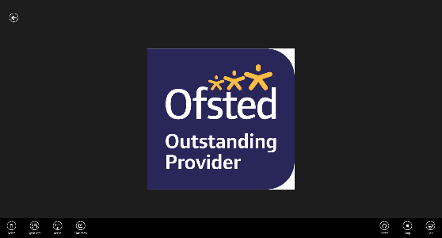

**Newsletter**

As the half-term draws to a close, I wanted to express my gratitude to all our pupils and their families for your continued support of the school. I see many of your smiling faces and chat to you all every morning; something I look forward to every single day.

Mrs Whitehead begins her maternity leave today ahead of her due date, we wish her well and look forward to meeting her new addition to the family. Mrs Bibi, Mrs O’Sullivan, Miss Bedford, and Miss Matthews have all had babies in the last few weeks; we have sent the families flowers by way of congratulations.

We have our first Summer Fayre in over two years coming up on Saturday 16th July. It will be open to the wider community as well as all families in school and would be lovely to see you all there. We are having stalls, animals, and a whole host of other surprises in the school playgrounds, halls, and field; we look forward to seeing you all there!

A huge thank you goes out to my staff who are relentless in their drive to provide the best education possible for our pupils. Despite this half-term being just five short weeks, we have had SATs in both Year Two and Year Six and assessments in other year groups ahead of the final half-term of the year.

As we head into the school holidays, I wanted to include a poem for you to share with your children. You may have seen it; I was shown it by a friend who is a retired teacher, but it really resonated with me. We know it is important for the children to try their best in any test they take; it is an important life skill, and our children are fabulous at it, but we must remember that these tests do not define who our children are.

All that leaves is for me to say have a fabulous break with your family and friends and see you bright and early on Monday 6th June!

Miss Marshall

**A message from Miss Marshall**

 Please be reminded that only **exceptional/emergency** circumstances warrant a leave of absence from school. School **must** meet a parent/carer to discuss this **before** any tickets are booked for a visit during school time. Headteachers are **not allowed**to approve leave of absence if the reason for absence is **not an emergency**.

Please also be reminded that school **must** inform Bradford Council if a child is taken out of school during term time, particularly if they are taken abroad. **Bradford council** then issue a **fine** to parents for taking their child abroad during term time. The current fine for this is **£60 per parent, per child**.

**Long Term Absence**

|  |  |
| --- | --- |
|  | **Diary Dates** |
| 27.5.22 | Break up for half-term |
| 6.6.22 | School reopens for the remainder of the summer term |
| W/B 4.7.22 | School sports days – specific dates TBC |
| 11.7.22 | School closed for 1 day for Eid |
| 16.07.22 | Summer Fayre |
| 20.7.22 | Year 6 Graduation Day |
| 22.7.22 | Break up for summer |

**Please ensure your child returns to school after the holidays with the correct uniform, including their PE kit. If your child attends school with the incorrect uniform/PE kit you will receive a phone call asking you to bring the correct items into school. If you are struggling to obtain uniform items, please contact the school office.**

**School Uniform**

White shirt or polo shirt with grey trousers/skirt/shalwar kameez/red gingham summer dress, maroon tie (optional,) and plain black or school hijab (optional) maroon sweatshirt/cardigan with logo, black shoes - **not trainers or boots.**

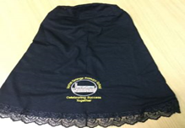

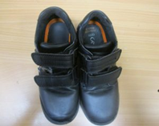

**No extreme hair cuts allowed, including train**

**tracks, lines, patterns or hair dye**



**No extreme hair cuts allowed, including train**

**tracks, lines, patterns or hair dye**

**Please ensure that all items of clothing are clearly labelled with your child’s name.**

**Please ensure that all items of clothing are clearly labelled with your child’s name.**

**No extreme hair cuts allowed, including train**

**tracks, lines, patterns or hair dye**