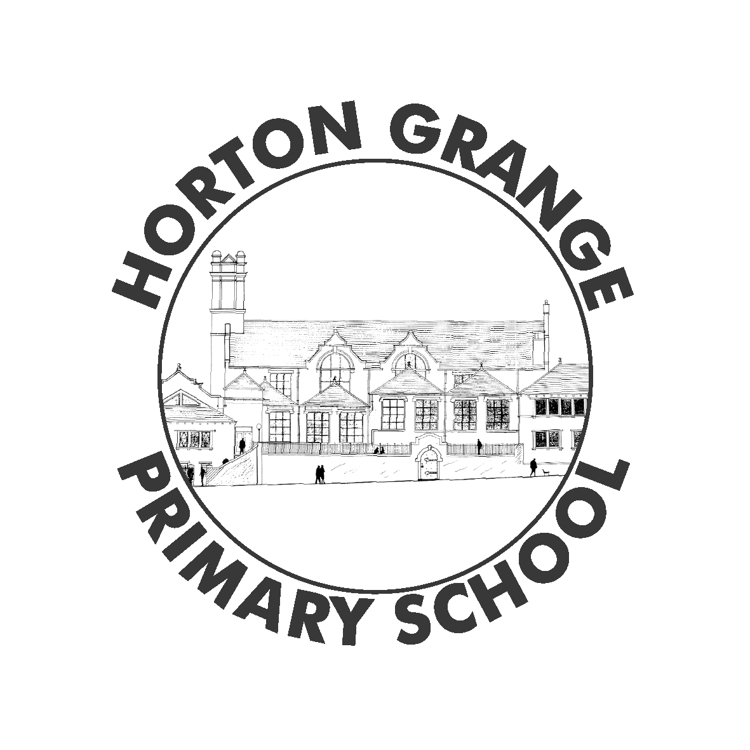
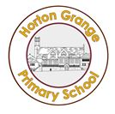
Horton Grange Primary School- Nursery Newsletter
Topic: Myself and Pets Term: Spring 1
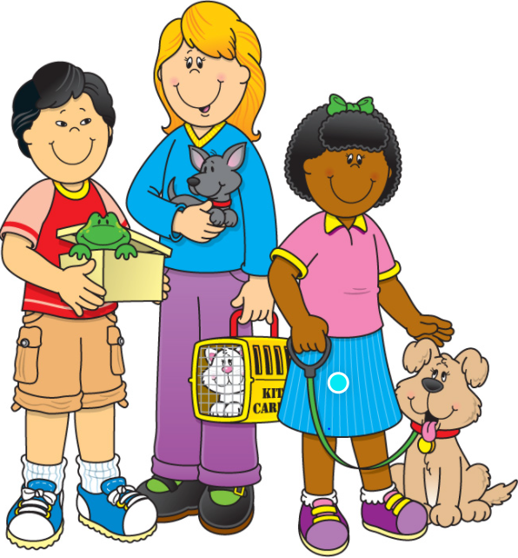
Prime Areas
Personal, Social and Emotional Development  This half term your child will be learning:  - Use and care for their toys and tidy them away before moving on to the next activity.  - To have a go at new challenges, to persevere when problems arise and to learn from their mistakes.  How can you help?  - Encourage your child to use and care for their things, and then trust them to do so independently.  - Support your child to try new activities and to judge the risks for themselves. Talk to them about how practising makes you better at things and how you learn when things go wrong.  Encourage your child to talk about what they are doing and what they are learning. |  | Communication & Language  This half term your child will be learning:  - Maintain their attention and concentrate during activities at their own level.  - To listen to and follow two part instructions.  How can you help?  - Play games with your child which involve them listening for a signal – such as “Simon Says.”  - Give children clear instructions to help them manage more than one action –“Please put your cars away and then wash your hands for lunch”. |  | Physical Development  This half term your child will be learning:  - Copy some letters from their name.  - Name some body parts.  - Notice what happens to their body when they exercise.  - Follow instructions in P.E. lessons.  How can you help?  - Encourage your child to hold mark-making tools using “froggy legs with log underneath.” Write their name and ask them to write over it or copy it underneath.  Talk with your child about how their body changes after exercise (such as their heart beating faster) and why they need to rest when they are tired.
Significant Steps of Development- Specific Areas
Literacy  This half term your child will be learning:  - Hold mark making tools using ‘froggy legs with log underneath’.  - Talk about pictures and words all around me.  - How can you help?  - Show your child how to ‘write’ their own name by writing their name and encouraging them to have a go!  - Help your child understand what a word is by pointing out words all around them such as words on a cereal packet or at the shops. | Mathematics  This half term your child will be learning:  - Link numerals and amounts: for example, showing the right number of objects to match the numeral.  - Compare quantities using language: ‘more than’, and ‘fewer than’.  How can you help?  - Talk in home language about quantities and numbers, linking these with English equivalents.  - Practise using the language ‘more than’ and ‘fewer than’ to describe two amounts. |  | Understanding of the World  This half term your child will be learning:  - Show interest in different occupations.  - Name their senses and use them to explore the world around them.  How can you help?  - Talk to your child about the different jobs your family members do.  - Give your child opportunities to talk about what they can see, hear, smell, etc.  Encourage them to speculate on the reasons why things happen or how things work. |  | Expressive Arts & Design  This half term your child will be learning:  - Join different materials and explore different textures.  How can you help?  - Support your child in planning their creative projects - thinking about what they want to make, what they will need to do and the materials and resources they might need. Encourage them to plan (perhaps making a drawing) before they start and persevere if problems arise.

