Thursday 7th January 2021

Dear parents/carers,

Learning from Home

We are working hard to ensure that minimal disruption to pupils’ learning throughout this period of National Lockdown.

If your child is learning from home, they will be able to continue their lessons by accessing their year group ‘Learning from Home’ page on our website.

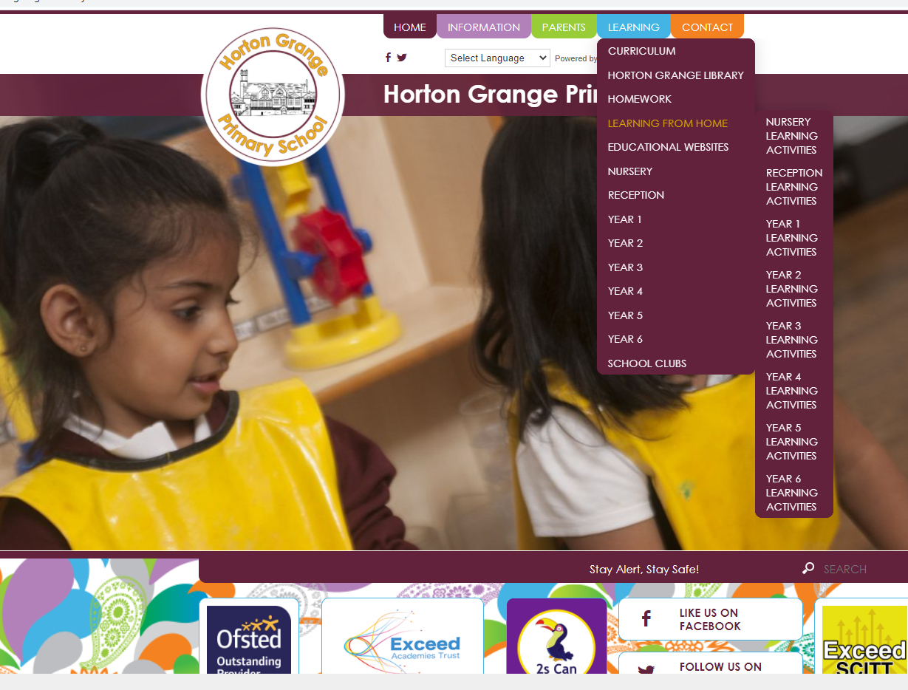

Each week, three Microsoft PowerPoint presentations will be uploaded onto our school website along with a timetable for the week. This will help you structure the children’s learning and make sure they are doing the same lessons that they would be if they were in school:
English: This will include grammar, reading comprehension and writing activities.
Maths: This will include arithmetic, mental recall and coverage of the maths curriculum.
Topic: This will include all other areas of the curriculum, such as; RE, Science, Music, Geography and History.

Every Monday, Wednesday and Friday at 9:00, all pupils will take part in their PE lessons online with Joe Wicks. This will mean that all children in one family can do PE together. We recommend, for your ease, that you may want to subscribe to Joe Wicks’ YouTube channel to access these lessons easily.

Please see the link below for access to this YouTube Channel:
https://www.youtube.com/channel/UCAxW1XT0iEJo0TYlRfn6rYQ
You can also find this by searching ‘Joe Wicks’ or ‘The Body Coach’ in the YouTube search bar.

If you are unable to do this, don’t worry, we will add a link to this YouTube channel to the PowerPoint or timetable each week.

If your child does not have access to a laptop, Ipad or tablet, you will have already been in touch with school about loaning a device from us.

We will also communicate about the learning your child will need to complete through a new app called Marvellous Me. If you have not added all children in your family to your Marvellous Me account, please contact your child’s class teacher for their individual ‘join code’, so you can add them to your account.

Should anything be unclear in the work that is set, parents can communicate with class teachers via the school email address – your child’s class eg: 3a@hortongrangeacademy.co.uk.

Work that children complete at home should be kept safe, ideally in their home learning book, and can be brought back to school once the child can return to school safely. We would encourage all parents to send photographs of pupils work to their child’s class teacher each week.

We would encourage parents to support their children’s work, including finding an appropriate place to work and, to the best of their ability, support pupils with work encouraging them to work with good levels of concentration.

School cannot guarantee that the parents will be able to access learning uploaded onto the school website by all devices. Should accessing work be an issue, parents should contact school promptly via your child’s class email address eg: 3a@hortongrangeacademy.co.uk.

Yours faithfully,

Miss R. Marshall
Headteacher

