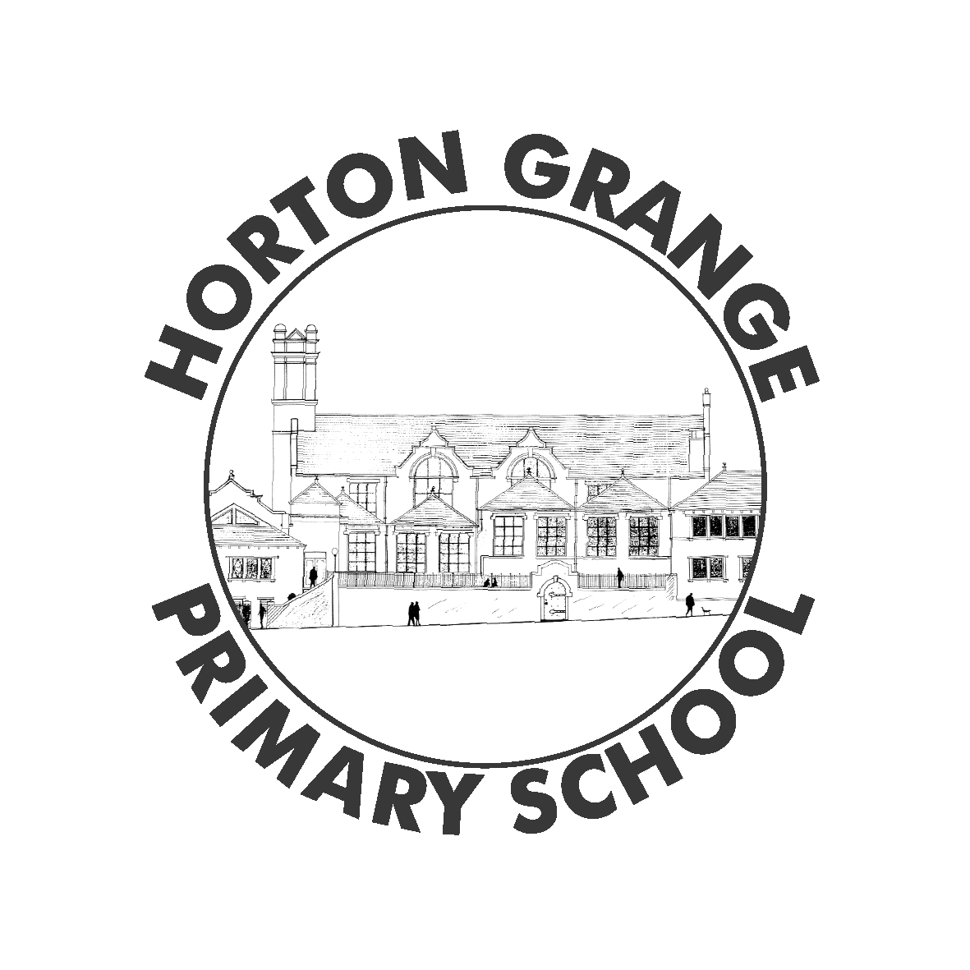
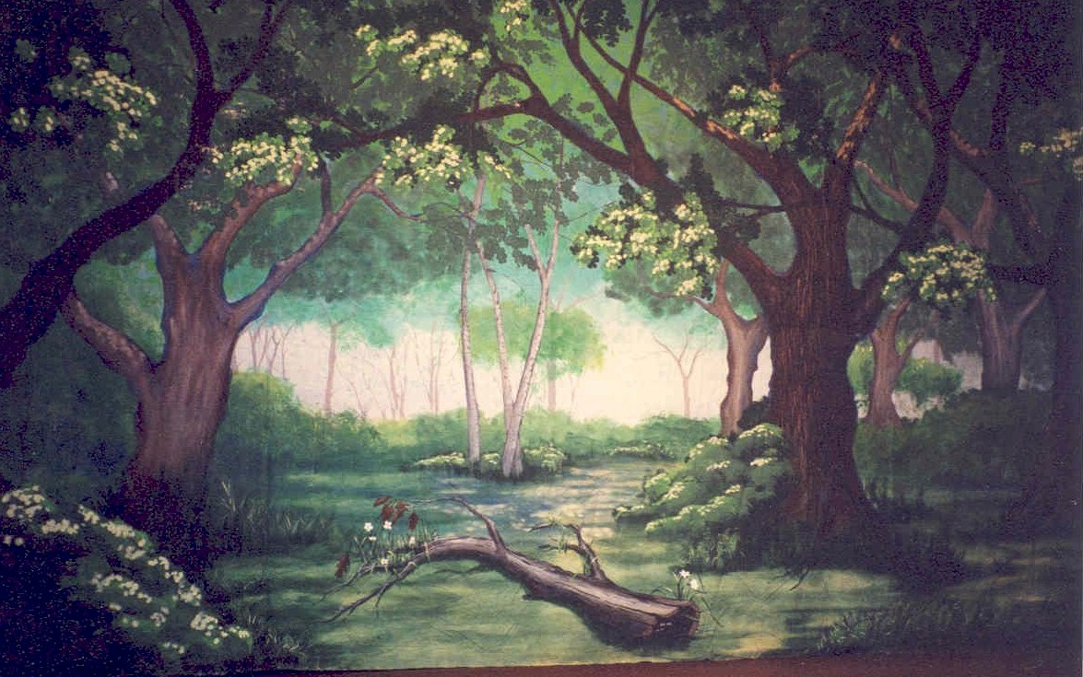
Horton Grange Primary School - Reception Newsletter
Topic: Traditional Tales Term: Autumn 2

Prime Areas
Personal, Social & Emotional Development  This half term your child will be learning:  - About different cultures through celebrations such as Bonfire Night, Diwali and Christmas.  - About how to be a good friend.  - To share with others and work as part of a group.  How can you help?  - Discuss why it is important to get along with others and encourage your child to think about other people’s feelings.  - Talk to your children about the different celebrations.  - Play board games to encourage sharing and teamwork. |  | Communication & Language  This half term your child will be learning:  - To listen to stories with increased attention.  - To join in with well known phrases in stories and rhymes.  - To begin to use ‘why’ and ‘how’ in questions.  How can you help?  - Read to your child at home.  - Ask your child to repeat any repetitive text in the book.  - Encourage your child to use ‘why’ and ‘how’ when asking a question. |  | Physical Development  This half term your child will be learning:  - Play games that involve rules.  - To move in different ways.  - To practise zipping and un zipping your coat.  How can you help?  - Play a simple board game or a game of football with your child following the rules.  - On your way to school, how many different ways can you move?  - To practise at home zipping and un zipping your coat.
Significant Steps of Development- Specific Areas
Literacy  This half term your child will be learning:  - To predict how a story may end.  - To write their own name.  - To form letters correctly.  How can you help?  - Ask your child how they think a story may end.  - Encourage your child to copy write their name.  - Encourage your child to trace an alphabet strip. | Mathematics  This half term your child will be learning:  - To say one more and one less of numbers 0-5.  - To say number bonds to 5.  - To describe shapes 2D and 3D.  How can you help?  - Talk about different shapes at home and outside.  - To practically say one more and one less of numbers 0-5.  - To practise saying number bonds to 5. |  | Understanding the World  This half term your child will be learning:  - About clothes from the past and present.  - How to compare different cultures.  - How to use a programmable toy.  How can you help?  - Look at fairy stories or films and talk about the clothes the characters wear.  - Talk to your child about your culture. What do you celebrate?  - Set up a simple treasure hunt and give your child instructions on how to find the treasure. Use words like forwards, backwards, left and right. |  | Expressive Arts & Design  This half term your child will be learning:  - To listen to instruments in music.  - To listen to and tap out the beat in music.  - To think about how music makes them feel.  How can you help?  - Talk to your child about the names and sounds of instruments.  - Clap along to a song. Encourage your child to clap along in time to the beat.  - Discuss how music makes you feel. Is the song slow, fast, loud, soft?

