What to do today
IMPORTANT Parent or Carer – Read this page with your child and check that you are happy with what they have to do and any weblinks or use of internet.

1. Make up a revolting menu
- Read Menu. What would you choose to eat? What do you think your friends and family would eat?
- Read Revolting Menu Prompts. Use these instructions to create a revolting yet delicious sounding menu.
- Watch this advert. Can you read your menu in the same style? You could record your own advert like this!
https://www.youtube.com/watch?v=EHFKE6PD_6U

2. Read gross recipes
- Look at the Gross Recipes. These have all been made to be edible but to look awful.
- Read the information carefully and try to fill in the missing parts: (i) Ingredients, (ii) Method, (iii) Ingredients and (iv) Picture.

Well done! You can check your answers at the end of this pack.

3. Make up recipes
- Read Roald Dahl Recipes. Choose one of the foods that he invented and make-up a recipe for it. Include a picture, ingredients and method in your recipe.

Menu

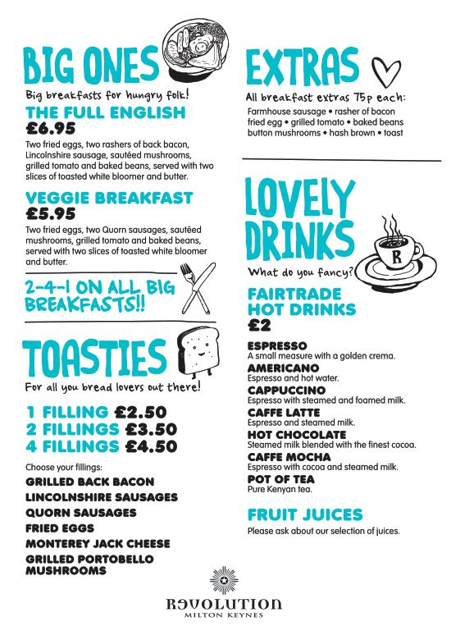

Revolting Menu - Prompts

- Add to this list of things that would be revolting to eat

dandruff  mould  slugs | slime  mud  hair | toe-clippings  ear wax | hoover bags  bins | dust  brick dust  pencil shavings

- Use words like those in the list below to describe some starters, main courses, desserts and drinks made out of your revolting list.

e.g. A delicious light sprinkling of mouth-watering dandruff served on prime mashed brick-dust.

delicious  tempting  succulent  divine  refreshing | mouth-watering  filling  creamy  special  steaming hot | deep-fried  juicy  spicy  tangy  exotic  luxurious | lavish  prime  mashed  minced  top quality

- Name your restaurant. Design a complete menu. Give your dishes a price and describe them.

Gross Recipes
 | Ingredients | Method
Rotten Eggs  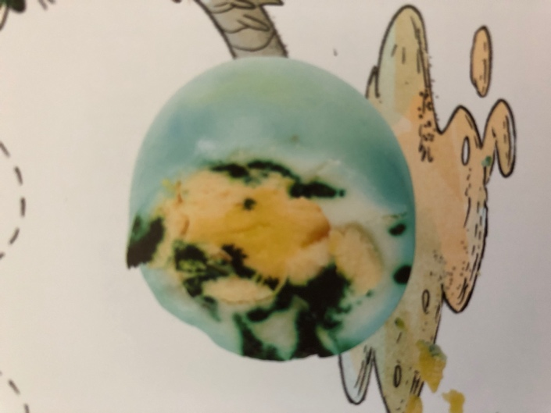 | (i) | 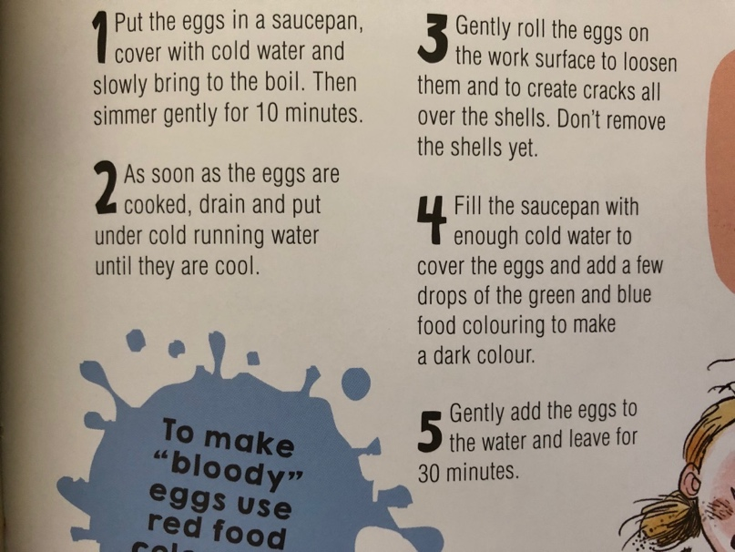
Lychee Eyeballs  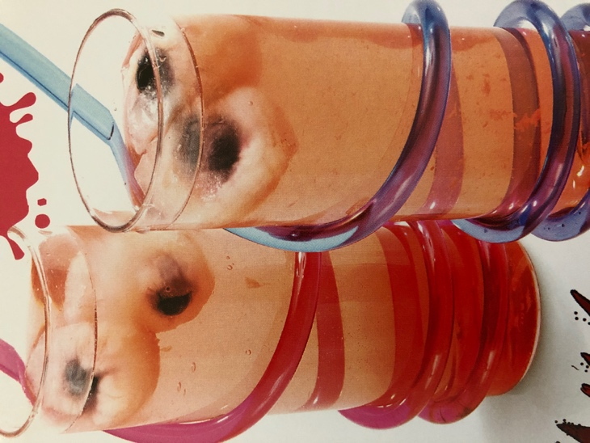 | 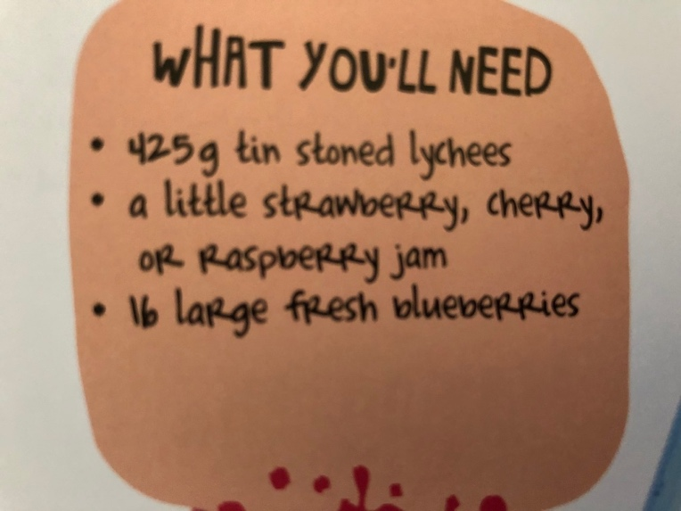 | (ii)

Chia frogspawn  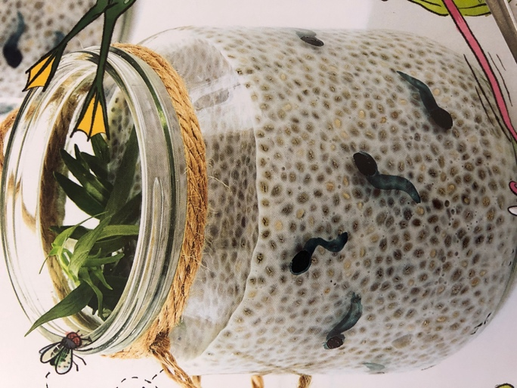 | (iii) | 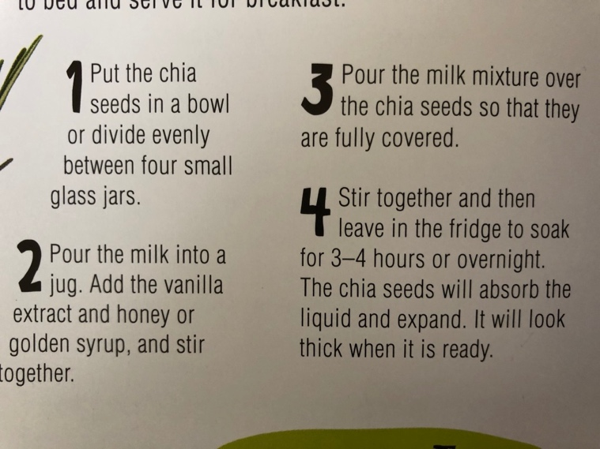
Roasted Mice (iv) | 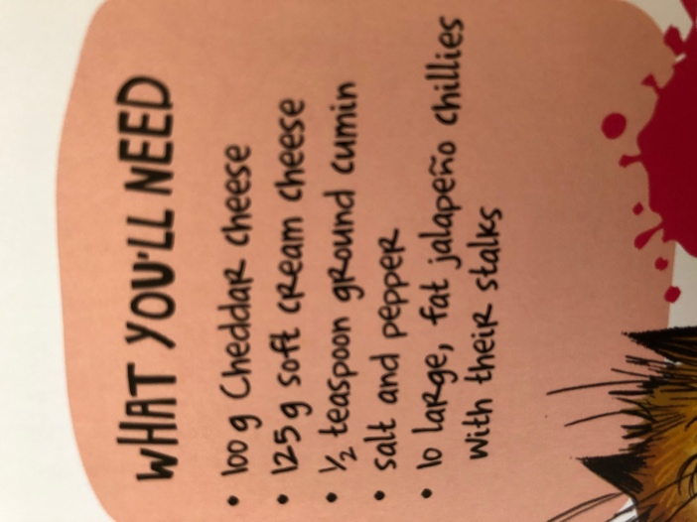 | 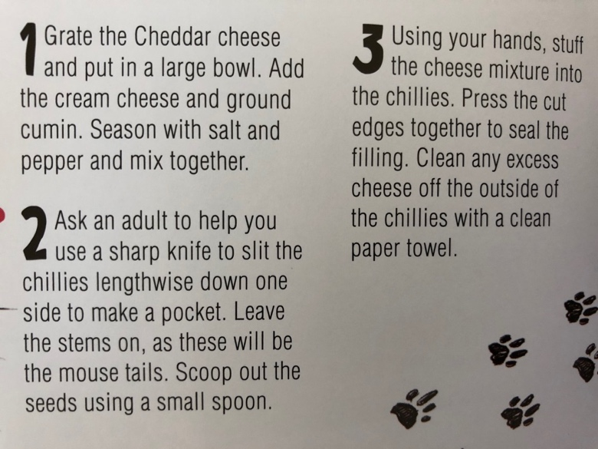
from This Cookbook is Gross by Susanna Tee
Roald Dahl Recipes

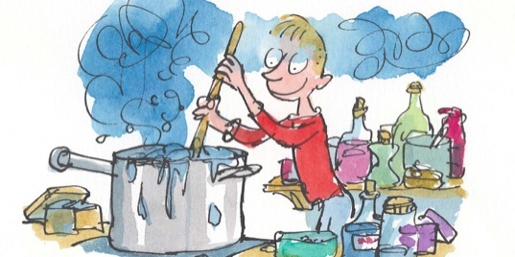

Choose one of the imaginary foods from Roald Dahl’s books. Make up a recipe for making this food.
Include a picture, ingredients and a method in your recipe.

Choose one of these foods:
- Stink Bugs’ Eggs (James and the Giant Peach)
- Crispy Wasp Stings on a Piece of Buttered Toast (James and the Giant Peach)
- Fresh Mudburgers (James and the Giant Peach)
- Hot Frogs (James and the Giant Peach)
- Lickable Wallpaper (Charlie and the Chocolate Factory)
- Frobscottle (A green drink – The BFG)
- Eatable Marshmallow Pillows (Charlie and the Chocolate Factory)
- Stickjaw for Talkative Parents (Charlie and the Chocolate Factory)
Gross Recipes – Answers
 | Ingredients | Method
Rotten Eggs | 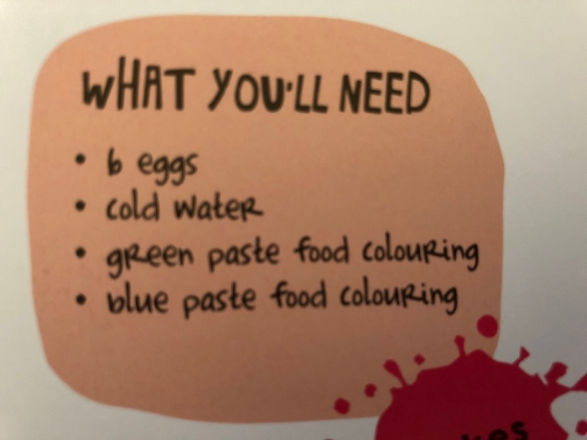
Lychee Eyeballs |  | 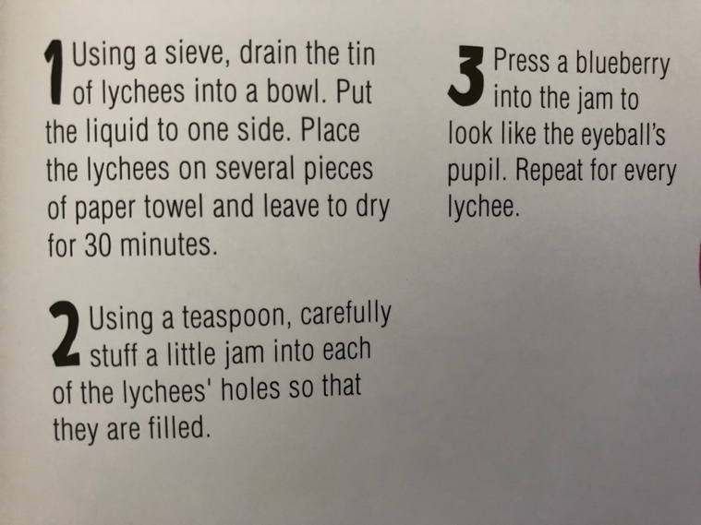

Chia frogspawn | 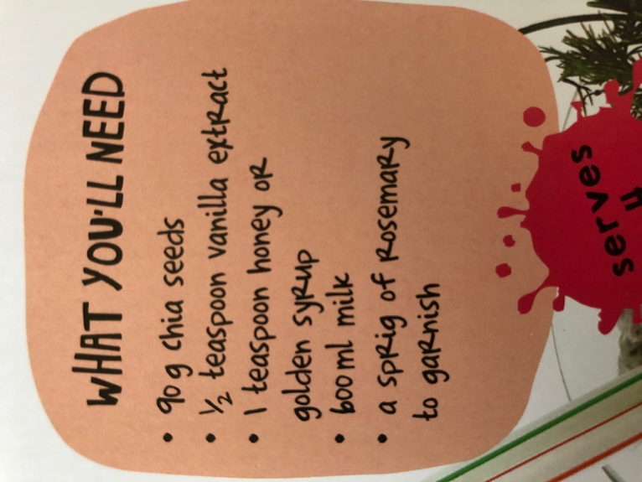
Roasted Mice
