What to do today
IMPORTANT Parent or Carer – Read this page with your child and check that you are happy with what they have to do and any weblinks or use of internet.

1. Complete a Crosspoints puzzle
- Read Crosspoints. Fill in the grid with words and then check your score.
- Use the other Crosspoint Grids yourself to try to beat your score OR challenge someone else to play the game and see how they do.

2. Complete a Crossword
- Complete Crossword 1. Read the clues and write your answers in the crossword grid. Find clues that you can do first and then use the letters from these to help you with other answers.
- Choose one of the Challenge Crosswords to complete. There are four and they get harder.
You could challenge yourself to complete all four!
- This website will give you suggestions if you have some of the letters for a word: https://www.crosswordsolver.org/

Well done! You can check your answers at the end of this pack. You can find more crosswords to solve on this website:

https://lovattspuzzles.com/kids/childrens-online-puzzles/

3. Make up your Crossword
- Either use the Crossword Template or this website to make up your own crossword:
http://puzzlemaker.discoveryeducation.com/CrissCrossSetupForm.asp
- Choose a theme. Choose words to fit. Make up clues that will lead to these words. Look at the example done by Owl to see how it works!
- Try your crossword out on someone else. How well did they do?

Crosspoints

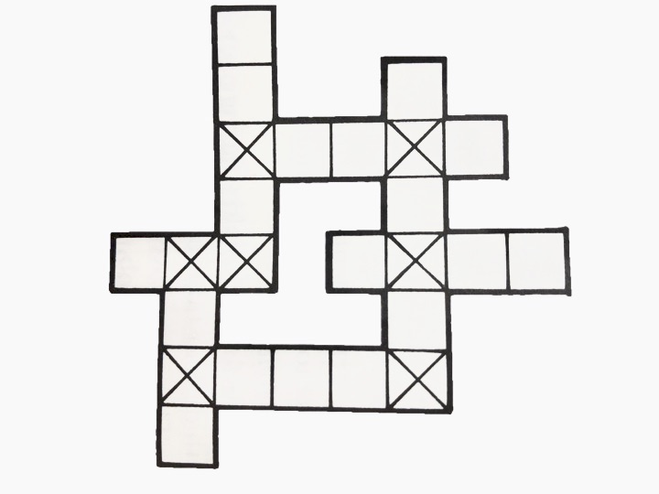
Fill in this grid with words of your choice. You gain points for certain letters. Different letters get different scores. A letter which falls on a ‘cross’ square is counted twice. How high a score can you get?
Letter scores Example
A-1 | N-2 |  | 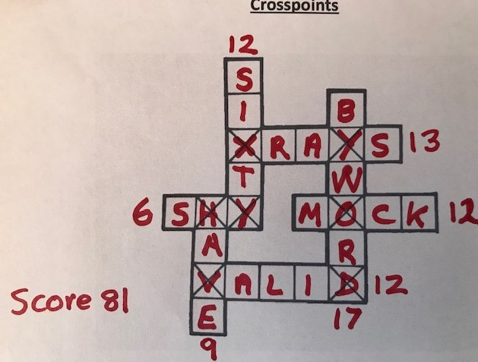
B-4 | O-2
C-3 | P-4
D-2 | Q-6
E-0 | R-2
F-3 | S-1
G-4 | T-1
H-2 | U-2
I-I | V-5
J-5 | W-4
K-4 | X-6
L-3 | Y-3
M-3 | Z-6

Crosspoint Grids

Crossword 1

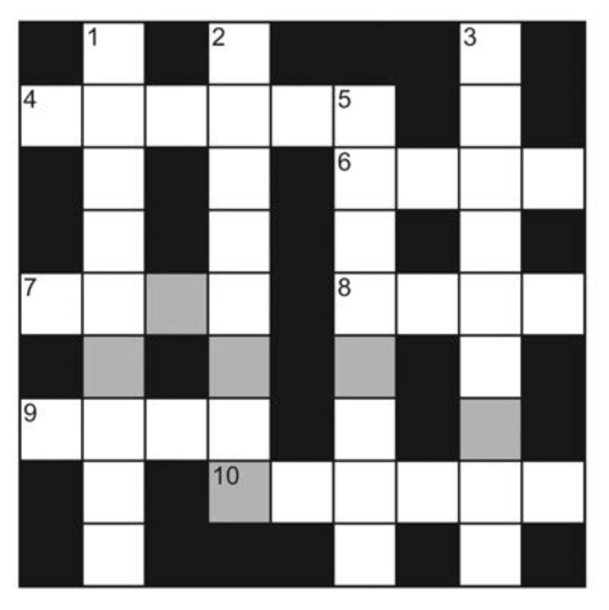

Across  4 Up to date (6)  6 Opposite of west (4)  7 A space or region (4)  8 Retain possession of (4)  9 How big something is (4)  10 Type of spacecraft (6) | Down  1 A two-wheeled vehicle with an engine (9)  2 Person aged 13-19 (8)  3 Unexplained things (9)  5 Jewellery item (8)

Challenge Crossword 1
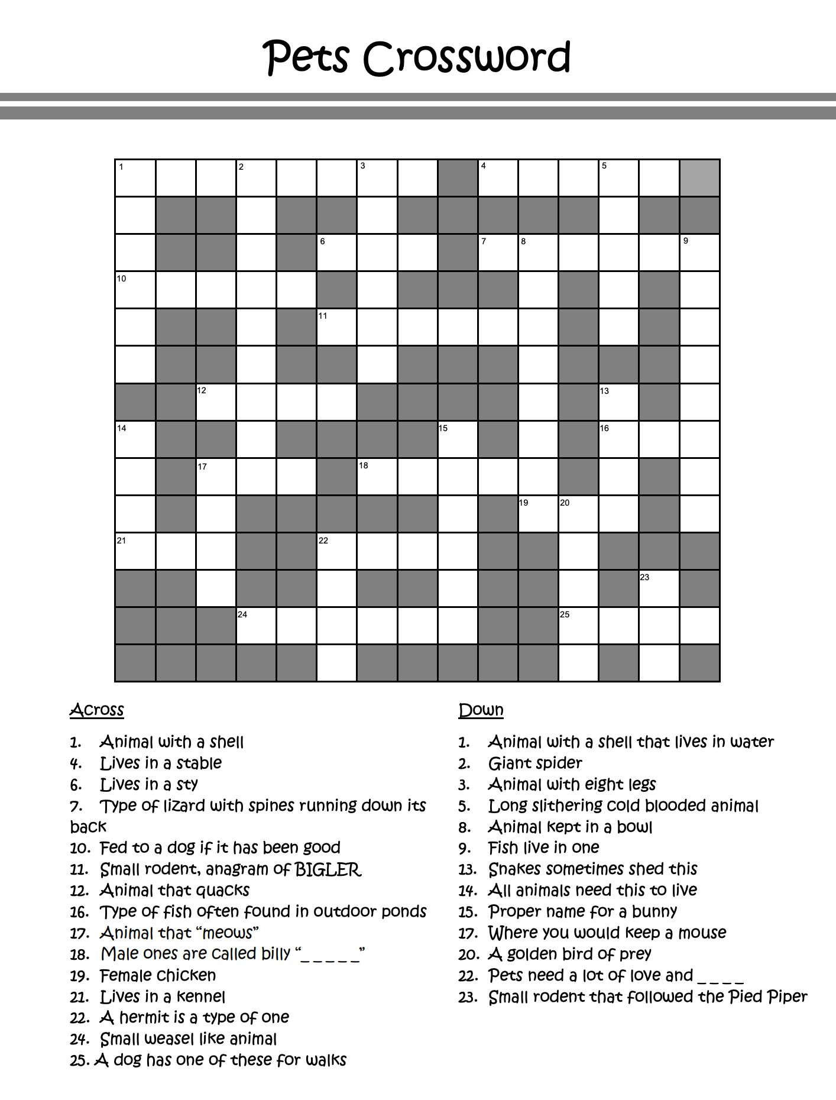
from www.kidspuzzlesandgames.co.uk

Challenge Crossword 2
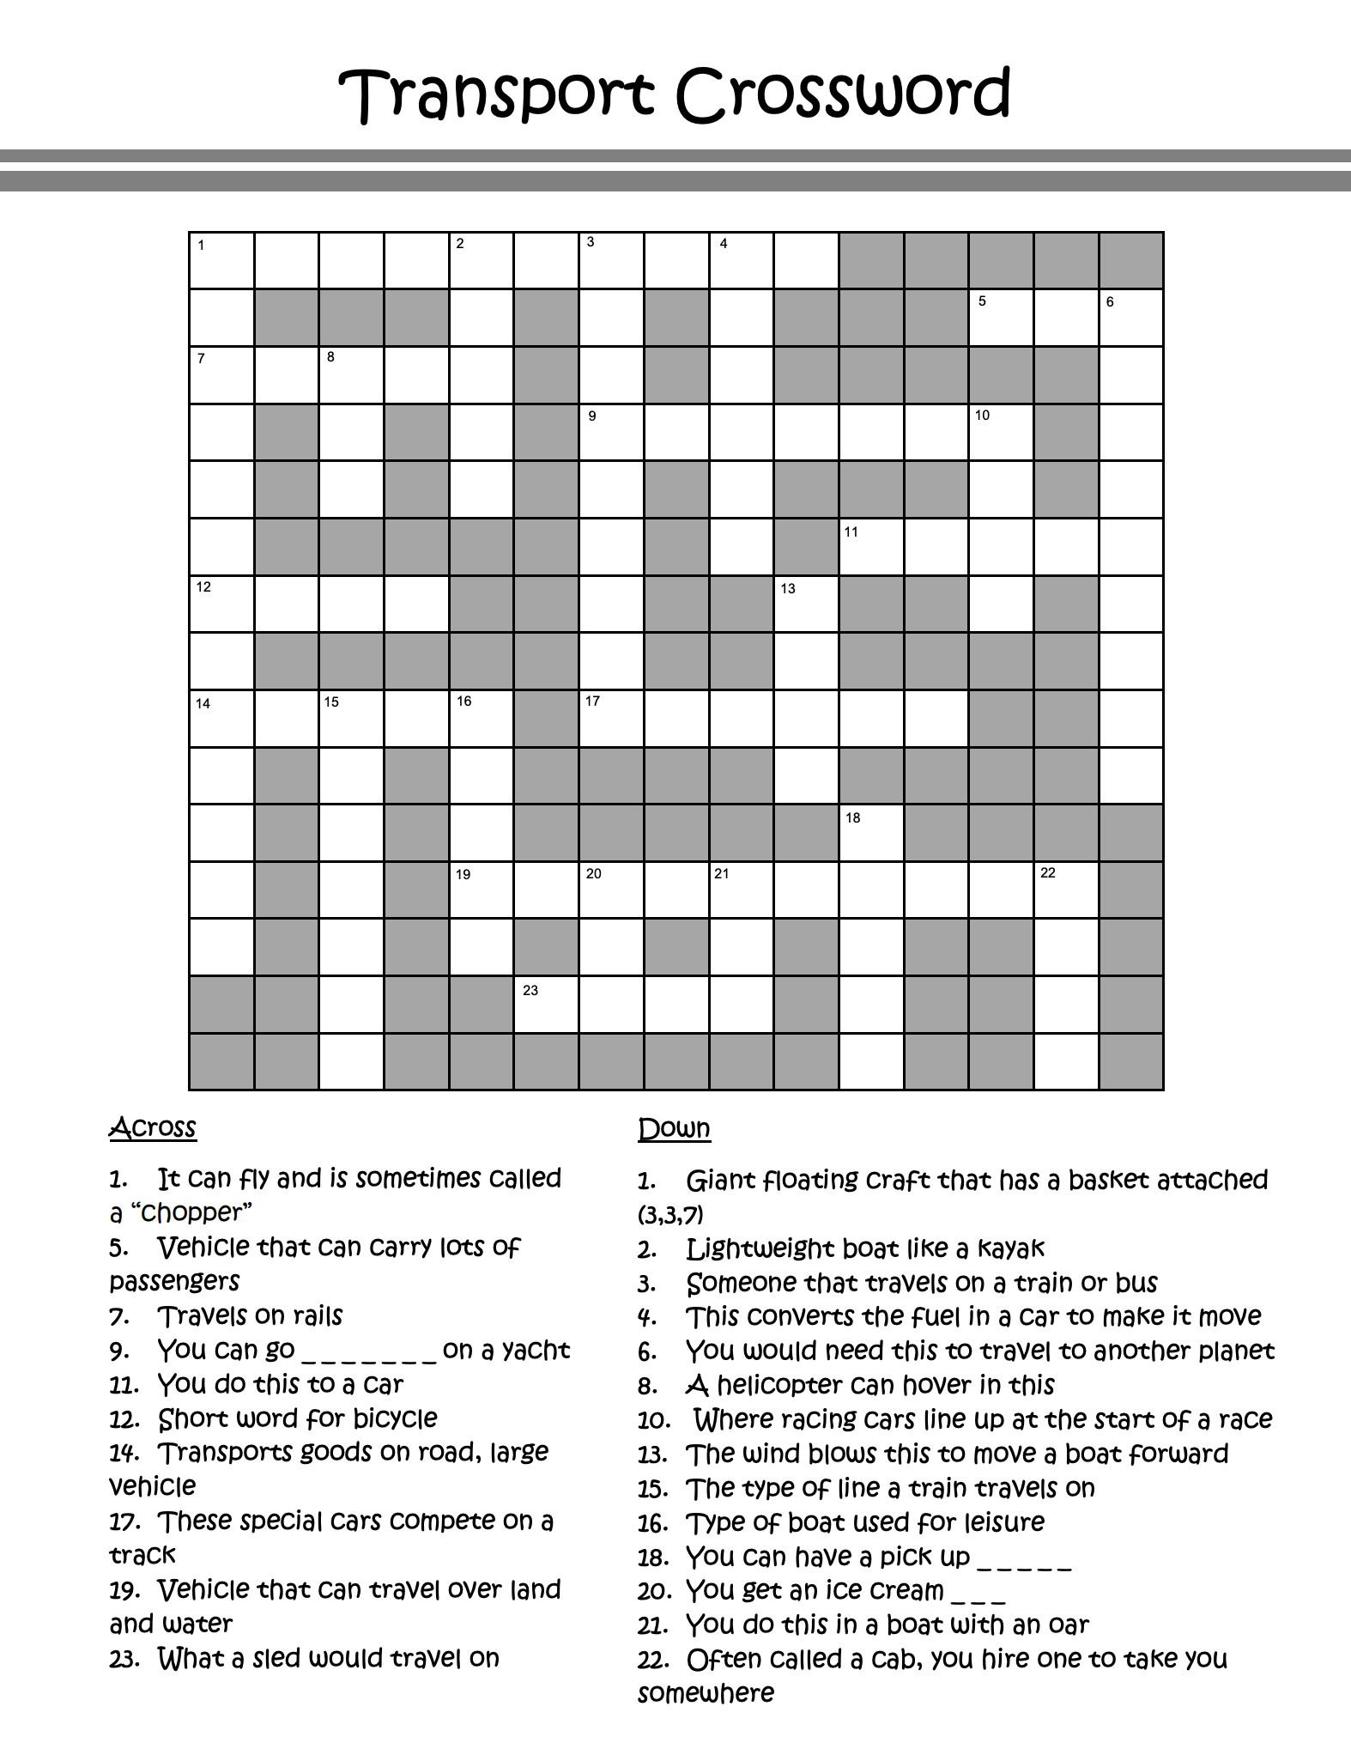
from www.kidspuzzlesandgames.co.uk
Challenge Crossword 3

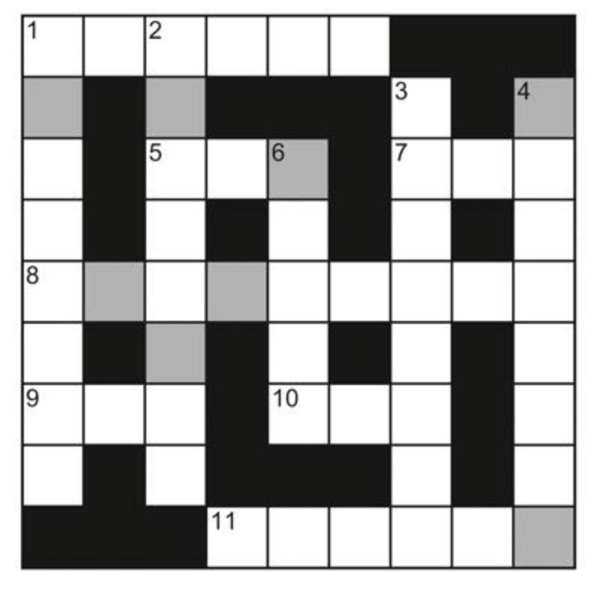

Across  1 Abilities (6)  5 Curved chest bone (3)  7 Regret (3)  8 Period of two weeks (9)  9 Steal (3)  10 Very warm (3)  11 Small shelter for a dog (6) | Down  1 Raised stage (8)  2 Cupboard for clothes (8)  3 Scare (8)  4 Day of celebration; gala (8)  6 Group of flowers tied together (5)

Challenge Crossword 4

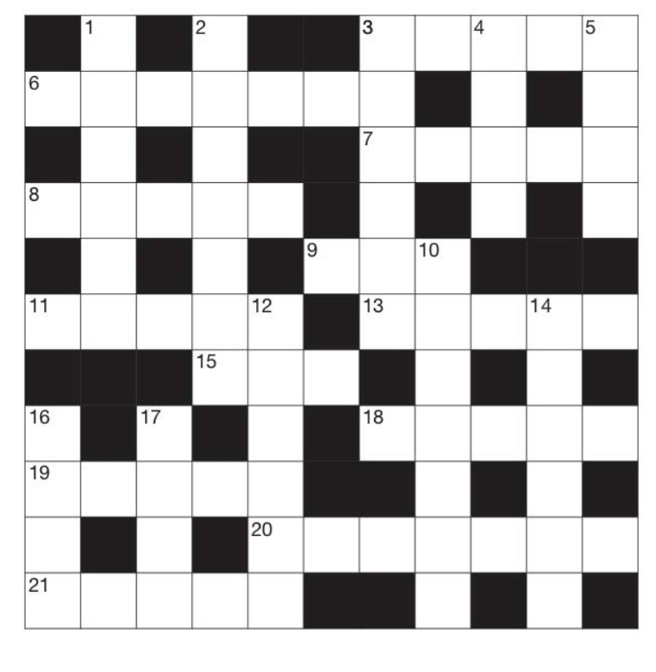
Across  3 Repaired (5)  6 Two-wheeled push toy that you stand on (7)  7 Picture (5)  8 Start (5)  9 Liquid used for writing (3)  11 You do this to show that you’re happy (5)  13 Rot: plant material does this when composted (5)  15 Perform a play on stage (3)  18 A word that might be shouted at the start of a race (5)  19 Black and white bear found in China (5)  20 Against the law (7)  21 A tall building, such as a skyscraper (5) | Down  - Loud, shrill cry (6)  - Powerful ape, found in central Africa (7)  - Someone who is your buddy (6)  - Photo of the inside of a body taken in a hospital (1-3)  - An action that is performed; a legal document (4)  10. Small falcon (7)  12. Long cake filled with cream and covered with chocolate (6)  14. In a foreign country (6)  16. Notice: see (4)  17. Flakes that fall from clouds (4)

Crossword Template

Choose a theme. Write in words to fit. Make up clues for your words.

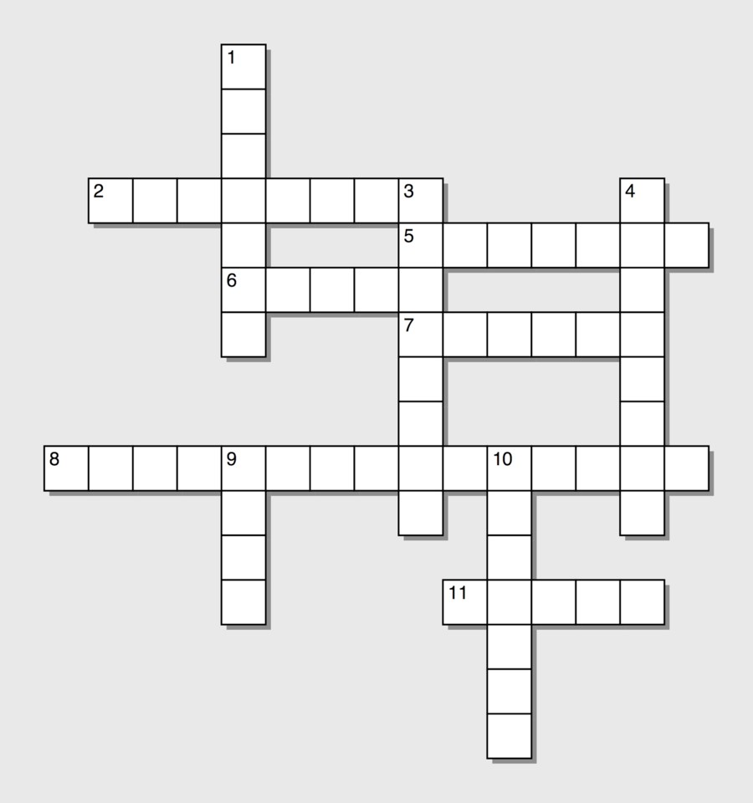

Crossword Answers

Crossword 1

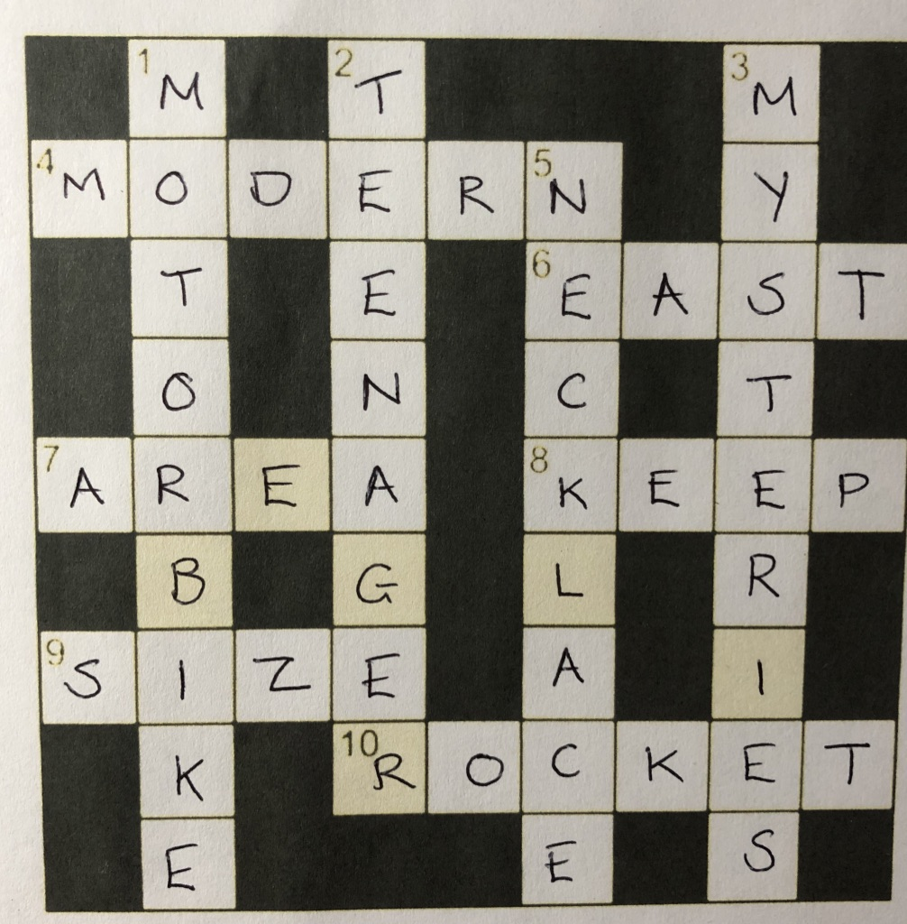

Challenge Crossword 1
Pets:
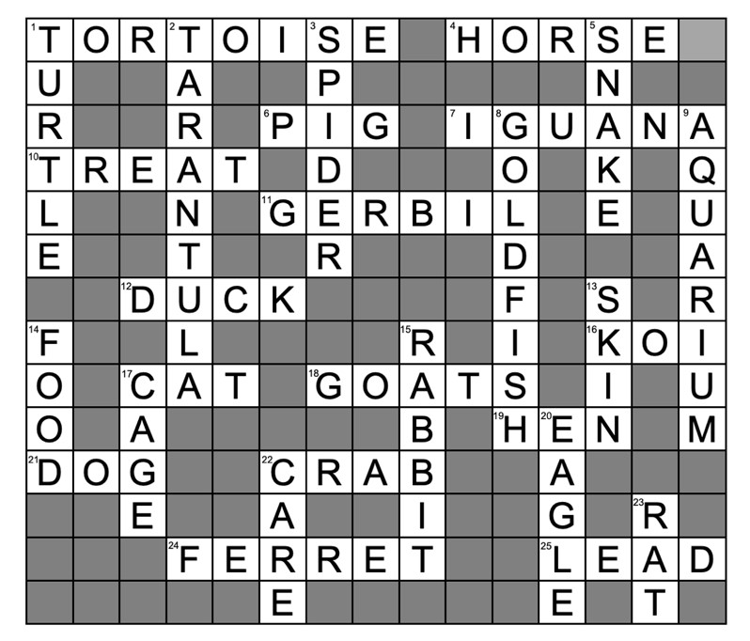

Challenge Crossword 2
Transport:
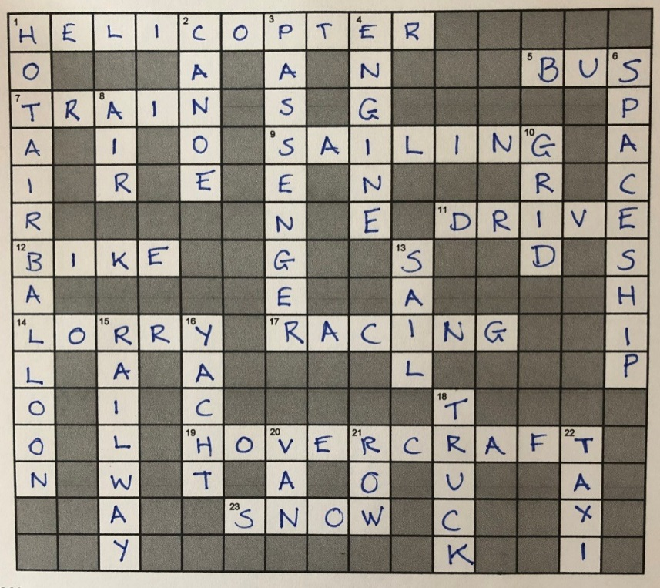

Challenge Crossword 3

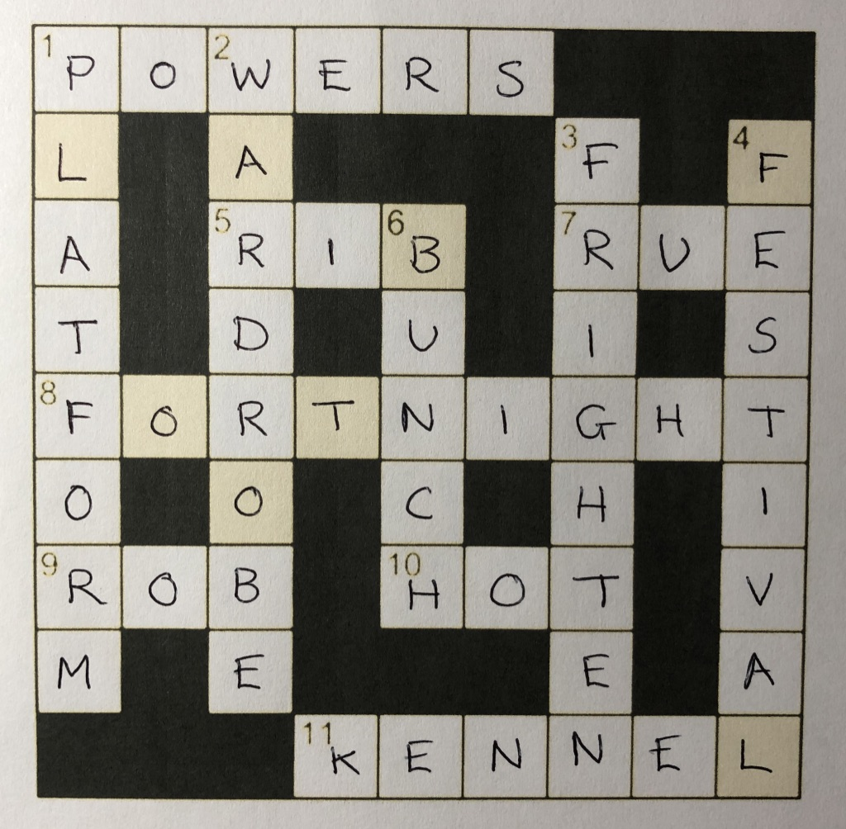

Challenge Crossword 4

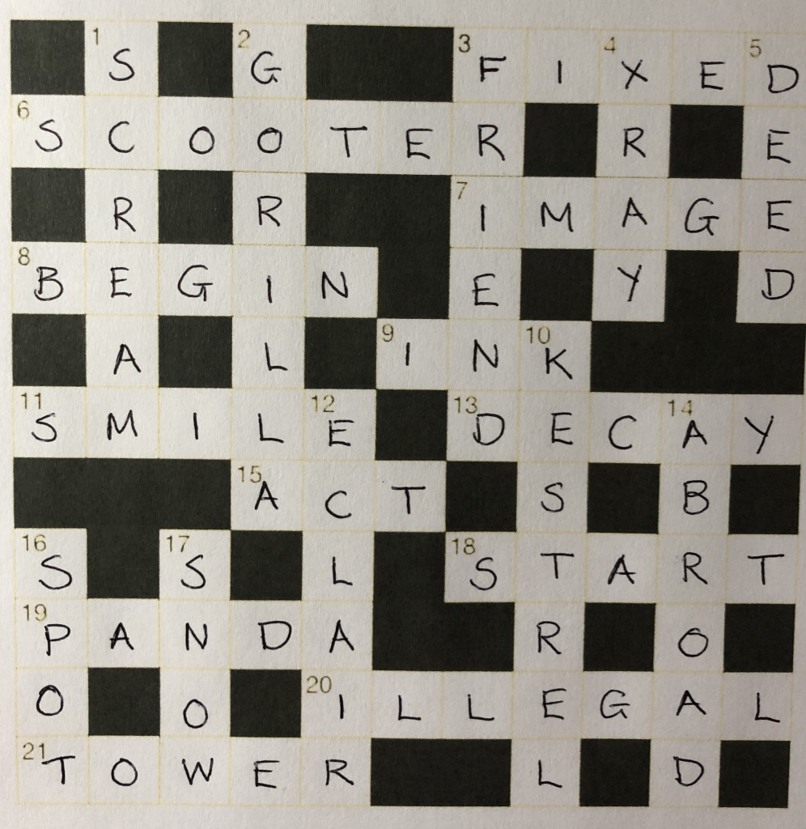

Example of Puzzle
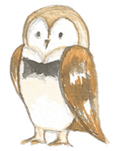
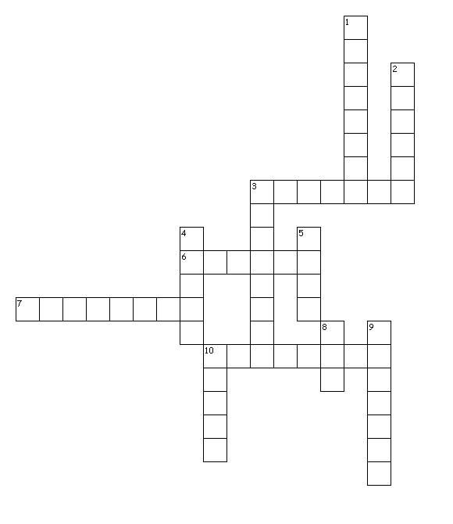
Across
3. Winged horse
6. Goddess of wisdom
7. Condemned to stay in the underworld
10. Half man half bull

Down
1. Clever inventor
2. Flew too close to the sun
3. God of the sea
4. God of the underworld
5. Anagram of S U Z E
8. God of nature
9. Lute player
10. Gold-loving king

