What to do today
IMPORTANT Parent or Carer – Read this page with your child and check that you are happy with what they have to do and any weblinks or use of internet.

1. Read jokes
- Read a set of short jokes: One Liners.
- Put a star next to the jokes that you really like. Put a question-mark next to any that you’re not sure about. Show the jokes to someone else. Do they agree with you?
- Choose 3 short jokes and learn them by heart. Practise telling them.
- Read a set of longer jokes: Shaggy Dog Stories. Which is your favourite? Do you prefer longer or shorter jokes?
- Now choose a Shaggy Dog Story. Read How to Tell a Shaggy Dog Story. Tell your story - add description and elaborate it to make it really good.
- If you can bear it, read More Jokes.

2. Try making up your own jokes
- Watch this video about writing jokes:
https://www.bbc.co.uk/programmes/p04v9hkx
- Read I’ve got a new job. Choose the best punchlines for the jokes.
- Try to write your ‘I’ve got a new job’ jokes.
- Watch these top five tips about writing jokes:
https://www.bbc.co.uk/programmes/p04v9hmz
Try following these tips and writing some of your own jokes.

3. Make a joke book
- Collect your favourite jokes from One Liners/Shaggy Dog Stories/More Jokes and the jokes that you have written yourself. Add any other favourite jokes that you or your family have.
- Use How to Make a Folded Book to create the book.
- Write the jokes in the book. Add comic illustrations too.

One Liners
How do all the oceans say hello to each other? They wave!
What did one wall say to the other wall? I’ll meet you at the corner!
What do you call a bear with no teeth? A gummy bear!
What do you get when you cross a snowman and a vampire? Frostbite!
What do elves learn in school? The elf-abet.
Why are seagulls called seagulls? Because if they flew over the bay, they’d be bagels!
Why did the girl smear peanut butter on the road? To go with the traffic jam!
How do you make a tissue dance? You put a little boogie in it.
What do you call a fake noodle? An impasta!
Why couldn’t the pony sing himself a lullaby? He was a little hoarse.
What’s a pirate’s favourite letter? Rrrrrrr!
What musical instrument is found in the bathroom? A tuba toothpaste.
Why are fish so smart? Because they live in schools!
What did 0 say to 8? Nice belt!
Why do bananas have to put on sunscreen before they go to the beach? Because they might peel!
What do you call a cow on a trampoline? A milk shake!
Where do cows go for entertainment? To the moo-vies!
How do you know if there’s an elephant under your bed? Your head hits the ceiling!
What do you call a cow with no legs? Ground beef!
What do you call a pig that knows karate? A pork chop!
Why are ghosts bad liars? Because you can see right through them!
Why do bees have sticky hair? Because they use honey combs!

What do you call an alligator in a vest? An investigator!
Why did the man run around his bed? Because he was trying to catch up on his sleep!
What do you call a dinosaur that is sleeping? A dino-snore!
What has ears but cannot hear? A field of corn.
What did the left eye say to the right eye? Between us, something smells!
What did one plate say to the other plate? Dinner is on me!
Why did the kid cross the playground? To get to the other slide.
What do you call a droid that takes the long way around? R2 detour.
How do you stop an astronaut’s baby from crying? You rocket!
What is a witch’s favourite subject in school? Spelling!
What do you call a duck that gets all A’s? A wise quacker.
What kind of tree fits in your hand? A palm tree!
What animal is always at a game of cricket? A bat.
What is a tornado’s favourite game to play? Twister!
How does the moon cut his hair? Eclipse it.
How does a scientist freshen their breath? With experi-mints!
How are false teeth like stars? They come out at night!
How can you tell a vampire has a cold? They start coffin.
What’s worse than finding a worm in your apple? Finding half a worm.
What do you call a boomerang that won’t come back? A stick.
Did you hear about the new restaurant on the moon? The food was good, but there really wasn’t much atmosphere.
How do you make an octopus laugh? With ten-tickles!
What goes ha, ha, ha, boom? Someone laughing their head off.
Shaggy Dog Stories

“Come on, Anna,” said her mum. “Hurry up and finish your breakfast or you’ll be late for school.”
“I don’t want to go to school,” said Anna.
“But you must,” said her mum.
“The teachers all hate me, and I hate them,” moaned Anna.
“Even so…” said her mum.
“The children, too,” said Anna. “None of them like me, and I don’t like them, either.”
“You still have to go,” said her mum.
“But why must I?” she wailed.
“Well,” replied her mum, “for one thing, you’re fifty-five years old, and for another, you’re the headteacher…”
_______________________________________________________________________
A man walks into a library, approaches the librarian and says, “I’ll have a cheeseburger and fries, please.”
The librarian says, “Sir, you know you’re in a library, right?”
“Sorry,” he whispers. “I’ll have a cheeseburger and fries, please.”
________________________________________________________________________
A man was driving down the road when a police-officer stopped him. The officer looked in the back of the man’s van and said, “Why are these penguins in your van?”
The man replied, “These are my penguins. They belong to me.”
“You need to take them to the zoo,” the police-officer said.
The next day, the officer saw the same guy driving down the road and pulled him over again. The penguins were still in the back, but they were wearing sunglasses this time. “I thought I told you to take these penguins to the zoo!” the officer said.
“I did,” the man replied. “And today I’m taking them to the beach."

Shaggy Dog Stories
One day a woman with an elephant walks into a cinema.
“I’m afraid I can’t let your elephant in here, madam,” the manager says.
“Oh, I assure you, he’s very well behaved,” the woman says.
“All right then,” the manager says. “If you’re sure. …”
After the movie, the manager says to the woman, “I’m very surprised! Your elephant was well behaved, and he even seemed to enjoy the movie!”
“Yes, I was surprised, too,” says the woman. “He hated the book.”
_________________________________________________________________________
Three friends are in the middle of a desert when their car breaks down. For their hike to town, they each decide to take one thing with them.
One friend takes a jug of water. The second friend takes a sandwich. The last friend takes one of the car doors.
The first friend says to the last one: "I'm bringing the water because if I get thirsty, I can take a drink. And it makes sense to bring a sandwich in case we get hungry, but why bring a car door?"
The last friend replies, "If I get hot, I can just roll down the window."
_________________________________________________________________________
A guy goes door to door looking for work. One homeowner hands him a brush and a can of paint and offers him £150 to paint her porch.
A few hours later, the guy comes back to the homeowner and says, "I'm finished. But you should know that your car's a Ferrari, not a Porsche."

How to Tell Shaggy Dog Stories
The important things about a shaggy dog story is that you embellish as you tell it.
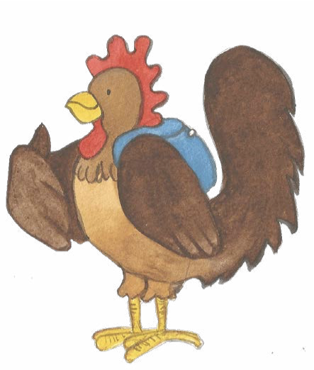

What does this mean…?
To embellish is to elaborate, to add detail, to
make it more descriptive and less plainly told.
Here are two versions of a Shaggy Dog story: Rabbit’s and Fox’s.
Read them carefully. Then say which you like best.

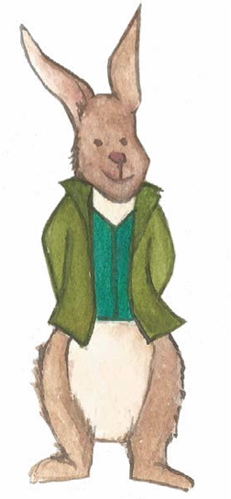 | A really tall man turned into a small back street one day. He went up to the door of the first house on the road. He leant forward and used his head to ring the house’s doorbell. When the owner opened the door, the tall man politely bowed. Without saying anything, he turned and walked quickly on to the next house. Again, he used his face to press the buzzer. Once again, when the owner answered the door, | One day, a man went down a street. He went up to the first house front door. He leant forward and used his head to ring the house’s doorbell. When the owner opened the door, the man bowed and then walked on to the next house. Again, he used | 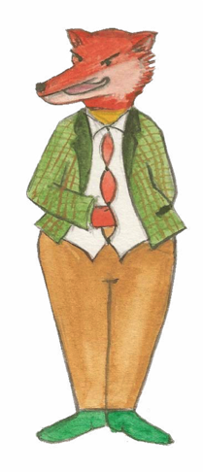
he bowed most courteously, turned and went on. This happened all the way down the street, from No 1 to No 33, with the tall man pressing his head on the doorbell of each and every house, then bowing politely and moving on. People on the street were rather startled. Some were annoyed, but they all watched him in great puzzlement. “Who on earth is that man?” asked one old lady. “I’m not quite sure,” replied her friendly neighbour, “but his face rings a bell.” |  | his face to press the buzzer and bowed when the owner answered the door. This happened all the way down the street, at each house, with the man pressing his head on the doorbell at every house in turn.  “Who is that man?” asked a house owner. “I’m not quite sure,” replied his neighbour, “but his face rings a bell.”

It makes a much better joke if you add descriptions and information as you go.
And you delay the punchline – which makes it all the funnier!

More Jokes

What is a vampire’s favourite fruit? A blood orange.
What do you call a dog magician? A labracadabrador.
Why didn’t the skeleton go to the dance? He had no body to dance with.
What kind of award did the dentist receive? A little plaque.
What do you call a funny mountain? Hill-arious.
What did the big flower say to the little flower? Hi, bud!
Why was the picture sent to prison? It was framed.
Where do rabbits go after they get married? On a bunny-moon!
What sound do hedgehogs make when they hug? Ouch!
Why do ducks make great detectives? They always quack the case.
What do you call an old snowman? Water.
Why didn’t the orange win the race? It ran out of juice.
What dinosaur had the best vocabulary? The thesaurus.
Why did the man put his money in the freezer? He wanted cold hard cash!
What creature is smarter than a talking parrot? A spelling bee.
What is orange and sounds like a parrot? A carrot!
What kind of dinosaur loves to sleep? A stega-snore-us.
Where do sheep go to get their hair cut? The baa-baa shop.
What do you call a group of disorganized cats? A cat-tastrophe.
Why did the chicken get a penalty? For fowl play.
Where do you learn to make banana splits? At sundae school.
Why did the tomato turn red? It saw the salad dressing.

Sherlock Holmes and Dr. Watson went camping.
They pitched their tent under the stars and went to sleep.
Sometime in the middle of the night Holmes woke Watson up and said: "Watson, look up at the stars, and tell me what you see."
Watson replied: "I see millions and millions of stars."
Holmes said: "And what do you deduce from that?"
Watson replied: "Well, if there are millions of stars, and if even a few of those have planets, it's quite likely there are some planets like Earth out there. And if there are a few planets like Earth out there, there might also be life."
And Holmes said: "Watson, you idiot, it means that somebody stole our tent."
_________________________________________________________________________
Three Little Pigs went out to dinner one night. The waiter comes and takes their order.
"I would like a Sprite," said the first little piggy.
"I would like a Coke," said the second little piggy.
"I want water, lots and lots of water," said the third little piggy.
The drinks are brought out and the waiter takes their orders for dinner.
"I want a nice big steak," said the first piggy.
"I would like the salad," said the second piggy.
"I want water, lots and lots of water," said the third little piggy.
The meals were brought out and a while later the waiter approached the table and asked if the piggys would like any dessert.
"I want a banana split," said the first piggy.
"I want an ice-cream," said the second piggy.
"I want water, lots and lots of water," exclaimed the third little piggy.
"Pardon me for asking," said the waiter, "but why have you only ordered water?"
The third piggy says - "Well, somebody has to go 'Wee, wee, wee, all the way home!'"

I’ve got a new job

- Read these examples

I’ve got a new job  What is it?  I’m a footballer  How’s it going?  Things keep kicking off | I’ve got a new job  What is it?  I’m a sugar farmer  How’s it going?  It’s sweet | I’ve got a new job  What is it?  I’m a lift operator  How’s it going?  It’s a bit up and down

- Choose the best punchline (end line) for these jokes

I’ve got a new job  What is it?  I sell underwear  How’s it going? | I’ve got a new job  What is it?  Working at the recycling centre  How’s it going? | I’ve got a new job  What is it?  Fixing fridges  How’s it going?
I’ve got a new job  What is it?  I work in a car shop  How’s it going? | I’ve got a new job  What is it?  I decorate holes in the ground  How’s it going? | I’ve got a new job  What is it?  I’m a beekeeper  How’s it going?

Possible punchlines

It’s pants! | It’s buzzing | Tiring
It’s cool | It’s rubbish | Pretty well

- Try making up your own ‘new job’ jokes.
Think of a job and then think of a word or expression that could go with it to make a punchline.
Or think of the expression and then think of the job it would match.

How to Make a Folded Book
1. Fold your sheet of paper along the two main directions (by folding it in half and then opening it, once for each direction).
2. Now make another pair of creases, dividing the long direction into quarters making 8 sections altogether. | 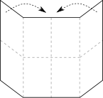
3. Unfold the paper again, fold it in half and make a cut with scissors as shown – you should be cutting through a double thickness of paper, but only as far as the quarter-folds you just made. | 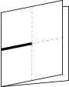
4. Open the paper out again. The resulting page should have a cut in its centre, a bit like this. | 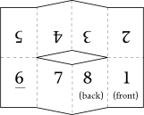
5. Fold it in half along the long direction, so that all your pages are still on the outside. | 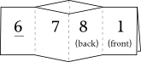
6. Now push the folded paper inwards from each end, so that the cut inner bit pushes out in both directions to make a kind of cross-shape. Fold the resulting pages together so that your front page is on the outside. | 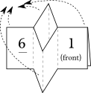
7. And there you have it: a little book of 8 pages that needs no stapling or gluing! Now make a dust jacket by cutting strips of coloured paper and folding them round each end of the book.

