What to do today
IMPORTANT Parent or Carer – Read this page with your child and check that you are happy with what they have to do and any weblinks or use of internet.

1. Read about an author
- Read Benjamin Zephaniah – Author Profile. Highlight the most important information.
- Read Benjamin Zephaniah – Interview. Highlight new information from the interview.
- Make notes to show what you have learnt about Benjamin Zephaniah that you think is important on Author Summary.

2. Read poems by Benjamin Zephaniah
- Read the three poems by Benjamin Zephaniah: Good Hope, Football Mad, People Need People. Try reading them in your head and out loud too.
- Pick your favourite poem. Write answers to Poetry Questions.
- Benjamin Zephaniah was asked to perform a poem on the One Show at the end of the first week of the Black Lives Matter protests. Which of these poems would you pick for him to perform? Why?

3. Watch a performance
- Watch Benjamin Zephaniah perform his poem on the One Show. Why do you think he picked this poem?
https://www.youtube.com/watch?v=8uHHjAsPbLc
- Practise reading the poem yourself. Can you learn some of it off by heart?

Try this extra activity
Find some more poems by Benjamin Zephaniah. You could start here:
https://childrens.poetryarchive.org/poet/benjamin-zephaniah/

Author Profile – Benjamin Zephaniah
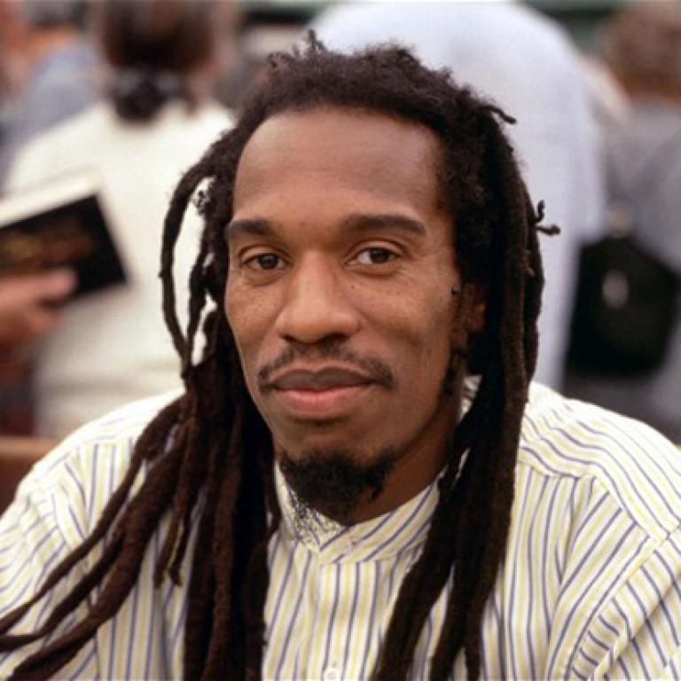 | Benjamin Zephaniah is a British poet and writer. In 2008, he was voted one of Britain’s top 50 writers.  He was born in Birmingham in April, 1958, the son of Caribbean immigrants. He was dyslexic, and left school at 13, as he couldn’t read or write.  His poetry book for children, Talking Turkeys, was an immediate bestseller. He has also written several novels aimed specifically at teenagers, as well as several collections of poetry.  In 1991, Zephaniah performed on all six continents in just a three-week period.  He has a fan club in the central African country of Malawi, and spends part of his time in Beijing, China.

Benjamin Zephaniah Interview

As a child was English your favourite subject? Was your aspiration writing back then?
It’s really weird to say, because I’m a writer, but I hated writing and I hated reading. But it’s really important. You get into the habit of reading and writing when you’re young, you have it for life. If you leave it too late and then it’s very difficult to go back and get it. I had a struggle with dyslexia as well. But if I can inspire people to read and write at a young age, I’m doing ok.
We hear you had a troubled time at school, but did you have a favourite or supportive teacher or teachers?
No. It’s a really sad thing to say. One has to understand that the schools that I went to: teachers were teachers, pupils were pupils and you just did as you were told. I was dyslexic – the word dyslexic wasn’t used. I was called stupid. I was told that because I was a young black boy I didn’t have to really concentrate on reading and writing and arithmetic - because I’d be good at sports! So, it was a different time…
What was your favourite book as a child?
Well, I’m sounding really negative, aren’t I? But in my house there were no books. Um, you know, if my dad saw me reading a book or trying to read a book, he would say, “you got nothing to do?” and he’d find me something to do. It’s really sad, I think, because when you’re young you have so much time to read books. I’m nearly a hundred years old now [this is a joke!] and I’m still catching up on my reading I should have done when I was a child!

Due to the time that you were young, we’re guessing there weren’t many black authors or non-white characters in books? How did that feel?
I didn’t know any – and that was one of the reasons why I wasn’t really that interested. My mother at home was telling me stories of Jamaica and Jamaican characters and in school I’m being told about all these characters who seem to live in a different world.
So, based on the fact that there weren’t many black authors in your childhood, is that one of the reasons you wanted to write? To kind of start the tradition of having black writers all over the world?
Yeah. I’m not sure I started the tradition but I wanted to be a part of that. I just wanted us all to be represented.
How important is it to shout out about not enough diversity in books?
It’s very important because if there’s not diversity in books, people won’t read them. I think when I started to notice that books were getting more diverse, I would say it was like the late 80s, early 90s - I noticed that there were a lot of female Asian writers writing about their experience and black writers writing about living in a multicultural country and dealing with the new culture and all that kind of stuff. I love diversity, I love multiculturalism, I love the fact that we all bring something different to the table, if you like. It makes Britain’s music interesting. It makes our food interesting. It makes our literature interesting. And it just makes for a more interesting country. If you don’t have diversity, what do you have? A country where people all look the same, dress the same, walk the same. It’s boring.

Benjamin Zephaniah – Author Summary

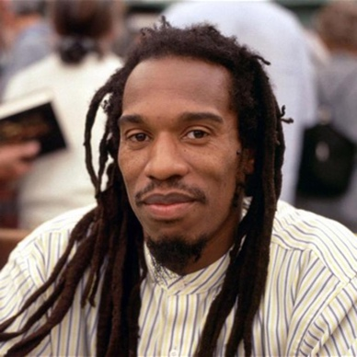
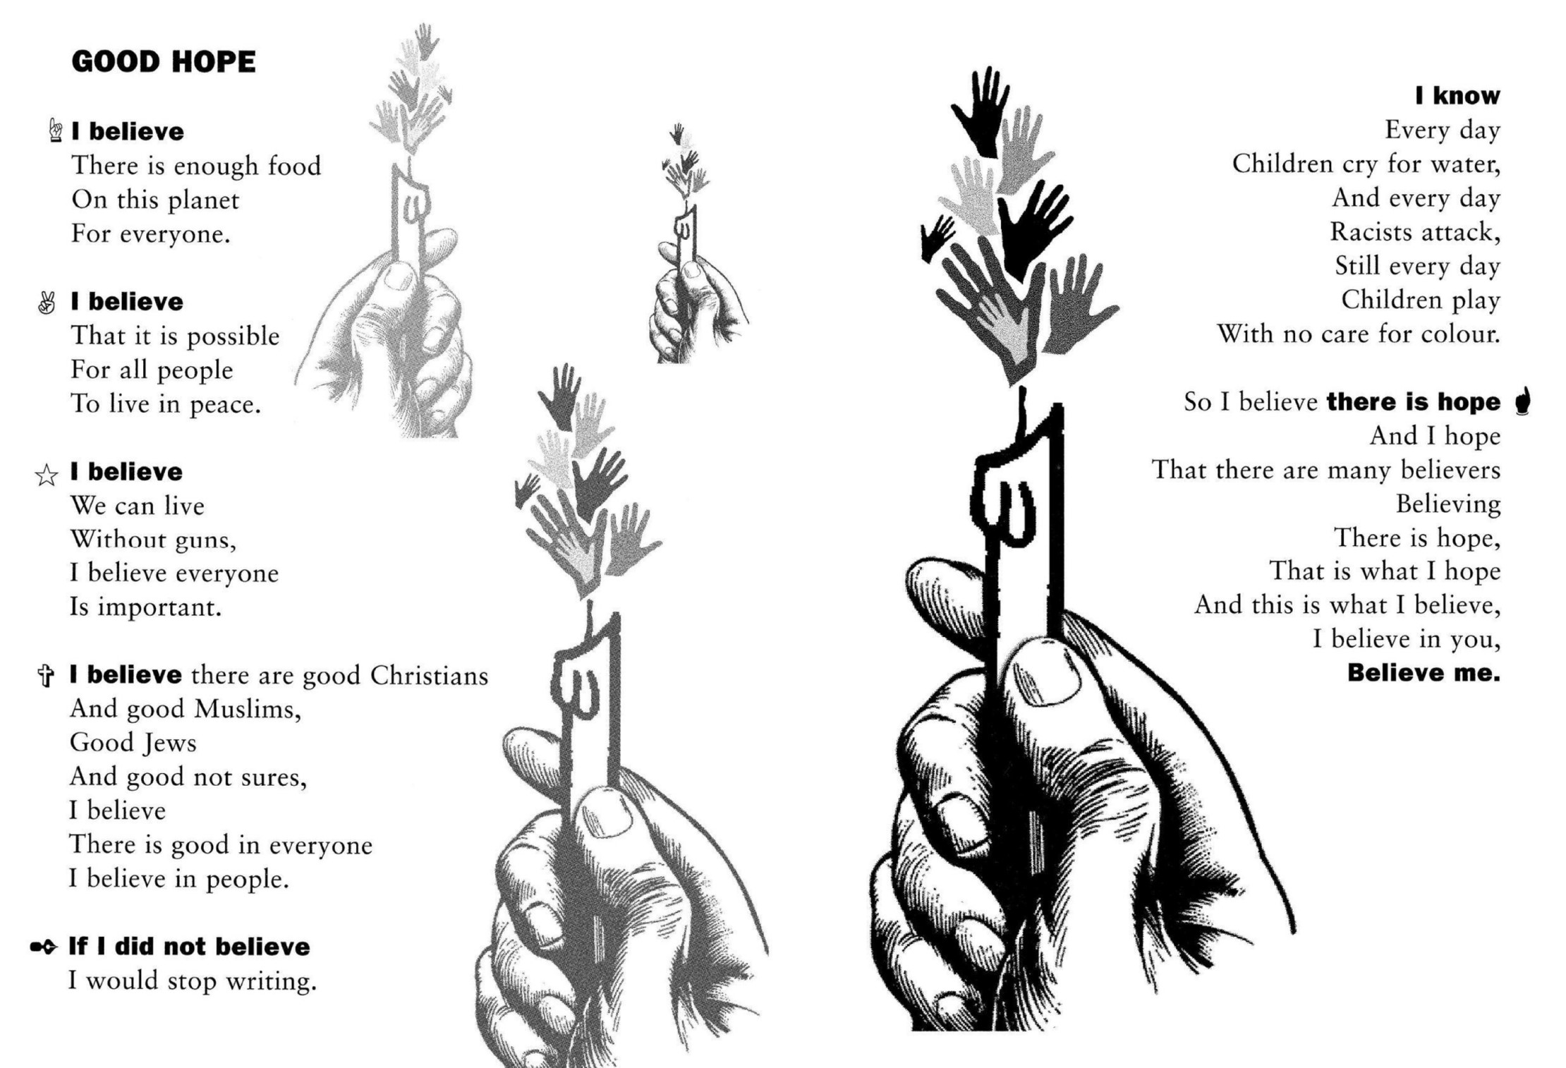
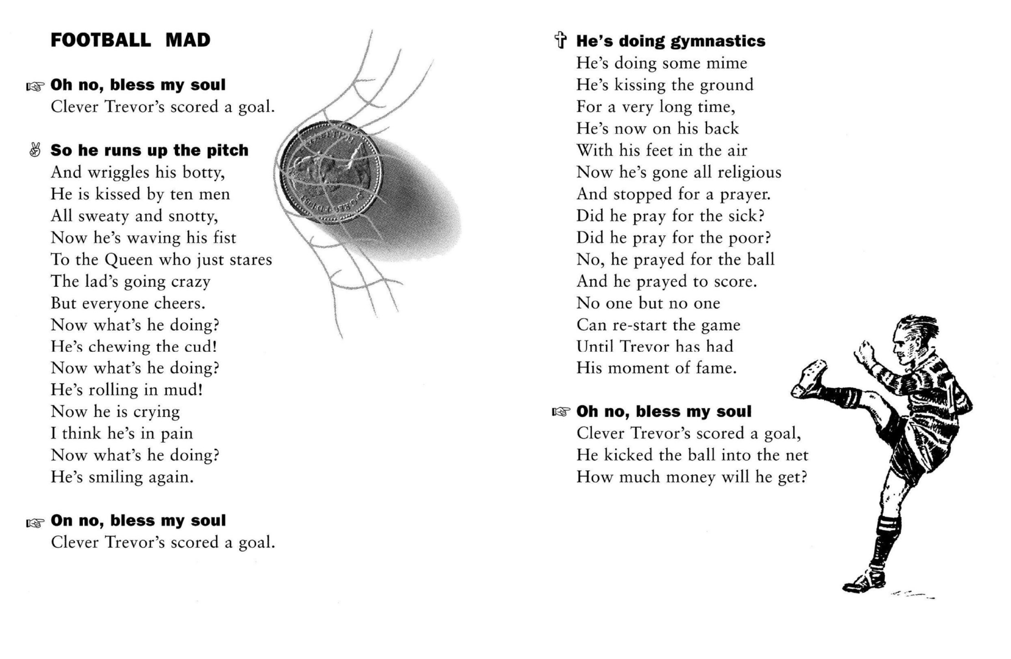
People Need People

To walk to
To talk to
To cry and rely on,
People will always need people.
To love and to miss
To hug and to kiss,
It’s useful to have other people.
To whom to moan
If you’re all alone,
It’s so hard to share
When no one is there.
There’s not much to do
When there’s no one but you.
People will always need people.

To please
To tease
To put you at ease,
People will always need people.
To make life appealing
And give life some meaning,
It’s useful to have other people.
It you need a change
To whom will you turn.
If you need a lesson
From whom will you learn.
If you need to play
You’ll know why I say
People will always need people.

As girlfriends
As boyfriends
From Bombay
To Ostend,
People will always need people-
To have friendly fights with
And share tasty bites with,
It’s useful to have other people.
People live in families
Gangs, posses and packs,
It seems we need company
Before we relax,
So stop making enemies
And let’s face the facts,
People will always need people,
Yes
People will always need people.

–Benjamin Zephaniah

Poetry Questions

What do you like about this poem? Is there anything that you dislike about it? | What does this poem make you think about? Does it remind you of anything else you have read or heard or seen? Does it remind you of anyone you know?
What patterns can you find in this poem? | What questions and puzzles does this poem leave?

