What to do today
IMPORTANT Parent or Carer – Read this page with your child and check that you are happy with what they have to do and any weblinks or use of internet.

1. Read a poem
- Read And Then They Came For Me.
- What do you like about this poem? Is there anything that you dislike? What patterns can you spot? Why do you think this poem has become famous?
- Practise reading the poem aloud. You could challenge yourself to learn it off by heart.

2. Read a non-fiction guide to Black Lives Matter
- Read Black Lives Matter: An Introduction.
- Highlight the text as you read to show the most important information.
- Make a poster to summarise and show the five most important things that you have learnt from this introduction.

3. Read and evaluate a fiction book about Black Lives Matter
- Watch the reading of the American children’s book:
https://www.youtube.com/watch?v=Pi7_Ps6Jf7Y
- Write what could be being said in each of the Three Pictures.
- Write answers to the question on the Book Evaluation.

Well done. Talk to a grown-up about three things that you have learnt today.

Try this extra activity
Go back to the ‘Why should you care?’ section of Black Lives Matter: An Introduction. Could you write to your MP about what you have learnt? Or could you write a story, poem or song about what you have learnt?

And then they came for me

First they came for the Communists
And I did not speak out
Because I was not a Communist
Then they came for the Socialists
And I did not speak out
Because I was not a Socialist
Then they came for the trade unionists
And I did not speak out
Because I was not a trade unionist
Then they came for the Jews
And I did not speak out
Because I was not a Jew
Then they came for me
And there was no one left
To speak out for me
by Martin Niemöller

Martin Niemöller wrote this poem after the Second World War. He believed that he had not done enough to oppose the Nazi Party who had arrested and killed group after group of people.
Black Lives Matter: An Introduction by Deanna Rodger
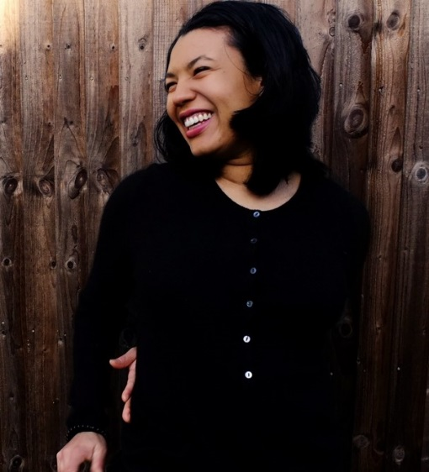

We all know that to be alive is to jump and dance and sing and play and also, to cry and be hungry and be told you must go to bed when you really, really don’t feel tired.
Well Black Lives Matter is a movement, an active message, a reminder that black people deserve all the fun, kind, and joyful things in life. They deserve to be safe, empowered and able to flourish.
Don't Black people have equal rights and opportunities?
Yes and no. You see, though slavery was legally abolished in the UK in the 1800s, in many places the racist idea that Black people are inferior to white people still holds strong. Some people cannot believe that black people are people, let alone people who deserve equal rights and opportunities. Well this is bad, but what makes it worse is that some of those people made laws and policies with this belief in mind. We call this in-built prejudice and unfairness systemic racism.
What does this mean? ​
It means that Black people are often treated unjustly in the eyes of the law, in healthcare, and even in education. It means that Black people are less likely to be employed in roles they are qualified for and fewer books, TV programmes or shows have Black people in leading roles or as heroes.

So, have a think, what was the last movie you watched? How many Black characters were there? Were the Black characters the heroes? Or think about our government. How many Black people are in the cabinet? In the cabinet office?
In the UK, Black women are five times more likely to die in childbirth, Black (Caribbean) children are nearly four times more likely to be expelled from school, and Black males are nine times more likely to be stopped and searched by the police. These are the signs of what we have called ‘systemic racism’.
Black Lives Matter, where did that come from?
It came from a group of Black female activists. In 2014 Alicia Garza​ wrote a Facebook post about an unarmed Black boy called Trayvon Martin who was killed by a neighbourhood-watch volunteer. This person was found not guilty. This inspired ​Patrisse Cullors to reply with ​#BlackLivesMatter and, with added support from​ ​Opal Tometi​, it has blossomed into an international human rights movement which campaigns against violence and systemic racism in all countries.
Such is the power of an idea!
Since then #BlackLivesMatter has increased and developed. Many people of all colours have grown in their understanding that, all too often, the lives of Black people are not seen as equal, whether that be in media representation, racist policies, or scandals such the Windrush deportations. Even in relation to global pandemics, the fatalities linked to Covid-19 are much higher for Black people.
So why do I personally care?
Well although I am mixed-race (White and Black Caribbean) I am classified as Black. Many of my formative experiences are experiences shared within the Black community. I care about the safety, empowerment and flourishing of all people.
Exactly, so why not ​all​ lives matter?
Of course, all lives matter. Black Lives Matter is in no way saying that they don’t. Black Lives Matter is simply focussed on the lived experiences of Black people which are unfairly affected by abuses of power. There are many texts clearly showing why Black Lives Matter is an important movement.
Here is one which helps make the point.
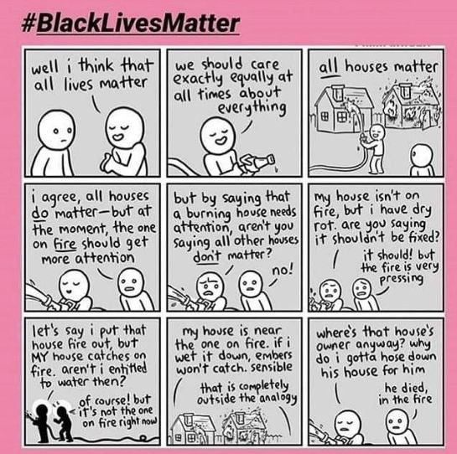

And why should you care?
Human rights are super important to defend even if you don't identify with the group they affect. This is at the heart of Niemöller’s poem. It is important to be specific when protesting to ensure that policies can be singled out and changed and behaviours can be altered to promote the welfare of the affected communities. There are many ways to do this such as through petitions to change policies, focus groups and discussions within the local community, writing letters to your local MP and, especially, through the creative arts such as writing poetry and songs.

Three Pictures
Write what could be being said in each of these pictures.

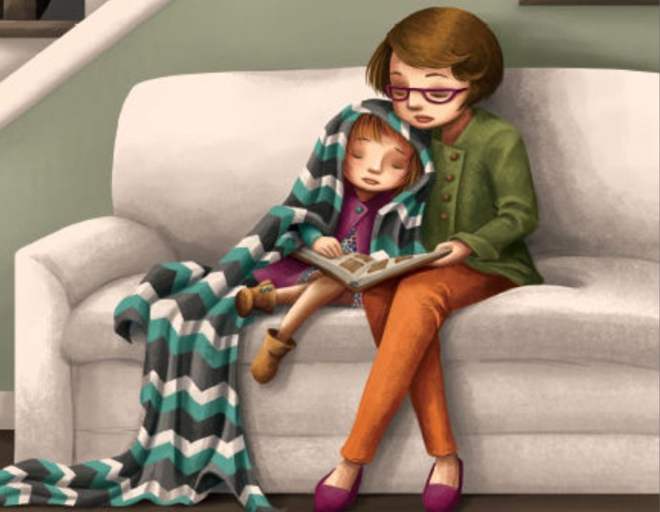
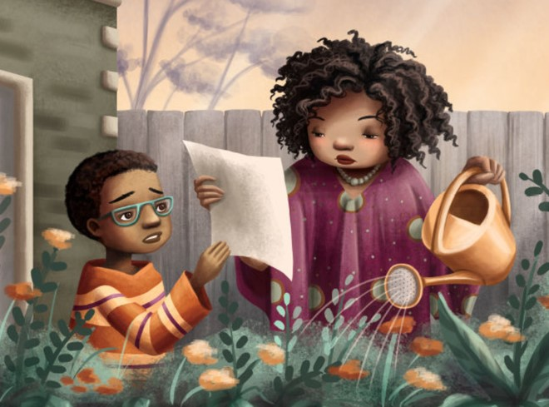
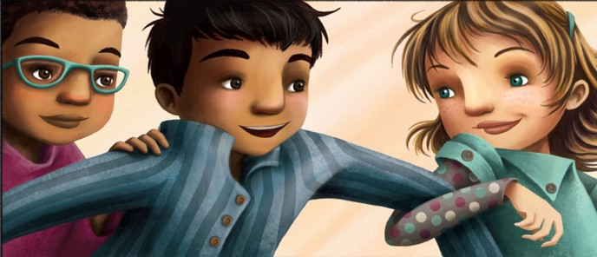

Book Evaluation
Write your answers and explain your opinions.
- What message do you think the book is trying to give?

- How well do you think that the book communicates this message?

- What do you think is the best thing about this book?

- Was there anything that surprised you in the book?

- This is an American book. Do you think it is relevant in other countries?

- The book is recommended for 4 year-old to 8 year-old children. Do you agree with this recommendation?

