What to do today
IMPORTANT Parent or Carer – Read this page with your child and check that you are happy with what they have to do and any weblinks or use of internet.

1. Remind yourself about Edward Colston
- Read Colston Information.
- Highlight the most important information in this article.

2. Listen to a poem and answer questions
- Watch this poem about the Colston Statue: Hollow
https://www.youtube.com/watch?v=b3DKfaK50AU
- Listen to the poem again, following the words provided below on Hollow. Which is your favourite line?
- Read Hollow Questions. Think about your answers and then write them as whole sentences.
- Check what you thought with the Suggested Answers below. Your answers are probably better than these!

3. Read a story and plan a new one
- Read Brave Molly. What does Molly discover about the monster? How is this similar to the poem’s discovery about Edward Colston?
- Use the Story-Planner to plan a story about someone or something that seems powerful but then is shown to weak or hollow.

Well done. Talk to a grown-up about your story idea. Show them the Hollow poem and talk about your answers to Hollow Questions. Would they have answered the same as you?

Try this extra activity
Write your story plan into a finished story. Show it to EVERYONE!

Colston Information

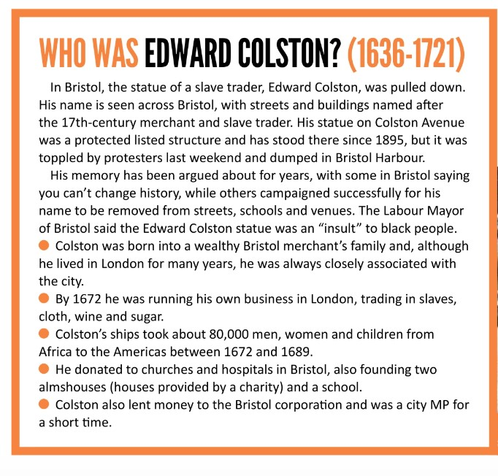
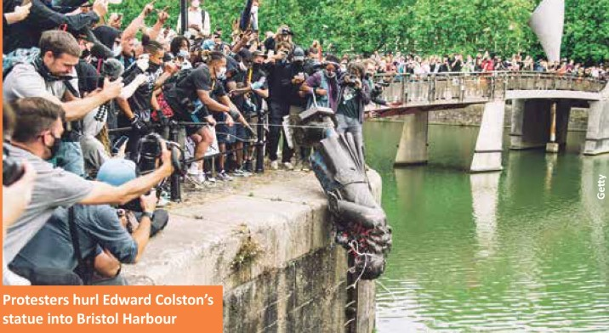
Hollow
Vanessa Kisuule, June 2020

You came down easy in the end
The righteous wrench of two ropes
In a grand plie
Briefly, you flew
Corkscrewed, then met the ground
With the clang of toy guns, loose change
Chains
A rain of cheers.
Standing ovation
On the platform of your neck
Punk ballet. Act 1.
There is more to come.

And who carved you?
They took such care
With that stately pose and propped chin.
Wise and virtuous the plaque assured us.
Victors wish history odourless and static
But history is a sneaky mistress
Moves like smoke, Colston,
Like saliva in a hungry mouth.

This is your rightful home
Here
In the pit of chaos with the rest of us.
Take your twisted glory
And feed it to the tadpoles.
Kids will write raps
To that syncopated splash.
I think of you lying in that harbour
With the horrors you hosted.
There is no poem
More succinct than that.

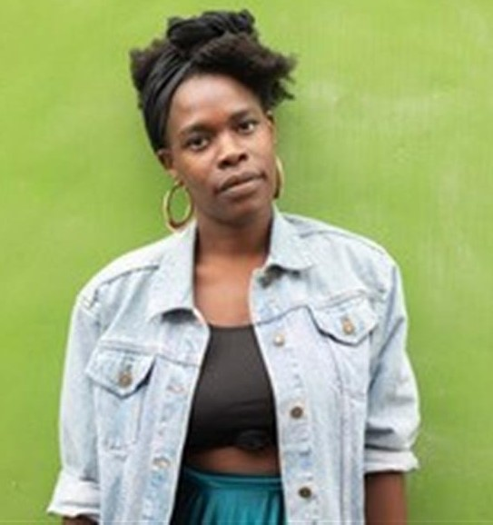

But still
You
Are permanent.

You who perfected the ratio.
Blood to sugar to money to bricks.
Each bougie building we flaunt
Haunted by bones.
Children learn and titans sing
Under the stubborn rust of your name.

But the air is gently throbbing with Newness.
Can you feel it?
Colston, I can’t get the sound of you from My head
Countless times I passed that plinth
Its heavy threat of metal and marble.
But as you landed a piece of you fell off
Broke away
And inside
Nothing but air.
This whole time
You
Were hollow.

Hollow Questions

- Who is the poem talking to?

- What do you think the poet thinks about Edward Colston? Why do you say that?

- Which is your favourite phrase in the poem? Why?

- What do you think the poem means when it says, ‘Children learn and titans sing under the stubborn rust of your name.’?

- What did the narrator of the poem discover at the end of the poem?

- Why do you think that this poem has become so popular?

Suggested Answers

- Who is the poem talking to?
It is talking to Colston, the statue or the man. Perhaps it is talking to the legacy that Colston has left.

- What do you think the poet thinks about Edward Colston? Why do you say that?
I think she hates him and yet is somehow weirdly impressed by him. She knows he did really evil things and used black slaves to make money. In many ways, she despises him.

- Which is your favourite phrase in the poem? Why?
Some suggestions
- History is a sneaky mistress
- Moves like smoke
- In the pit of chaos with the rest of us
- Blood to sugar, money to bricks
- The air is gently throbbing with newness
- Its heavy threat of metal and marble

- What do you think the poem means when it says, ‘Children learn and titans sing under the stubborn rust of your name.’?
Everything goes on, from kids being taught in schools and celebrities and the rich and famous doing their stuff, all in the shadow of buildings, schools and a concert hall all named Colston, plus a statue – all of which commemorate a man who made money by selling black people as slaves.

- What did the narrator of the poem discover at the end of the poem?
The statue of Colston was hollow and not solid.
What does this tell us about his reputation? Perhaps about the man? About the racist ideas he represents?

Brave Molly
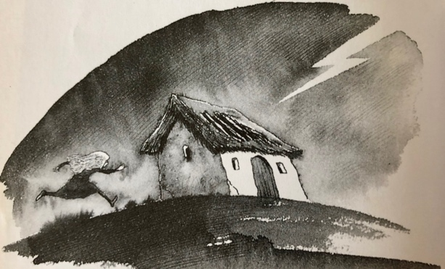

A little girl was once caught in a thunderstorm. The day grew dark, and the wind started to blow, and suddenly a fork of lightning streaked across the sky and a great clap of thunder rolled all around her. Poor Molly trembled with fright, and she wished she were back at home with her mother. Then it started to rain. Such a cloudburst it was! The heavens just opened up and down came the rain in great big drops the size of your fist.
In the distance, Molly could see a little hut, so she ran up to it and, finding the door open, she slipped into the gloomy inside. No sooner had she shut the door than a deep growling voice said: “Grrr! Who are you?”
Molly looked around her, but the inside of the hut was quite dark, and she couldn't see anyone.
“P-p-p-please . . . my name's M-M-M-Molly,” she said. “Who are you?”
“Grrr! I'm a Terrible Monster — that's who,” said the voice.
Just then a bolt of lightning lit up the inside of the hut for a fraction of a second and, in that moment, Molly saw a huge shape crouching against the far end of the hut. “Ohhhhh!” she cried.
“What's the matter?” growled the Terrible Monster. “Frightened, are you?”
“Indeed I am,” said Molly. 'You're green and slimy, as big as a house and covered in hair.”
“And I've got a terrible roar,” said the Monster. AAAAAAAARRRRRRRGH!”

Poor Molly fell over backwards in her fright. And the thunder crashed over their heads, and another flash of lightning lit up the Monster, and Molly could see that he had great green claws and glowing eyes and huge yellow teeth.
“Pretty frightening, huh?” bellowed the Monster.
“Oh y-y-y-yes,'' cried Molly.
“And I'm as strong as two hundred oxen!” he cried and, as the lightning flashed, Molly saw the Monster rear up on his legs and throw the roof of the hut high into the air.
“Oh . . . please don't,” cried Molly, as the rain started to pour down on her and the thunder crashed.
“And I eat little girls for my supper!” roared the Monster. And he bent down and put one glowing eye right up against poor Molly, and said: “How about that?”
“Well,” Molly thought to herself, “it's no use being frightened. If he's going to eat me — he's going to eat me.” So, she picked up her satchel and hit that Monster right on the nose. And do you know what happened? Well, the Monster didn't pick her up in his huge claws, and he didn't gobble her up with his great yellow teeth. Do you know what he did? First, he turned green, then he turned purple and then he turned bright pink, and a bunch of flowers grew out of the top of his head.
“Why! You're not a frightening monster at all!” cried Molly.
“Aren't I?” said the Monster.
“No!” said Molly, and a beautiful ribbon tied in a bow suddenly appeared right round the Monster's middle. And Molly took hold of the ribbon and pulled it and the Monster opened up and inside was a little rabbit who looked very frightened and said: “Oh please! Don't put me in a pie.”
And Brave Molly said: “I won't put you in a pie this time, but don't go around trying to frighten little children in future.”
“No . . . I promise,” said the rabbit, and scuttled off out of the hut. And just then the sky cleared and the sun came out, and Brave Molly set off home again, and she didn't meet another monster all the rest of the way.
Adapted from Fairy Tales and Fantastic Stories by Terry Jones
Story Planner

Write your story here

