What to do today
IMPORTANT Parent or Carer – Read this page with your child and check that you are happy with what they have to do and any weblinks or use of internet.

1. Read a news report
- Read News Report – The Week Junior.
- Highlight the most important information in this article.
- What could be the headline for this news report? Try to write five different possible headlines.

2. Read other newspaper articles
- Read First News 1 and First News 2.
- Read First News Questions. Think about your answers.
- Write your answers in clear sentences.

3. Prepare an interview
- Watch the video of Blue Presenters talking about this news:
https://www.youtube.com/watch?v=9LLBDsVREaI
- Imagine that you were going to interview the three presenters. What questions would you ask them? Write three Question Ideas for each presenter and explain why you are asking them those things.

Well done. Talk about your answers to First News Questions with a grown-up. You can check your answers at the end of this pack.

Try this extra activity
Find out more about this news by watching some of the Newsround programmes on this website:

https://www.bbc.co.uk/newsround/53070882

News Report – The Week Junior

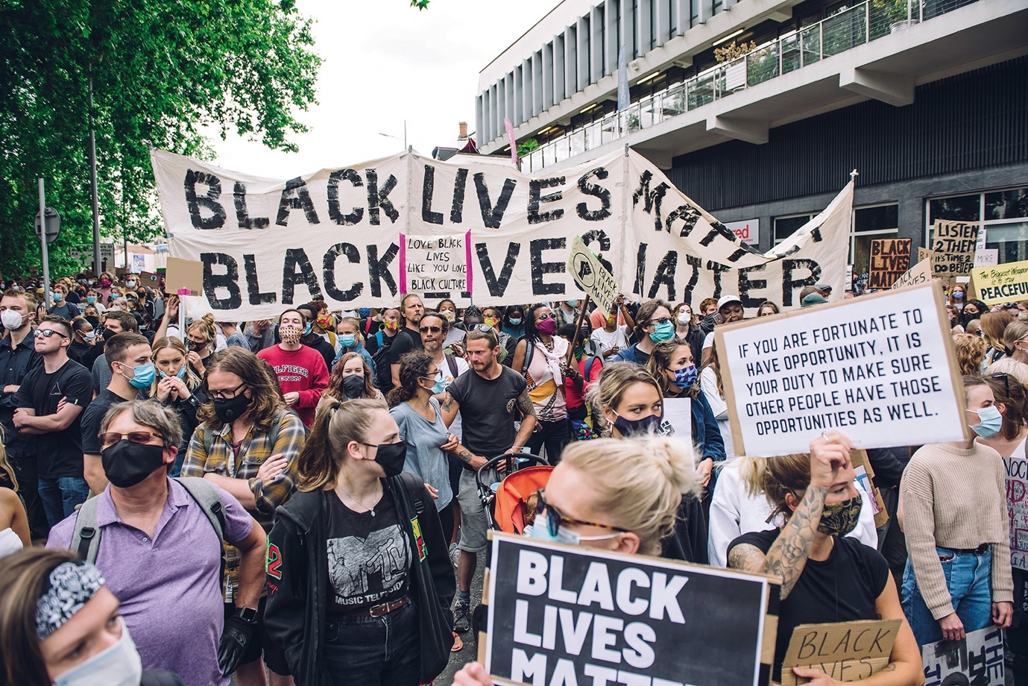

On 7 June, thousands of people protested in the UK calling for an end to racism. Racism is when people are treated badly or unfairly because of their race. It is when actions and words are used to discriminate against people because of the colour of their skin, their culture or their ethnic background. In Bristol, England, a statue of a 17th century slave trader was pulled down.

Why are people protesting?
On 25 May, a black man called George Floyd died shortly after he was arrested by a white police officer in Minneapolis, US. In a video of the arrest, the officer is seen putting his knee on Floyd’s neck. Floyd could be heard saying he couldn’t breathe. The officer has been charged with murder. Many people believe Floyd’s death was racist. It is not the first time a black person has died as a result of police violence. This has led to worldwide protests.

What happened in the UK?
In the UK, around 137,000 people demonstrated in cities including Bristol, Cardiff, Glasgow and London. In Bristol, protesters pulled down a statue of Edward Colston,

a 17th century slave trader, rolled it along the street and pushed it into the harbour.

Who was Edward Colston?
Colston was born in Bristol in 1636. In 1680, he joined a company that forcibly took people from Africa and sold them as slaves in the Caribbean and in North and South America. There, they were made to work in terrible conditions. Britain was the biggest slave-trading country from 1640 until 1807, when it became illegal.

What was the reaction?
Bristol’s mayor Marvin Rees, whose father was Jamaican, said he felt no “sense of loss” at the statue’s removal, but said he did not support criminal damage. UK Prime Minister Boris Johnson said it was a criminal act. In London, a statue of a slave trader, Robert Milligan, was removed by the authorities, and protests were held in Oxford, demanding that a statue of the 19th century figure Cecil Rhodes be taken down. Rhodes held racist views.

Is there racism in the UK today?
Racism still exists in the UK. Black people in England and Wales are 9.5 times more likely to be stopped and searched by police than a white person, and black people are five times more likely to have force used against them by police. Many people believe there is inequality in education, health and at work. One London protester said, “People out here showing support is a great step… but there is still so much more to be done. People still need to educate themselves.”

If you’re upset by this story
If you’re feeling worried or scared by the events described in this report, talk to your parents or another adult you trust. For some advice on dealing with your feelings, visit theweekjunior.co.uk/TWJ-Protests

First News 1

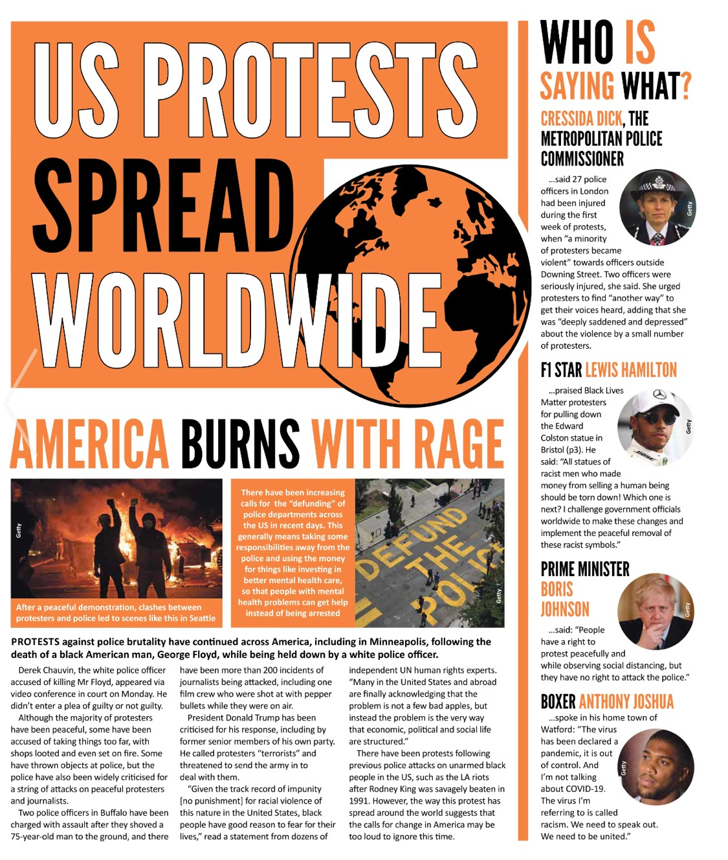
First News 2
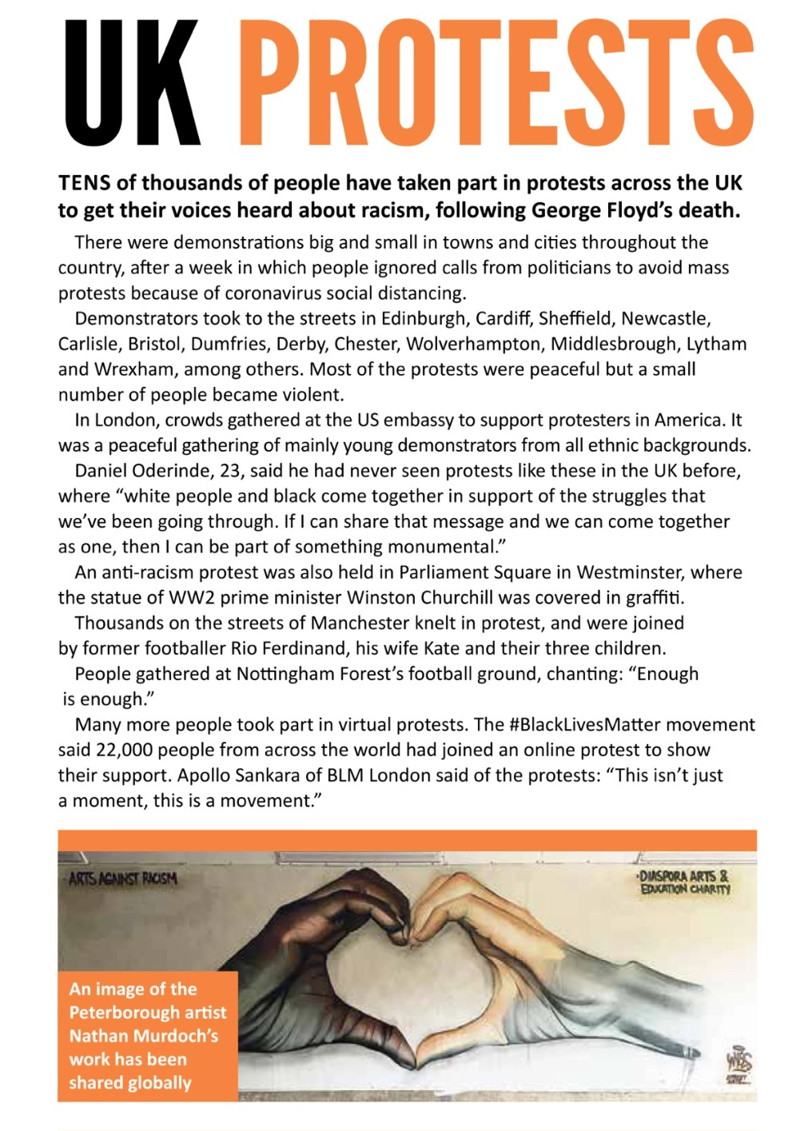

First News Questions

These questions are about First News 1
- Whose death sparked the protests against police brutality in America?

- Why does the article suggest that ‘calls for change in America may be too loud to ignore this time’?

- What was the Metropolitan Police Commissioner concerned about?
- Who did Lewis Hamilton praise?
- What did Anthony Joshua compare racism to?

These questions are about First News 2
- Were the protests in the UK mainly peaceful or mainly violent?
- Who did Daniel Oderinde say had come together to protest?
- Who joined the protests in Manchester?
- How many people joined protests online?
10. Why do you think that Nathan Murdoch’s artwork has been so popular?

This question is about The Week Junior
- Why do you think the news report highlights the fact that the Bristol Mayor is of Jamaican origin, and yet, does not make any mention of the fact that Boris Johnson is white?

Question Ideas
Write your interview questions and why you would ask them.
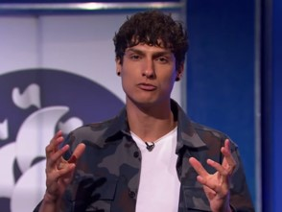  Richie Driss | 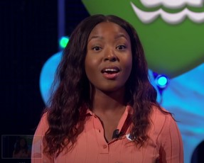  Mwaka Mudenda | 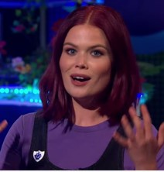  Lindsey Russell

First News Questions – Possible Answers
These questions are about First News 1
- Whose death sparked the protests against police brutality in America?
It was the death of George Floyd that sparked the protests.
- Why does the article suggest that ‘calls for change in America may be too loud to ignore this time’?
It suggests this because of the way that the protests has spread around the world.
- What was the Metropolitan Police Commissioner concerned about?
Cressida Dick was concerned about violence and the injury to police officers.
- Who did Lewis Hamilton praise?
Lewis Hamilton praised the protestors who pulled down the Colston statue.
- What did Anthony Joshua compare racism to?
Anthony Joshua said that racism is like a virus.
These questions are about First News 2
- Were the protests in the UK mainly peaceful or mainly violent?
The protests in the UK were mainly peaceful.
- Who did Daniel Oderinde say had come together to protest?
He said that white people and black people had come together in support of the issue.
- Who joined the protests in Manchester?
Rio and Kate Ferdinand and their family joined the protests.
- How many people joined protests online?
Twenty-thousand people joined the protests online.
- Why do you think that Nathan Murdoch’s artwork has been so popular?
Give reasons for your answers.
These questions are about The Week Junior
- Why do you think the news report highlights the fact that the Bristol Mayor is of Jamaican origin, and yet, does not make any mention of the fact that Boris Johnson is white?
Perhaps the reporter feels that it is necessary to point out the fact that the Mayor of Bristol is Black since most city mayors are white. However, the effect of this statement is to suggest that the major is likely to be sympathetic to the removal of the slave trader’s statue. Thus, it could be argued to be biased reporting. Also, the article seems to assume that people know the Prime Minister of the UK is white, and so makes no comment on Boris Johnson’s ethnic background.

