What to do today
IMPORTANT Parent or Carer – Read this page with your child and check that you are happy with what they have to do and any weblinks or use of internet.

1. Find out about Star Wars droids
- Look at Droid Pictures. What do you know already about any of these?
- Read Droid Descriptions. Look for any clues that will help you to match each description to the right picture. You may need to look up some vocabulary. Use a book dictionary or https://www.wordsmyth.net/
- Read Droid Questions. How many can you answer?
- Check your answers with Droid Answers.
- Write a Multiple-Choice Quiz. Write three options for each question: the right answer, a close answer and a ridiculous answer. Don’t always put these in the same order.
- Try your quiz out on some other people. How many can they get right?

2. Invent a droid
- Design a droid that would be most helpful to you.
- Draw your droid. Write a description of it. You can make up your information!
- Make an advert for your droid. You could make a poster or you could film an advert.

3. Imagine living gadgets
- Imagine if some modern day gadgets had personalities like the StarWars droids, e.g. your watch could speak to you and gave you advice on how not to be late!!
- Complete Gadget Personalities.
- Use your ideas to write a story.

Droid Pictures
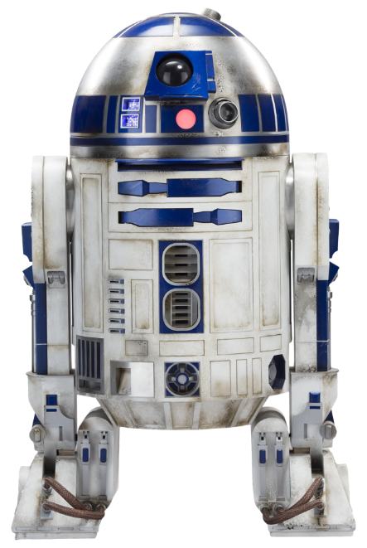  A | 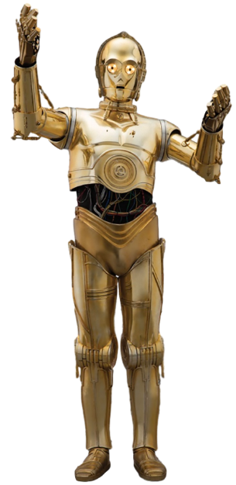  B
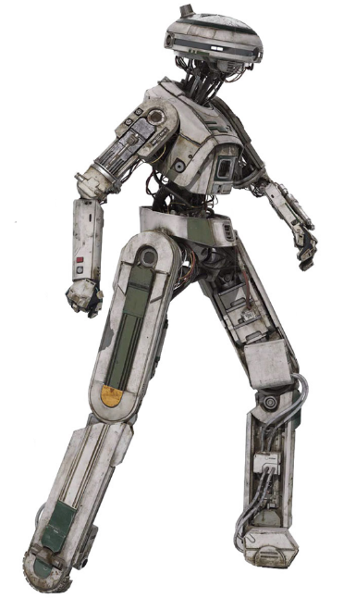  C | 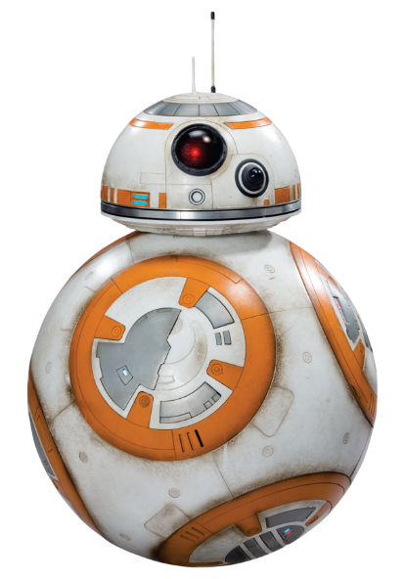  D

Droid Descriptions
Match the description to the picture. Look carefully at the picture for clues and read the writing looking for any links.
BB-8
BB-8 is a BB-series astromech droid. Astromech droids are a type of repair droid. It has a dome head similar to R2-D2, with the bulk of its body made up of a rolling ball. It is mostly white, with some silver and orange on its body, as well as a photoreceptor.

R2-D2
R2-D2 is a small astromech droid, standing 0.96 meters tall. He rolls on three legs, one of which can retract into his body, and has a silver and blue domed head. His white, blue, and silver body houses many arms, sensors, and other apparatuses, many of which are not readily seen by the typical human eye. While R2-D2 contains many specialised gadgets, he is also quite good at taking the initiative and often employs unorthodox means to help his friends.

L3-37
L3-37 is a custom self-made piloting droid, able to fly spaceships. She is a unique droid, assembling and improving herself with scraps of other droids, including her torso, which she pieced together from an old astromech. Her plating is grey/silver and, like C-3PO, she is bipedal.

C-3PO
Built by Anakin Skywalker, C-3PO is a protocol droid intended to assist in etiquette, customs and translation. Gold-plated and bipedal, the droid is fluent in over six million forms of communication. He has developed a fussy and worry-prone personality through his many decades of operation.
Answers

BB-8 D L3-37 C
R2-D2 A C-3PO B

Droid Questions

How does R2-D2 move?

In how many forms of communication is C-3PO fluent?

What characteristic do L3-37 and C-3PO share?

Why is L3-37 unique?

What shape is BB-8’s body?

With which metal is C-3PO’s body plated?

How can C-3PO’s personality be described?

What can R2-D2 retract into his body?

What shape is R2-D2’s head?

How is BB-8 similar to R2-D2?

Droid Answers

How does R2-D2 move? (Rolls on three legs)

What characteristic do L3-37 and C-3PO share? (Both are bipedal)

In how many forms of communication is C-3PO fluent? (Over six million)

Why is L3-37 unique? (She is self-made)

What shape is BB-8’s body? (Spherical)

With which metal is C-3PO’s body plated? (Gold)

How can C-3PO’s personality be described? (Anxious and worried)

What can R2-D2 retract into his body? (His legs)

What shape is R2-D2’s head? (Domed)

How is BB-8 similar to R2-D2? (Both are astromechs; both have domed heads)

Multiple Choice Quiz
Make up multiple choice options for each question.
Make one ridiculous and one more believable.
Two have been done for you. Put the right answer in different places, sometimes as A., sometimes as B. and sometimes as C.
How does R2-D2 move?  - Rolls on three legs  - Hovers  - Uses a scooter | What characteristic do C-3PO and L3-37 share?  - They have bicycles  - They are bipedal  - They are astromechs

In how many forms of communication is C-3PO fluent?

Why is L3-37 unique?

What shape is BB-8’s body?

With which metal is C-3PO’s body plated?

How can C-3PO’s personality be described?

What can R2-D2 retract into his body?

What shape is R2-D2’s head?

How is BB-8 similar to R2-D2?

Design Your Droid

Gadget Personalities
What sort of personality might these gadgets have? What might they say to their owners?
 | Personality | Quotes
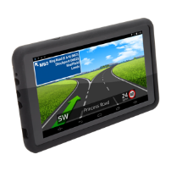
Sat-Nav
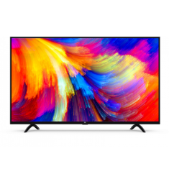
Smart TV
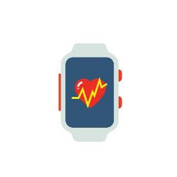
Fitness Tracker

Gadgets Alive
Write a story about home gadgets coming alive. What will they say to their owners? What will happen?

