What to do today
IMPORTANT Parent or Carer – Read this page with your child and check that you are happy with what they have to do and any weblinks or use of internet.

1. Read escape puzzles
- Read Escape Puzzles. Can you work out solutions to any of them? Show them to someone else. Can they work them out?
- Have a proper go at a couple of them.
- Check Solutions on the second page. Which do you think is cleverest?
- Learn your favourite off-by-heart and try it out on other people.

Well done. You could try playing this online Harry Potter escape-puzzle game.

https://bit.ly/2A6jKxY

2. Imagine some escapes
- Watch Anthony Horowitz talking about the top five escapes for Alex Rider (the character he writes about).
https://www.youtube.com/watch?v=ZiGlRtbXKiI
- Complete Alex Escapes with your ideas.
- Read Alex Rider Extract. Underline all the challenges that Alex faces as he tries to escape the prison.

3. Write about an escape
- Look closely at the Alcatraz diagram. Visit Google Earth to explore this real-life island prison in more detail.
https://bit.ly/2A61CnY
- Imagine you were locked up in Alcatraz and you were innocent! You have to get out. Plan your escape from Alcatraz, using Escape Planner.
- Write your plan as a story.

Escape Puzzles

- ﻿Two convicts are locked in a cell. There is an unbarred window high up in the cell. No matter if they stand on the bed or one on top of the other, they can’t reach the window to escape. They then decide to tunnel out. However, they give up with the tunnelling because it will take too long. Finally, one of the convicts figures out how to escape from the cell. What is their plan?

- ﻿A woman is trapped in a room. In the room there is a table, chair, two doors, and a small hole in the ceiling thirty centimetres in diameter. Behind one of the doors is an extremely hungry lion that ﻿hasn't eaten in a couple of days. Behind the other door is a glass tunnel that magnifies the sun creating temperatures so high that even opening the door could kill you. How does she escape?

- A man is trapped in a room by his enemies. He is given the chance to leave through one of three rooms. The first is full of raging fires, the second is full of assassins with loaded guns, and the third is full of lions that haven't eaten in 3 years. Which room is safest for him?

- There are two doors and there is one guard for each door. One door leads to life and the other leads to death. You only have one question to ask and you can
only ask one guard. One of the guards always tells the truth and the other always lies. What question do you ask to find out which is the door to life?

- A man is inside a prison cell. The cell is completely empty except for the man and a table. There are no doors or windows to escape from. There is also a desert surrounding the prison. At the edge of the desert is a town. The man escapes and traverses the desert to reach the town without walking over the desert. How?

Escape Puzzle - Solutions

- ﻿Their plan is to dig the tunnel and pile up the dirt to climb up to the window to escape.

- ﻿She waits until it is night (she can tell through the hole in the ceiling) then leaves through the glass tunnel.

- ﻿The third room. Lions that haven't eaten in three years are dead.

- ﻿ You would ask: "If I were to ask the other guard which door leads to life, what would he say?" The guard that tells the truth knows that the other guard would lie. So he tells the truth and points to the door that leads to death. The guard that lies knows that the other guard would tell the truth. So he lies and points to the door that leads to death. Both guards point to the death door.

- The man hits his hand on the table until it is sore. He then uses the saw to chop the table into two halves. He puts the two halves together to make a whole. He jumps through the hole and lands in the desert. He shouts and shouts until his voice is hoarse. He jumps onto the horse and rides to the town. Before he gets to the town, he comes across a river. He then remembers that the banks close at 5pm. So he waits until 5pm and crosses the river into town.

Alex Escapes

 | Scenario | Your idea for escape
1 | Alex is hidden in a broken-down car. It has been lifted into a car-crusher.
2 | Alex is imprisoned a school in the mountains. There are no skis or snowboards. He cannot leave on foot.
3 | Alex is fighting in zero-gravity. His opponent is armed with a knife.
4 | Alex is in a sabotaged car that has sunk fifty metres into a frozen lake.
5 | Alex is locked in a maximum-security prison in Gibraltar.

Alex Rider Extract

He grabbed hold of what was left of the office chair and began to carry it upstairs. It weighed less without its back and arms and he could manage it easily. He still had no idea if he was going to find what he was looking for and even if he did, he hadn't worked out the angles, the distances. He was just hoping that Julius Grief had done the work for him. Julius had manufactured the key. He must have believed it was actually worth the effort.
They came to the first landing. The doors were locked here too but to Alex's immense relief the same key opened them just as he had thought. The first led into the governor's bedroom with a king-sized bed covered in a pink duvet. Next to it there was a bathroom, then a guest bedroom, then a laundry room.
"You have one minute!" The same voice echoed from outside. "Give yourselves up or we're coming in."
Alex ignored it. He found the door he was looking for at the very end of the corridor. It opened onto a short corridor with a narrow flight of stairs leading up to the second floor. Carrying the chair, Alex clambered up and found himself walking through a series of empty storage rooms, some of them with slanted ceilings that followed the line of the roof. Alex was sweating. He could feel his shirt sticking to his shoulders and back. The welts on his neck had gone down a little but they were still hurting.
"There has to be a trapdoor!" he said.
"It's here." Freddy had already found it but from the tone of his voice he was in no hurry, as if he was enjoying wandering around the governor's villa in what might be the final moments of his life.
"Then open it!"
The trapdoor was in a ceiling high above them, with a handle clearly visible but far out of their reach. Looking around him, Alex saw a pole with a hooked end, propped up in a corner. He snatched it and threw it to Freddy who used it to reach up and catch hold of the handle. Freddy pulled. The trapdoor swung downwards, releasing a flight of metal steps, a ladder that unfolded all the way down to the carpet. Looking up, they could see the dark shadows of an attic.
"Thirty seconds!" the voice warned.
Freddy had already begun climbing the ladder with the gun tucked into the waistband of his trousers. Alex pushed the office chair over to him and, holding it awkwardly between them, the two boys carried it up into a narrow, uneven space packed with old trunks and boxes. There was a single window in front of them and as Alex went over to it, a cobweb brushed against him, depositing itself over his face.
The window wasn't locked. Alex pushed it open and climbed out. Freddy passed him the office chair and followed.
They found themselves on a small, lead-lined platform, hidden from the ground below, with a chimney towering over them and two red-tiled roofs, one on either side. The roofs were shaped like two ticks in an exercise book. They sloped down steeply, then rose for just a couple of metres at the end. One of them faced the compound, but the other reached out towards the electrified fence and the wall that stood next to it. Alex worked out the distances. The edge of the roof finished at least five metres away from the double barrier. Much too far to jump. But if he could get over the fence and the wall, he might have a chance. There was a small wood made up of pine trees on the other side and the nearest of them had several branches stretching out towards him.
Reach the branches and they could climb down. They would be on the outside of the prison, away from the guards. But they would need extra propulsion to get over the two barriers. If they hit the wall, they would electrocute themselves first.
Far below, somewhere in the house, Alex heard the crash of breaking wood. The guards had charged the front door. They were in!
Freddy knew what they were going to do and the idea delighted him. He had manipulated the chair so that it was at the top of one of the roofs — a rocket on a launch pad. Kneeling down, he lowered his body so that his stomach was on the seat. There was hardly any space left for Alex but he somehow managed to do the same so that they were now lying next to each other, one arm around each other's shoulders, the other holding tight to the chair.
There were shouts, echoing up from the hallway. The stamp of heavy boots on the main staircase.
From Nightshade by Anthony Horowitz

Alcatraz Diagram
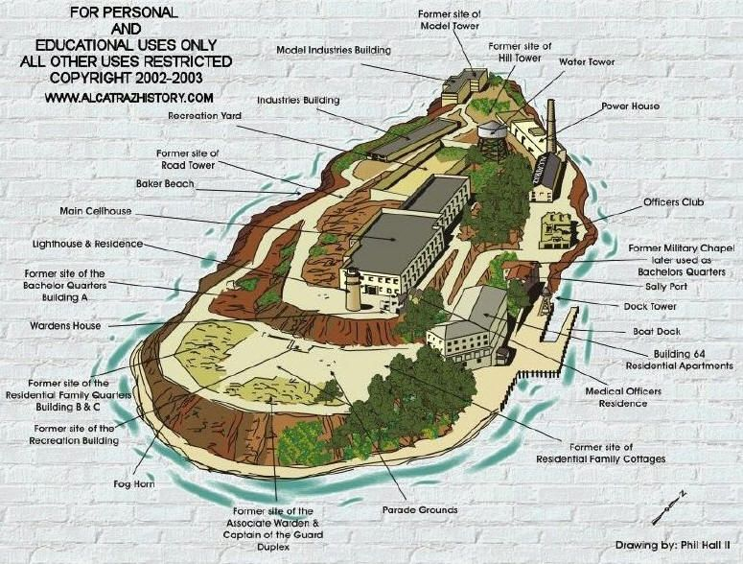
Escape Planner

What equipment will you gather? Restrict yourself to five items and write how you’ll get each.
How will you escape from your cell?
How will you avoid being seen by the guards?
How will you cross the sea to get to the city?
What will you do once you reach the city?

Escape Story
Remember to start by explaining what were you accused of and how was it that they didn’t believe you when you said you were innocent?

Then continue with your escape from Alcatraz!

Write your story here

Continue here…

