What to do today
IMPORTANT Parent or Carer – Read this page with your child and check that you are happy with what they have to do and any weblinks or use of internet.

1. Explore features of limericks
- Read The Old Man. What do you notice about its features? Write notes about the patterns that you spot.
- Read Three Limericks by Edward Lear. Do these have the same features? Complete Comparing Limericks. What do you notice?
- Remember Relative Clauses? Well, limericks rely on these.
Look at Underlining Relative Clauses and identify these. Notice where they come in the limerick! Check with Answers below.

2. Read more limericks
- Read More Lear Limericks Sets 1-3.
- Choose your favourite of these limericks and practise reading it until you know it off by heart. Ask someone to test you.
- Challenge yourself to learn another of the limericks off by heart.

3. Write your own limerick
- Use My Limerick Planner to write your own limerick.
- Start with the first line and then think of words that could rhyme with the last word of your first line.
- The Example may help you to use the planner.
- Look at Edward Lear’s illustrations. Present your limerick carefully with an illustration on the Template.

Try the Fun-Time Extras
Try learning more of the Edward Lear limericks off-by-heart.
Share your limerick with other people and see if you can teach them to write their own.

The Old Man

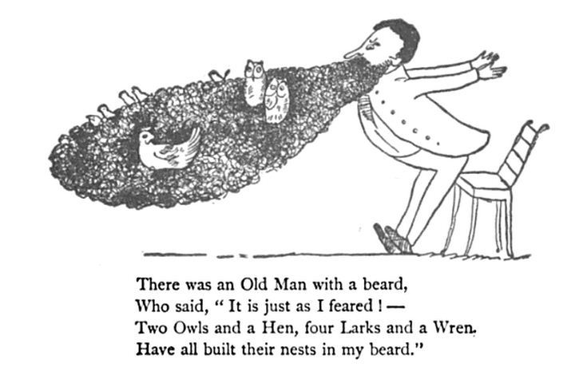

Three Limericks by Edward Lear

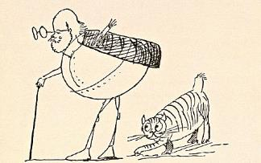

There was a Young Lady of Ryde

There was a young lady of Ryde,
Whose shoe-strings were seldom untied.
She purchased some clogs,
And some small spotted dogs,
And frequently walked about Ryde.

There was an Old Man of Kilkenny

There was an Old Man of Kilkenny,
Who never had more than a penny;
He spent all that money,
On onions and honey,
That wayward Old Man of Kilkenny.

There was an Old Man with a nose

There was an Old Man with a nose,
Who said, 'If you choose to suppose,
That my nose is too long,
You are certainly wrong!'
That remarkable Man with a nose.

Comparing Limericks

Put a tick in the box each time the limerick matches the description.

Description: | There was a Young Lady of Ryde | There was an Old Man of Kilkenny | There was an Old Man with a nose
Has an opening line about a person which begins, ‘There was a/an…’
Has 5 lines arranged in the same way – 2 long lines, 2 shorter lines, 1 last long line
Has an AABBA rhyme pattern
Has the same rhythm or beat when read out loud
Has a funny or silly idea behind it!

Underlining the relative clauses

There was a young lady of Ryde,
Whose shoe-strings were seldom untied.
She purchased some clogs,
And some small spotted dogs,
And frequently walked about Ryde.

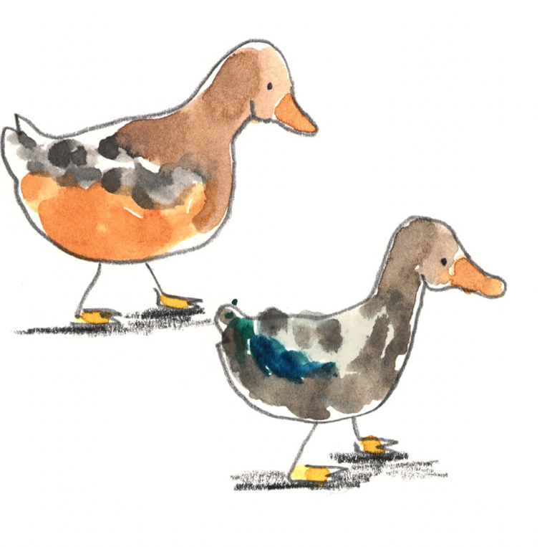
There was an old lady of France
Who taught little ducklings to dance.
When she said, ‘Tick-a-tack’
They only said, ‘Quack!’
Which grieved that old lady of France.

There was an old man of Dundee
Who taught little owls to drink tea.
For he said, ‘To eat mice…
Is not proper or nice.’
That amiable old man of Dundee.

ANSWERS Underlining the relative clauses

There was a young lady of Ryde,
Whose shoe-strings were seldom untied.
She purchased some clogs,
And some small spotted dogs,
And frequently walked about Ryde.

There was an old lady of France
Who taught little ducklings to dance.
When she said, ‘Tick-a-tack’
They only said, ‘Quack!’
Which grieved that old lady of France.

There was an old man of Dundee
Who taught little owls to drink tea.
For he said, ‘To eat mice…
Is not proper or nice.’
That amiable old man of Dundee.

More Lear Limericks
Set 1

There was an Old Lady of Chertsey,
Who made a remarkable curtsey;
She twirled round and round,
Till she sunk underground,
Which distressed all the people of Chertsey.

There was a Young Lady whose bonnet,
Came untied when the birds sat upon it;
But she said: 'I don't care!
All the birds in the air
Are welcome to sit on my bonnet!'

There was an Old Man of the West,
Who wore a pale plum-coloured vest;
When they said, 'Does it fit?'
He replied, 'Not a bit!'
That uneasy Old Man of the West.

More Lear Limericks
Set 2

There was an Old Man on a hill,
Who seldom, if ever, stood still;
He ran up and down,
In his Grandmother's gown,
Which adorned that Old Man on a hill.

There was an Old Man, on whose nose,
Most birds of the air could repose;
But they all flew away
At the closing of day,
Which relieved that Old Man and his nose.

There was an Old Person of Chili,
Whose conduct was painful and silly,
He sat on the stairs,
Eating apples and pears,
That imprudent Old Person of Chili.

More Lear Limericks
Set 3

There was an Old Man with a poker,
Who painted his face with red oker
When they said, 'You're a Guy!'
He made no reply,
But knocked them all down with his poker.

There was an Old Man of Peru,
Who watched his wife making stew;
But once by mistake,
In a stove she did bake,
That unfortunate Man of Peru.

There was an Old Man on some rocks,
Who shut up his wife in a box;
When she said, 'Let me out!'
He exclaimed, 'Without doubt,
You will pass all your life in that box.'

My Limerick Planner by ____________________________________

Line | Ideas for rhyming words

1
2
3
4
5

My Limerick Planner by EXAMPLE

Line | Ideas for rhyming words

1 | There was an old man with a key | see bee sea he flea pea wee tea me
2 | Who decided to sit down for his tea
3 | He jumped up and said | bed head fed read dead
4 | I must go to bed
5 | But not before I feed my pet bee!

Edward Lear’s Limerick Illustrations

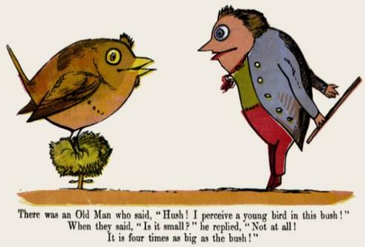
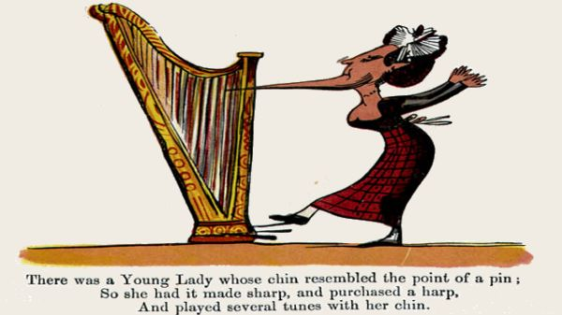

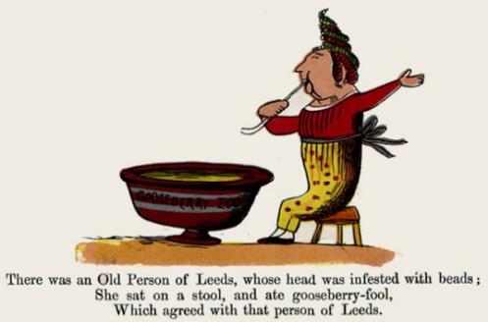

Template
________________________________________________________

by _______________________________

______________________________________________________________________________________________________________________________________________________________________________________________________________________________________________________________________________________________________________________________________________________________________________________________________________________________________________________________________________________

