What to do today
IMPORTANT Parent or Carer – Read this page with your child and check that you are happy with what they have to do and any weblinks or use of internet.

1. Research vocabulary
- Read the Owl and Pussycat again. What do you notice that is new when you read it today?
- Look up the meanings of the words on Vocabulary. Write the definitions and then write your own sentences using the words.

2. Find out about other versions and sequels to the poem
- Read The Owl and the Astronaut. This is a new version of the poem. What do you like about this poem? What do you notice?
Is it like the original?
- Read the first two verses of The Further Adventures of the Owl and the Pussycat by Julia Donaldson. What makes it like Lear’s poem?
- What do you think will happen next? Quickly write your ideas on Predictions. What will be the final ending?
Watch a reading of the whole sequel. Was it as you expected?
https://www.youtube.com/watch?v=IvmhjF0XamI

3. Write your own sequel to the poem
- Look at The Further Adventures. You are going to write your own sequel – very much in the style of Julia Donaldson.
- Complete Sequel Planner to plan your own sequel. Now write it – you can either choose to write it as a poem or as a story.

Well done. Show your plan to a grown-up. Explain what happens.

Try the Fun-Time Extras
- Try learning all or some of the poem off by heart. The Top Tips for Learning a Poem by Heart may help you.

The Owl and the Pussy-cat

The Owl and the Pussy-cat went to sea  In a beautiful pea-green boat,  They took some honey and plenty of money,  Wrapped up in a five-pound note.  The Owl looked up to the stars above,  And sang to a small guitar,  “O lovely Pussy, O Pussy my love,  What a beautiful Pussy you are,  You are,  You are!  What a beautiful Pussy you are!” | 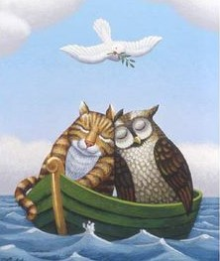
Pussy said to the Owl, “You elegant fowl!
How charmingly sweet you sing!
O let us be married! Too long we have tarried:
But what shall we do for a ring?”
They sailed away, for a year and a day,
To the land where the Bong-Tree grows
And there in a wood a Piggy-wig stood
With a ring at the end of his nose,
His nose,
His nose,
With a ring at the end of his nose.

“Dear Pig, are you willing to sell for one shilling
Your ring?” Said the Piggy, “I will.”
So they took it away, and were married next day
By the Turkey who lives on the hill.
They dined on mince, and slices of quince,
Which they ate with a runcible spoon;
And hand in hand, on the edge of the sand,
They danced by the light of the moon,
The moon,
The moon,
They danced by the light of the moon.

Edward Lear
Vocabulary

Use a book dictionary or https://kids.wordsmyth.net/

elegant
fowl
tarried (or tarry)
shilling
quince
runcible

The Owl and the Astronaut

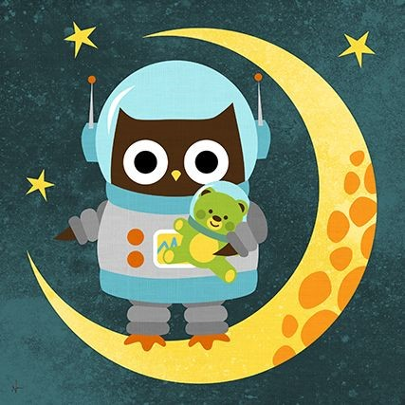

The owl and the astronaut
Sailed through space
In their intergalactic ship
They kept hunger at bay
With three pills a day
And drank through a protein drip.
The owl dreamed of mince
And slices of quince
And remarked how life had gone flat;
‘It may be all right
To fly faster than light
But I preferred the boat and the cat.’

by Gareth Owen

The Further Adventures of the Owl and the Pussy Cat

The Owl and the Pussy-cat went to sleep
By the light of the moon so pale.
Their beautiful ring was tied with string
In a bow round the Pussy-cat’s tail.

They dreamed of mice and raspberry ice
While slumbering cheek to cheek.
But down flew a crow who unravelled the bow
And flew off with the ring in his beak!

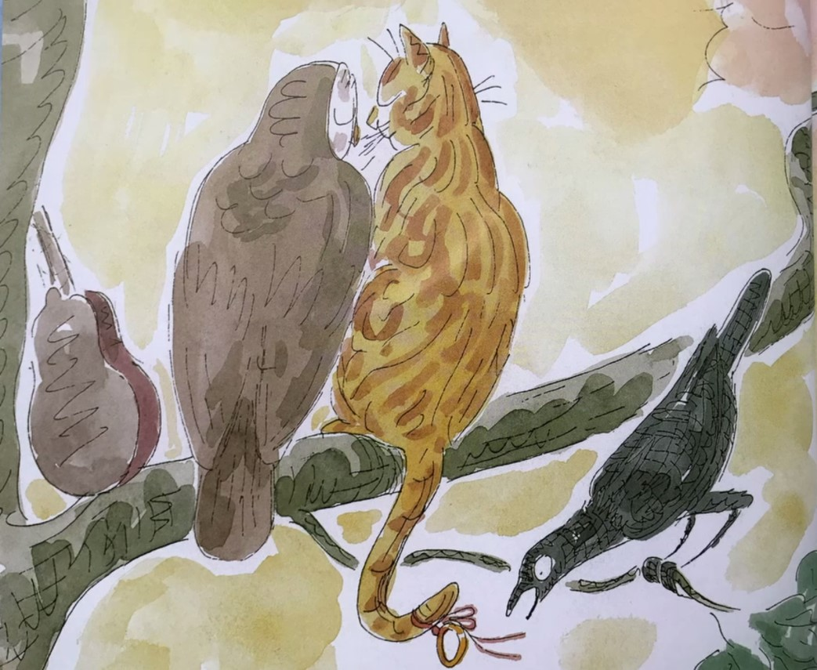

By Julia Donaldson and Charlotte Voake
Predictions
What will the owl and pussycat do? | Will they find the ring? How? | What will happen at the end?
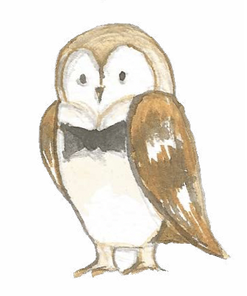 | 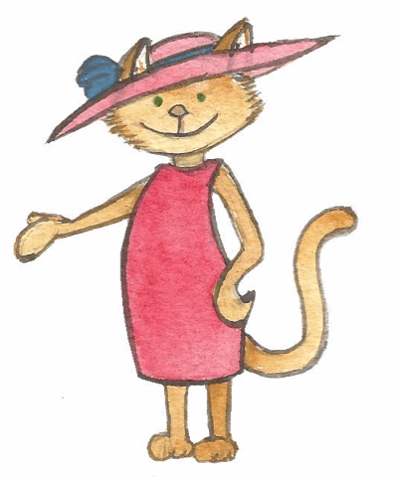 | 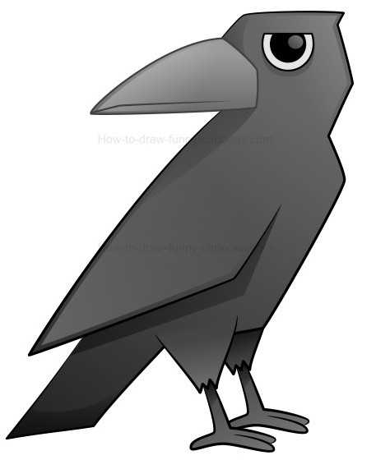

My Sequel Planner

What happens at the start of your sequel?
Does it happen to Owl or Cat or to both of them?
What does Owl or Pussycat or both decide to do about it? Does it involve going somewhere?
What happens when they get there?
In the end how it is resolved?

My Sequel

Write your story or poem here.

Top tips for learning a poem by heart

- Read the poem aloud several times slowly.
- Copy the poem out a couple of times.
- Be strategic. Poems with pattern, metre and rhyme are much easier to learn by heart than free verse.
- Learn and internalise the “story” in the poem
- Understand the poem by knowing every word’s meaning
- With a card, cover everything but the first line of the poem. Read it. Look away, see the line in the air, and say it. Look back. Repeat until you’ve “got it.”
- Uncover the second line. Learn it as you did the first line, but also add second line to first, until you’ve got the two.
- Then it’s on to three. Always repeat the first line on down, till the whole poem sings.

