What to do today
IMPORTANT Parent or Carer – Read this page with your child and check that you are happy with what they have to do and any weblinks or use of internet.

1. Make up a revolting menu
- Read Menu. What would you choose to eat? What do you think your friends and family would eat?
- Read Betty’s Butty. Which, in your opinion, is the worst food described?
- Make a menu for Betty’s Butty. Write short descriptions of some of the meals, add your own ideas for revolting food and add pictures too.

2. Read gross recipes
- Look at the Gross Recipe – Pictures. These have all been made to be edible but to look awful.
- Match the Picture, Ingredients and Methods. Which of these recipes do you think looks best? Which would you most like to try?

Well done! You can check your answers at the end of this pack.

3. Make up recipes
- Read Roald Dahl Recipes. Choose one of the foods that he invented and make-up a recipe for it. Include a picture, ingredients and method in your recipe.

Menu
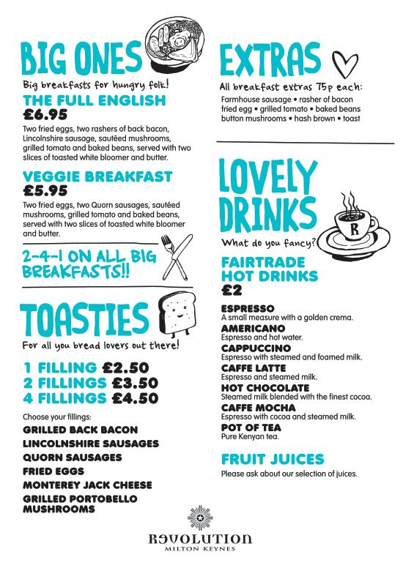

Betty’s Butty
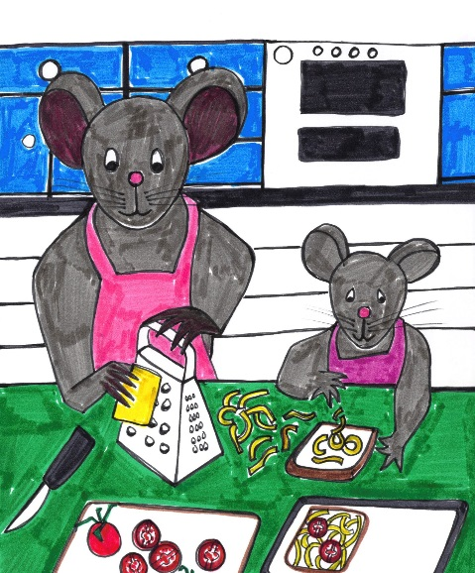

At Betty’s Butty you will find
Delicious food of every kind:
Fried rats’ tails and slugs on toast -
Though beetle dung’s a tasty roast.

At Betty’s Butty try the worms -
Oh come on! Don’t sit there and squirm.
Mixed with spaghetti, they’re a treat
Though some might find them rather sweet.

At Betty’s Butty, there’s much more
Which hungry children will adore:
Shredded boots and old-shoe stew -
These delicacies are good for you.
​
At Betty’s Butty - try her cakes!!!
They’re often made from rotting snakes
But with rat sauce and sweet poo spice
I think you’d find them rather nice.

At Betty’s Butty - - Oh! Come back-
I haven’t started yet on snacks!
Well, since you don’t want help from me
I’m off to get some green grass tea. By Josie Whitehead
https://josiewhitehead.wixsite.com/josiespoems/betty-s-butty

Gross Recipes - Pictures

Frogspawn  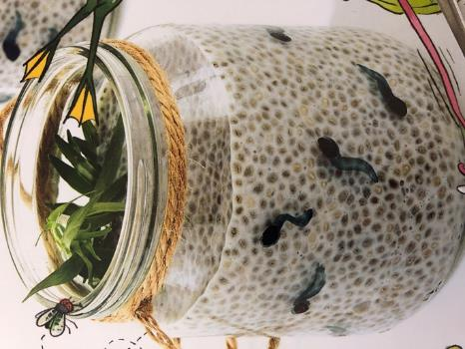 | Rotten Eggs  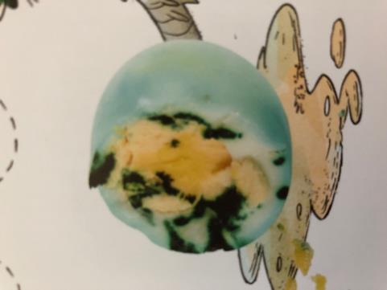
Eyeball Ice Cubes  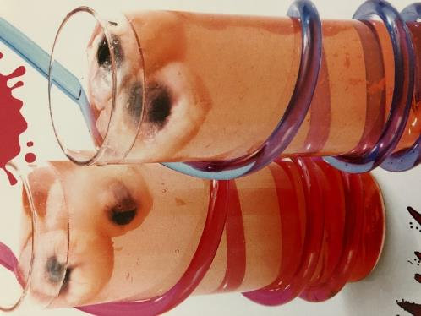 | Roasted Mice  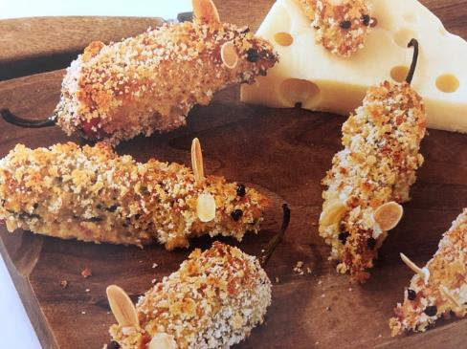
from This Cookbook is Gross by Susanna Tee

Gross Recipes - Ingredients

1  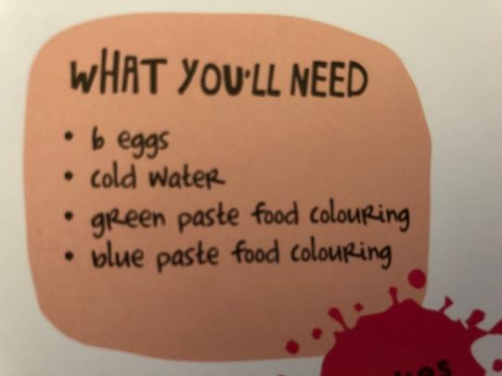 | 2  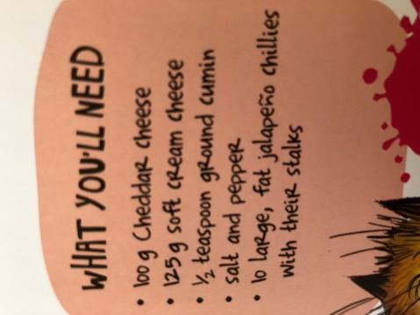
3  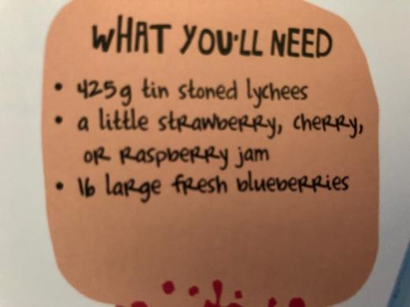 | 4  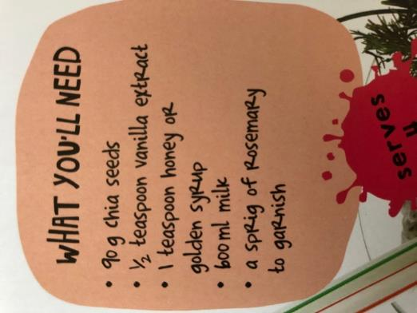
from This Cookbook is Gross by Susanna Tee
Gross Recipes - Methods
A  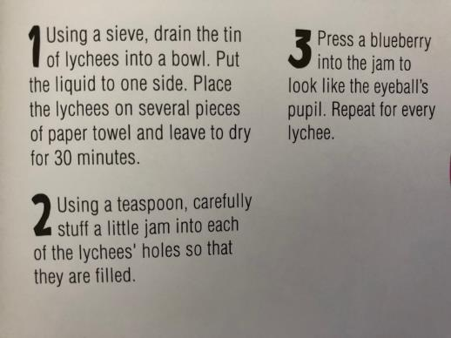 | B  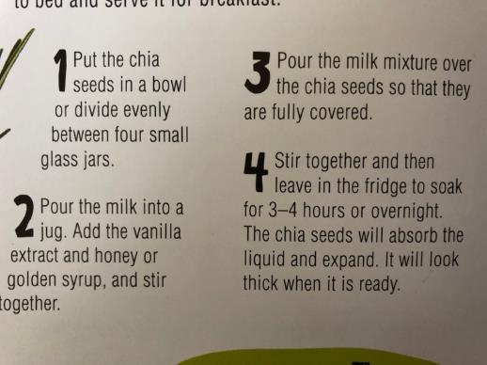
C  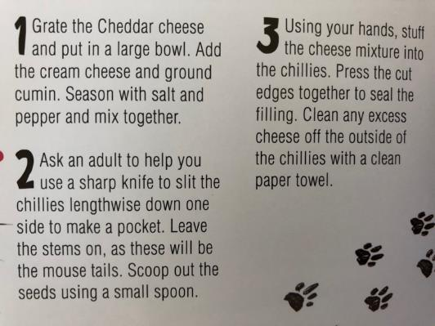 | D  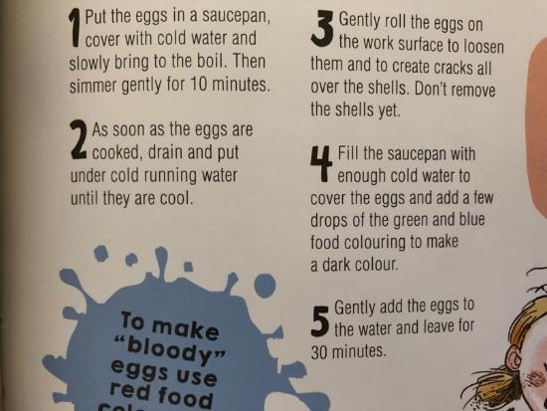
from This Cookbook is Gross by Susanna Tee
Roald Dahl Recipes

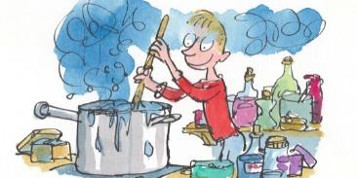

Choose one of the imaginary foods from Roald Dahl’s books. Make up a recipe for making this food.
Include a picture, ingredients and a method in your recipe.

Choose one of these foods:
- Stink Bugs’ Eggs (James and the Giant Peach)
- Crispy Wasp Stings on a Piece of Buttered Toast (James and the Giant Peach)
- Fresh Mudburgers (James and the Giant Peach)
- Hot Frogs (James and the Giant Peach)
- Lickable Wallpaper (Charlie and the Chocolate Factory)
- Frobscottle (A green drink – The BFG)
- Eatable Marshmallow Pillows (Charlie and the Chocolate Factory)
- Stickjaw for Talkative Parents (Charlie and the Chocolate Factory)
Gross Recipes – Answers

Frogspawn  Ingredients – 4  Method - B | Rotten Eggs  Ingredients – 1  Method - D
Eyeball Ice Cubes  Ingredients – 3  Method - A | Roasted Mice  Ingredients – 2  Method - C

