What to do today
IMPORTANT Parent or Carer – Read this page with your child and check that you are happy with what they have to do and any weblinks or use of internet.

1. Find out about six types of dragons
- Look at Dragon Pictures. What can you spot in each picture that someone else might not notice?
- Read Dragon Descriptions. Look for any clues that will help you to match each description to the right picture.
- Then check your thinking with the Answers which are upside down at the bottom of the page.

2. Make a dragon quiz
- Read Dragon Questions. How many can you answer?
- Check your answers with Dragon Answers.
- Write a Multiple-Choice Quiz. Write three options for each question: the right answer, a close answer and a ridiculous answer. Don’t always put these in the same order.
- Try your quiz out on some other people. How many can they get right?

3. Invent your own dragon
- Draw your own dragon. Write a description of it. You can make up your information!
- Look at the Top Trumps Example. Make a Top Trump card for your dragon. You could make Top Trump cards for the six other dragons too.

Dragon Pictures
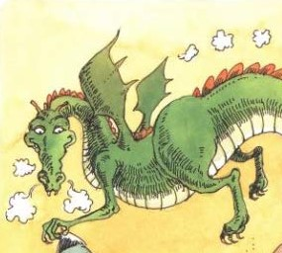  A | 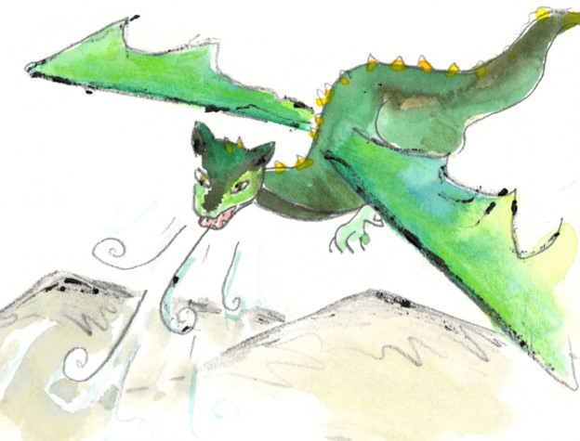  B
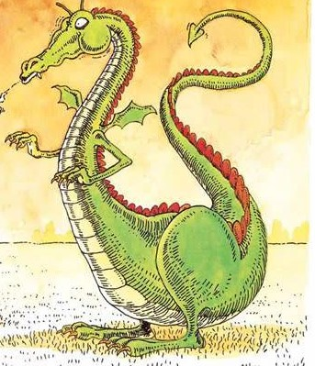  C | 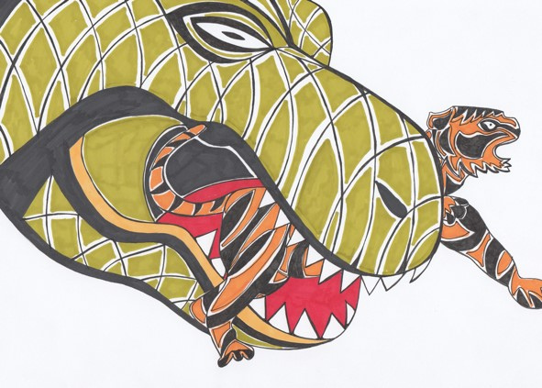  D
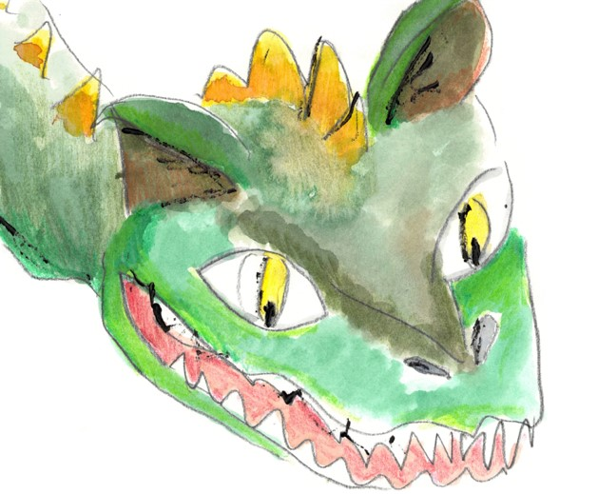  E | 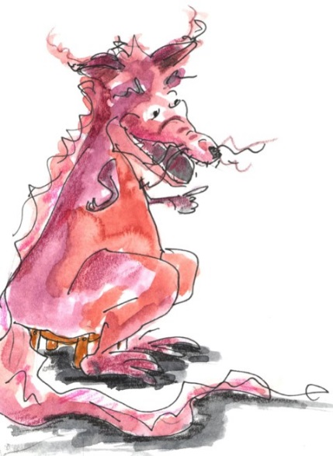  F

Dragon Descriptions
Match the description to the picture. Look carefully at the picture for clues and read the writing looking for any links.

Greedy Dragon
Greedy dragon likes to eat massive animals. Their very favourite foods are tigers and lions, but it won’t turn its nose up at elephants or hippos. Greedy dragon does not like eating giraffes because their necks are too bony. The food it really hates is fish. “The smell is disgusting!” they say. But don’t be fooled. Greedy dragon is more than happy to eat people!

Puffing Dragon
This little dragon is only the size of a large eagle. It flies most of the time and doesn’t really like to land, except in the top of trees. As it flies, it puffs out little clouds of smoke from its fiery nostrils. But these float gently up through the air behind it, and rarely set light to anything. Occasionally in winter, this dragon swoops down to catch rabbits, and eats them semi cooked as they pass through its hot mouth. But mostly it lives on birds which it catches on the wing.

Portly Dragon
This dragon’s name comes from the fact that, once it is six months old, it puts on a ring of fat around its belly which is with it for the rest of its life. Deep red in colour, Portly Dragon can live for several months without eating. Like the camel, it stores energy in its ‘hump’, the ring of fat around its middle. When it does get hungry, it is an efficient hunter, and catches small animals such as shrews and mice. Its favourite food is rats – the larger and smellier, the better!

Golden-horned Dragon
Golden-horned dragons have can be found in mountainous regions throughout the world. This dragon has a series of golden spikes or horns down its back, starting on its forehead. It has a large mouth with a jaw that, like that of a boa-constrictor, can dislocate to open really wide. This dragon likes to eat its food whole, and since it lives on mountain deer and goats, it has to be able to make that mouth as big as possible!

Japanese Plated Dragon
This small Japanese Dragon is known as ‘plated’ due to the large flat scales down its tummy which look a bit like a series of ‘plates’. The size of a horse, this dragon looks almost cute. But do not be fooled! Its main diet is people, and it particularly likes to eat old ladies or men! No wonder the Japanese stay well away from it!

European Dragon
This emerald-green, flying dragon is now extremely rare. Once common in the mountains of Scotland and Scandinavia, it is now only seen around Easter, when it comes south with the reindeer to breed. A protected species, it is a herbivore, and lives on just one particular species of fir tree. Occasionally, if food is scarce, it will also eat heather.

Answers

Puffing Dragon A European Dragon B
Japanese Plated Dragon C Greedy Dragon D
Golden-horned Dragon E Portly Dragon F

Dragon Questions

Which Dragon hates fish?

Whose favourite food is rats?

Which dragon is only the size of a large eagle?

Name a dragon that swallows its food whole.

Which is the cutest-looking dragon?

Which is the rarest, most endangered dragon and where does it live?

Which is the only dragon mentioned as eating people?

Which dragon cooks its food as it eats it?

Name the only herbivore.

Which dragon is compared to a camel and why?

Dragon Answers

Which Dragon hates fish? Greedy Dragon hates fish.

Whose favourite food is rats? Portly Dragon’s favourite food is rats.

Which dragon is only the size of a large eagle? Puffing Dragon is the size of a large eagle.
Name a dragon that swallows its food whole. Golden-horned dragon can eat its food whole by dislocating its mouth.
Which is the cutest-looking dragon? Japanese Plated Dragon is described as looking ‘almost cute’.
Which is the rarest, most endangered dragon and where does it live? European Dragon is very rare and lives in the mountains of Scotland and Scandinavia.
Which is the only dragon mentioned as eating people? Japanese Plated Dragon is mentioned as eating people.
Which dragon cooks its food as it eats it? Puffing dragon cooks rabbits as it eats them.
Name the only herbivore. European Dragon eats only fir trees and heather.
Which dragon is compared to a camel and why? Portly dragon can store food in the ring of fat around its belly in the same way that camels can store energy and water in their hump.

Multiple Choice Quiz
Make up multiple choice options for each question.
Make one ridiculous and one close to the real answer.
Two have been done for you. Put the right answer in different places, sometimes as A., sometimes as B. and sometimes as C.
What do Puffing Dragons eat?  - Bats  - Birds  - Hamburgers | Why does Greedy Dragon prefer not to eat giraffes?  - Giraffes can run too fast  - It hates the colour yellow  - Their necks are too bony

What is special about a Japanese Dragon’s tummy?

Which dragon would you least like to meet and why?

How do Golden-horned Dragons eat their food?

What do European dragons eat?

What does Puffing Dragon only rarely do?

What does Portly Dragon have around his tummy?

Design Your Own Dragon
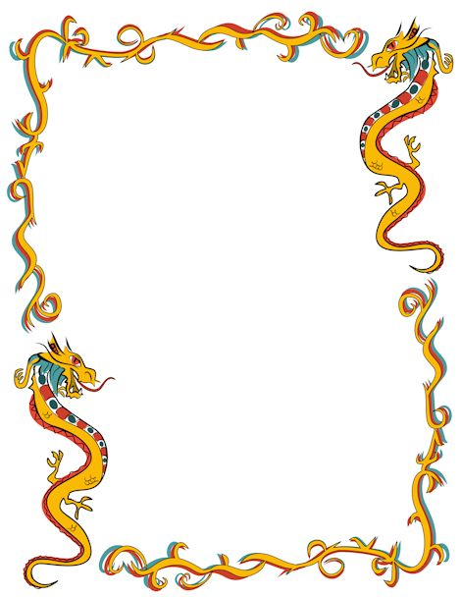

Top Trumps Example

