What to do today
IMPORTANT! Parent or Carer – Read this page with your child and check that you are happy with what they have to do and with any weblinks or use of the Internet required.

1. Story time
In The Terrible, Horrible, No Good, Very Bad Day, Alexander was miserable in the school dinner hall. Might he have enjoyed this dinner hall a bit more?
- Go to https://www.youtube.com/watch?v=_41r11dO0mg
- Listen to Dinner Hall, written and read by Michael Rosen.

3. Weird menus
Steven put chocolate custard on his chips! What other icky food suggestions can you come up with for a restaurant’s menu?
- Look at the ideas on A Terrible, Horrible, No Good, Very Bad Menu.
- Create your own (horrible!) menu.

2. Dinner time is just not good enough
Can you imagine an even worse dinnertime than the one Michael Rosen tells us about?
- Read the information on using The Progressive Past Tense.
- Use the progressive past when you write the story of a really bad lunchtime in the school hall. Use How to Write About the Worst School Dinnertime Ever to help you get started.

Now try this Fun-Time Extra
- Packed lunch or school dinners: which is best? You decide! Maybe there are some days when it is better to be one thing and other days when it’s better to be the other? Write what you think on Lunch at School.

A Terrible, Horrible, No Good, Very Bad Menu

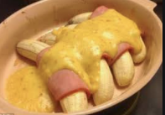

To start with:

A boiled egg with a bitter marmalade dressing
Whole sardines served with mint ice cream
Dainty ham cubes covered in a tangy raspberry sauce

Main courses:

Crisp green lettuce with clear honey
Delicious roast chicken served with cold green snail jelly
Thick wedges of pizza toped with cream and sugar
Deep fried fish in a ginger syrup
Bubbling cheese on toast garnished with cat food

From the sweet trolley:

Cold mushroom yoghurt
Rhubarb and mustard
Fresh strawberries coated in marmite and garlic
Doughnuts bursting with spiced fish eggs
Tempting cheesecake served with salt and vinegar

To drink:
Oniony milk
Salt Water
Hot chocolate with Brussel sprouts.

To create your menu, think of things that really don’t go together. Try choosing a sweet thing and combining it with something savoury. Add some tempting describing words to each item of food as if the food was actually lovely.

The Progressive Past Tense
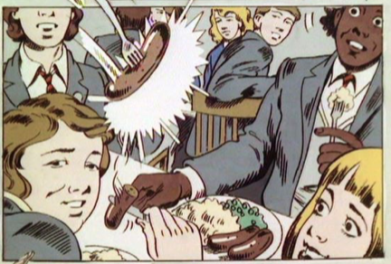

Past tense verbs can be in progressive or continuous form.

Steven was eating his chips. The children were listening to the Head.

Shaun was putting a potato in his pocket.
Two girls were using the chocolate custard as lipstick.

These are in the past tense, but describe something that carried on happening, something that lasted for a while – Steven kept eating; the girls carried on putting on lipstick.

Often the progressive or continuous form is used when two things are happening at the same time, one which carries on and one which doesn’t.

Melvin was singing (progressive) ‘Come on you Reds!’, when the Head came in.

The football team were jumping on crisp packets (progressive), but Mrs Gallagher yelled at them to stop.

Verbs in the progressive past are always made by writing was (singular) or were (plural) + a verb ending in -ing

How to Write About the Worst School Dinnertime Ever

You are going to describe a really terrible dinner time at school where everyone is naughty, everything goes wrong and the food is dreadful!

Think of these things

- Who is there? What are the names of the characters you will be talking about?

- What is the food? Think of the worst food that can possibly be served by a school kitchen.  - What goes wrong? Do people fall over? Does a coco-cola can explode? Does someone drop a big pan of custard?  - Who is naughty? What do the dinner ladies do? | 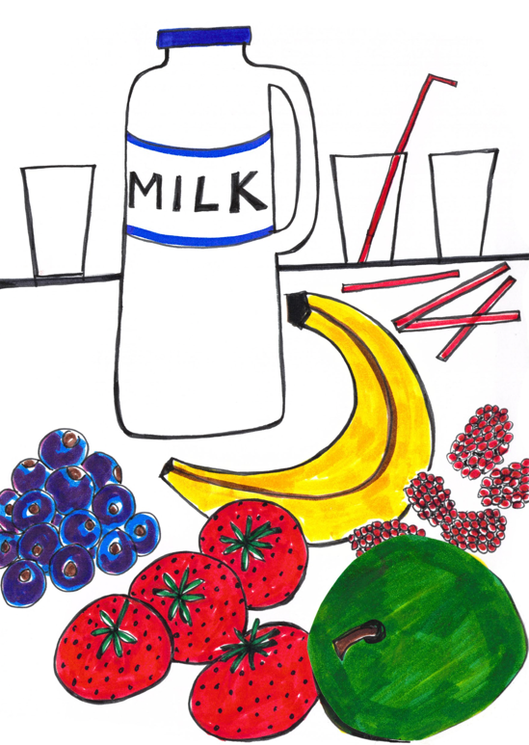

Think about how to use the progressive form of the past tense to say what happened while something else was going on.

As Danny was wiping the floor, Asha slipped in the custard.
Amit threw the can over to me while Mrs Boney was looking the other way.

The Worst School Dinnertime Ever

Lunch at School

