What to do today
IMPORTANT! Parent or Carer – Read this page with your child and check that you are happy with what they have to do and with any weblinks or use of the Internet required.

1. Story time
To Alexander, his teacher Mrs Dickens seemed quite strict. Well, compare Mrs Dickens to this teacher...
- Read and enjoy Strict by Michael Rosen.

2. Writing commands
Go to https://www.youtube.com/watch?v=z1cfVQyrQ3Q.
Watch Michael Rosen himself retell Strict.
Think of a good name for the class teacher. You are going to write that teacher’s set of Class Rules.
- Carefully read the Instructions for Writing Class Rules.
- Record the teacher’s rules on the classroom display paper.

3. Creative writing
How would you have avoided being spotted breathing by the strict teacher?
- Consider all the ways you can think of to not to get caught breathing (maybe you would snatch a quick breath while you sharpen your pencil or put your jumper on!).
- On Dodges and Tricks, write in detail about all your clever ideas to avoid being sent to the school prison (or worse!) for breathing.

Now try this Fun-Time Extra
- The teacher’s question to the class in Strict was, ‘Where’s Tibet?’
You had better find out before you get into trouble! Use the Internet, a globe or an atlas to find out where Tibet is and what it is like to live there. This website is a good place to start: https://kids.britannica.com/kids/article/Tibet/346219

Strict

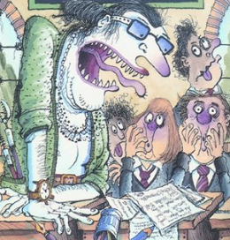

Maybe you think you have a
teacher
who’s really strict,
maybe you know a really strict
teacher.
But when I was at school
we had a teacher who was so strict
you weren’t allowed to breathe
in her lessons.

That’s true, we weren’t allowed to
breathe.
It was really hard to get through
a whole day without breathing.
Lips tightly shut.
Face going red.
Eyeballs popping out.
She’d go round the class glaring at us
and she’d suddenly catch sight of
one of us and she’d yell,

‘NO BREATHING, DO YOU HEAR ME? NO BREATHING.’
And you had to stop breathing
right away.

The naughty ones used to try and
take quick secret breaths
under the table.
They’d duck down where she
couldn’t see them,
snatch a quick breath and come
back up
with their mouth shut tight.
Then someone would say,
‘Excuse me, miss, can I go outside
and do some breathing?’
And she’d say,

‘WHAT? CAN’T YOU WAIT? YOU'VE HAD ALL PLAYTIME TO BREATHE, HAVEN’T YOU?’
And then she’d ask someone a
question
like, ‘Where’s Tibet?’
and someone would put up their hand
and say, ‘Er... it’s – ’
and she’d be right in there with:

‘YOU’RE BREATHING. I SAW
YOU BREATHE.’
‘I wasn’t, miss, really I wasn’t.’
‘WELL, YOU ARE NOW, AREN’T YOU?’
It was terrible.
She was so strict.

by Michael Rosen
From No Breathing in Class by Michael Rosen and Korky Paul

Instructions for Writing Class Rules

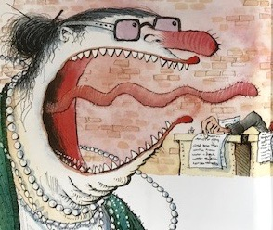

You are going to write the set of class rules put up by the teacher in Strict.

Each rule must begin with something you must or must not do:

No breathing
Never leave the lids off the felt pens
Always sit in total silence

Remember, this particular teacher is extremely strict, so all her rules are likely to be very tough and extreme.

For each rule, think of a punishment the teacher would give if you broke the rule:

No breathing.
Anyone found breathing will immediately be sent to the school dungeon.

Never leave the lids off the felt pens.
If found doing so children will be made to clean out the school tiger’s cage while he is still in it.

How many hideous rules can you think of?
Write these down as a bullet-pointed or numbered list on the My Class Rules page.

Sign with the teacher’s name: Mrs Bitterton, Miss Savage, Mrs Harsh, etc.

My Class Rules

Dodges and Tricks

