**What to do today**

*IMPORTANT! Parent or Carer – Read this page with your child and check that you are happy with what they have to do and with any weblinks or use of the Internet required.*

**1. Story time**

Go back to <https://www.youtube.com/watch?v=w6HhKlpp7ok&t=117s>.

Re-listen to *Alexander and the Terrible, Horrible, No Good, Very Bad Day.*

* Why do you think the pictures in the book show everything in black and white? Why is Alexander in colour?

**2. Comprehension questions**

Read the *Questions about the Story*.

Answer the questions in the spaces provided.

**3. Adaptations of famous books**

Watch the trailer for the film version of Alexander’s story:

<https://www.youtube.com/watch?v=Z_dideF5qvk&t=65s>

* Follow the instructions on *Turning a book into a film* and tell Miguel Arteta what parts of the book really, really should be in the film.

**Now try one of these Fun-Time Extras**

* **Either** ask your parents/carers if you could watch the whole of *Alexander and the Terrible, Horrible, No Good, Very Bad Day* and discover whether your three key scenes from the book actually made it into the film!
* **Or** make a ‘storyboard’ for a scene in the film. Storyboards are like comics and film directors use them to ‘see’ what a film might look like before it has been made. Draw a comic strip storyboard for your favourite part of the book.

**Questions about the Story**

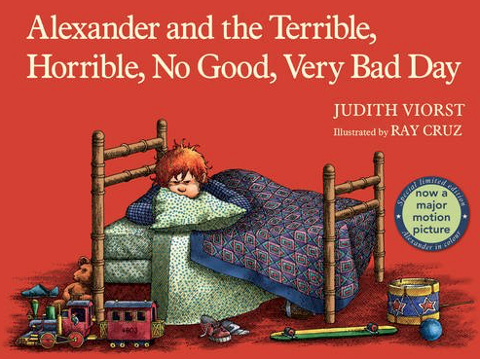

1. What is the very **first** thing that goes wrong for Alexander on his very bad day?

______________________________________________________________

2. What are Alexander’s two brothers called?

______________________________________________________________

3. Which of these words describes Alexander’s day at school? Circle all the words that you think describe his day well.

|  |
| --- |
| frustrating satisfying successful infuriating unsatisfactory |

4. True or false? At the end of the story Alexander is upset because his pet dog wants to sleep on his brother’s bed instead of his.

_____________________________________________________________

5. Describe what you think was the very worst thing that happened to Alexander.

______________________________________________________________

6. Explain why you feel that was the most terrible and horrible of all the very bad day’s events.

__________________________________________________________________________________________________________________________________________________________________________________________

7. In your own words, describe the reaction of Alexander’s Dad to what happens when his family come to his office to collect him from work.

__________________________________________________________________________________________________________________________________________________________________________________________

8. Do you feel more sorry at the end of the very bad day for (a) Alexander or (b) his family?

Explain your answer.

___________________________________________________________________________________________________________________________________________________________________________________________________________________________________________________________________________________________________________________________________________________________________

9. Alexander keeps saying that he is going to go to Australia.

Will he really go to Australia? If not, why does he keep saying this?

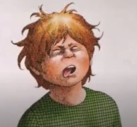__________________________________________________________________________________________________________________________________________________________________________________________

**Turning a book into a film**

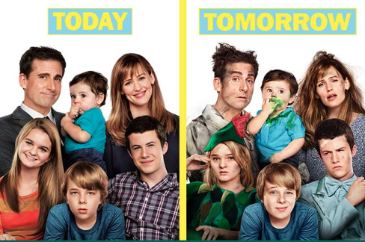

Think about the trailer you watched for the film of *Alexander and the Terrible, Horrible, No Good, Very Bad Day* Alexander.

What was the same as the book? What was different?

Now for a bit of time travel...

Imagine that it is 2014 and the film’s director, Miguel Arteta, is getting ready to make his movie of the story.

As with all film adaptations of books, there are going to be some changes to the story, with parts of the original book left out and some new material added in.

Miguel Arteta has asked for suggestions from people who know the book about which bits of the story should really, really still be in the film when it gets made.

On *My Suggestions to Miguel Arteta*, describe in detail the **four** scenes or moments of the book that you think should still be in the movie. Explain fully why you think each one of these moments or scenes is so special and important.

**My Suggestions to Miguel Arteta**

I think the following **three** scenes from the book should still be in the film.

|  |
| --- |
| Scene 1:  ________________________________________________________________________________________________________________________ |
| Reason it should be in the film version:  ____________________________________________________________________________________________________________________________________________________________________________________________________________________________________________________________________________________ |

|  |
| --- |
| Scene 2:  _______________________________________________________________________________________________________________________ |
| Reason it should be in the film version:  ____________________________________________________________________________________________________________________________________________________________________________________________________________________________________________________________________________________ |

|  |
| --- |
| Scene 3:  ________________________________________________________________________________________________________________________ |
| Reason it should be in the film version:  _________________________________________________________________________________________________________________________________________________________________________________________________________________________________________________________________________________________________________________________________________________________ |