What to do today
IMPORTANT! Parent or Carer – Read this page with your child and check that you are happy with what they have to do and with any weblinks or use of the Internet required.

1. Story time
Go to https://www.youtube.com/watch?v=w6HhKlpp7ok&t=117s.
Listen to the reading of Alexander and the Terrible, Horrible, No Good, Very Bad Day, written by Judith Viorst and illustrated by Ray Cruz.
- What do you think is the very unluckiest thing that happened to Alexander on his bad day? Explain your answer.

2. Reading and writing about characters
Read the description of Alexander’s Mum.
- Follow the instructions on Describing Alexander and write a description of him using powerful adjectives and adverbs.

3. Story writing
Would the story have been exactly the same if it had been about a girl called Alexandra, instead of a boy called Alexander?
- On Alexandra’s Terrible, Horrible, No Good, Very Bad Day, write a short new version of the story featuring the unlucky girl.
- Describe in detail at least four new terrible and horrible things that happened to make it such an awful day for her.
- Don’t forget to regularly use the line, I could tell it was going to be a terrible, horrible, no good, very bad day.

Now try this Fun-Time Extra
- On Alexander’s Free Cereal Gift draw and write about the perfect free gift that Alexander could have found in his cereal.

Alexander’s Mum

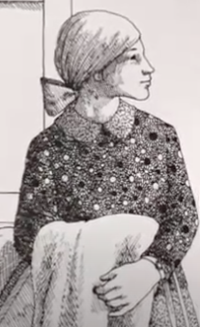

Alexander’s mum looks nice and friendly. She has long hair tied back in a ponytail and fixed with a smart bow. She carries a handbag over her shoulder and wears a flowery shirt and long skirt.

She is extremely patient and very long-suffering. She puts up with Alexander’s bad behaviour and moaning and still manages to be kind and considerate towards him. Well – most of the time anyway! She does get cross when she finds Alexander fighting in the mud with his brothers and is not overly impressed when, at Alexander’s Dad’s office, Alexander manages to cause all sorts of mayhem and even phone Australia. Also, at suppertime, she gets really angry when Alexander bleats about having to eat lima beans.

She is always busy sorting Alexander and his brothers out – taking them to the shoe shop, picking them up from school and arranging for them to go to the dentist (shudder!). She is probably quite sleepy by bedtime, after a day coping with Alexander!

Describing Alexander

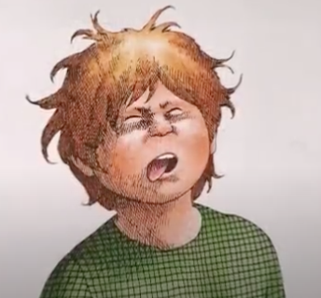

Instructions:

- Start by drawing your own picture of Alexander in the box at the top of My Profile of Alexander.
- Think hard about what Alexander is like. Consider what he looks like, what kind of personality he has and what sorts of things he does.
- Write a paragraph about each of these. Use your best handwriting. Remember to use really good adjectives (describing words) to provide lots of detail: Alexander’s mum looks nice and friendly, with long hair tied back in a pony tail and fixed with a smart bow. She carries a handbag over her shoulder and wears a flowery shirt and long skirt.
- Use adverbs to add detail to the adjectives: She is extremely patient and very long-suffering.
- When you think you have finished, read back all that you have written. Have you mentioned everything you wanted to say? Add in anything that got left out accidentally.

My Profile of Alexander

________________________________________________________________________________________________________________________________________________________________________________________________________________________________________________________________________________________________________________________________________________________________________________________________________________________________________________________________________________________________________________________________________________________________________________________________________________________________________________________________________________________________________________________________________________________________________
Alexandra’s Terrible, Horrible, No Good, Very Bad Day

Alexander’s Free Cereal Gift

__________________________________________________________________________________________________________________________________________________________________________________________________________________________________________________________________________________________________________________________________________________________________________________________________________________________________________________

