What to do today
IMPORTANT! Parent or Carer – Read this page with your child and check that you are happy with what they have to do and with any weblinks or use of the Internet required.

- Solving a crossword
Have you ever completed a crossword? Go to http://www.whenwecrosswords.com/crossword_puzzles/kids_crosswords.jsp or, if you can’t print at home, try https://lovattspuzzles.com/kids/childrens-online-puzzles/
- Select a crossword from the list and have a go.

2. Creating a crossword
Go to http://puzzlemaker.discoveryeducation.com/CrissCrossSetupForm.asp or http://www.printablecrosswordmaker.com/crossword_maker/crossword_maker.jsp
and follow the instruction for making your own crossword.
- Look at the example on My Puzzle.
- Chose a subject for your crossword that you know lots about – an animal you are really interested in or your favourite book, a TV character you know or the sport you like the most.

3. Palindromes
Read all about Palindromes.
- Copy your favourites from the page or More Palindromes into the box.
- Be careful: one is NOT a palindrome. Can you spot it?
- Can you create your own palindromic word or phrase?

Now try this Fun-Time Extra
- Have a go at more of the crosswords from
https://lovattspuzzles.com/kids/childrens-online-puzzles/

My Puzzle

This is the puzzle I made using
http://www.printablecrosswordmaker.com/crossword_maker/crossword_maker.jsp

Pets
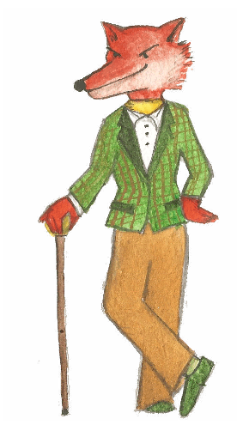

Go slowly and carefully and you'll definitely succeed
 |  |  |  | 1
2
 |  |  |  |  |  |  | 3 |  | 4
 |  |  | 5
 |  | 6

Across | Down
1 A pet that swims and lives in water in a bowl  2 Soft cuddly pet with silky ears  5 A small animal that likes to run in a wheel  6 Pet that needs lots of walks | 1 Smaller than a rabbit and larger than a hamster  3 Very clever pet that purrs  4 Clever bird that can learn to say words

Palindromes

Palindrome words and phrases spell themselves properly both ways round! You can read them as normal from left to right but you can also read them from right to left. Just ignore the gaps between the words and any capital letters.
eye
mum

pup

toot
radar

level

too hot to hoot

was it a rat I saw

do geese see god

More Palindromes
One is NOT a palindrome!
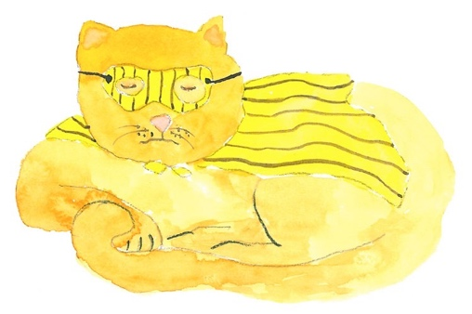

noon
gag

a nut for a jar of tuna
pipe

was it a car or a cat I saw

never odd or even
Madam, in Eden, I’m Adam

Look at the palindrome words here and scroll down to see the phrases. https://kids.kiddle.co/Palindrome
Write down your favourites in the box below. Can you think of any others?

