What to do today
IMPORTANT! Parent or Carer – Read this page with your child and check that you are happy with what they have to do and with any weblinks or use of the Internet required.

1. Dictionaries and definitions
There are about one hundred and seventy thousand words in the English language – how many of them do you think you know?!
- Look at What’s My Meaning?
- Follow the instructions.
- Use a dictionary to find the correct meaning of each of the words in yellow boxes.

2. Making a word meanings puzzle
You are going to make your own page of What’s My Meaning? word puzzles for someone else to try and solve.
- Read the instructions on Creating Your Own Word Puzzle.
- Use the blank What’s My Meaning? page to write out your puzzle.

3. Making a word chain
You are going to make a chain of words.
- Read the instructions on Word Chains.
- Write your word chain out in the box.

Now try this Fun-Time Extra
- Go back to the page of What’s My Meaning? that you started with earlier. Use the dictionary to find what the opposite (antonym) of each of the words in the yellow boxes is.

What’s My Meaning?
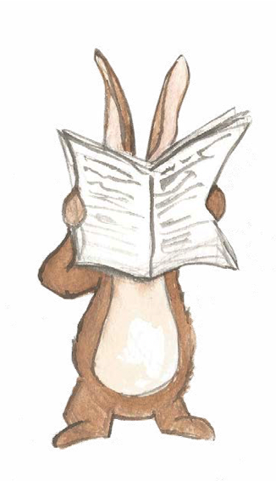

What to do:
- Read the word in the yellow box.
- Read the words in the boxes below and say which you
think it means.
- If you do not know the word, look it up in the dictionary.
Use a paper dictionary or go to https://kids.wordsmyth.net/we/
- Highlight the word that is the closest in meaning.
- Check with the Answers.
- Look up any other words on the page that you don’t know the meaning of.

colossal
lose | shout | huge

coarse
boat | exclaim | rough | pony

valiant
cheap | hill | brave | relative

pursue
follow | wallet | girl | rumble

waffled
fought | smelled | fled | chatted

astute
donkey | statue | cooking | clever | help

jettison
aeroplane | child | discard | bridge | drink

Answers
What’s My Meaning?

colossal
lose | shout | huge

coarse
boat | exclaim | rough | pony

valiant
cheap | hill | brave | relative

pursue
follow | wallet | girl | rumble

waffled
fought | smelled | fled | chatted

astute
donkey | statue | cooking | clever | help

jettison
aeroplane | child | discard | bridge | drink

Creating Your Own Word Puzzle

You are going to make your own version of What’s My Meaning?

Use the blank puzzle page to write down all your words.

What to do:
- Open a book or a magazine at a random page.

- Close your eyes and put your finger on the page.

- Open your eyes again and find an unusual word near where your finger has landed. You may need to look around a bit till you find a funny or uncommon word.

- Write this word carefully in the first yellow box.

- Look the word up in the dictionary at https://kids.wordsmyth.net/we/ and put a word that means the same thing as it in one of the empty boxes underneath.

- Fill out the remaining boxes with other words that mean different things.

- Vary the position of your ‘right answer’ word so that people can’t just guess it because of where it is.

- Repeat for all the other yellow boxes.

- Give your puzzle to a relative or friend to try and solve. Can they do it without the dictionary?

What’s My Meaning?

Word Chains

What to do:
1. Think of any word you like. If you get stuck for a ‘start’ word, chose one from What’s My Meaning?
2. Write your word in the yellow box below and look at the last letter of the word.
3. This letter will now be the first letter of your next word. Think of a word that begins with that letter. Write it after your word.
4. Now look at the last letter of that word and repeat. You are making a chain of words.

How many words can you make your chain out of? Can you avoid using the same word twice? Try including some funny and unusual words in your chain. You must look these words up in the dictionary so you know what they mean.

_________________________________________________________________________
______________________________________________________________________________________________________

______________________________________________________________________________________________________

______________________________________________________________________________________________________

______________________________________________________________________________________________________

______________________________________________________________________________________________________

______________________________________________________________________________________________________

