What to do today
IMPORTANT! Parent or Carer – Read this page with your child and check that you are happy with what they have to do and with any weblinks or use of the Internet required.

1. Reading magic spells
Do you know any magic spells?
- Read the Magic Spells. Have you heard any of them before?

2. Spelling spells
The spell from Macbeth is made by three scary witches.
- On The Three Witches, draw the witches around their cauldron (really, a big cooking pot), and write out the spell.
- How much of the spell can you learn off by heart?

3. Magic hands
You are now ready to plan some magic.
- Draw round your hand and make a magic hand.
- Make up a magic spell of your own in the style of Double, double...

4. Magic Wands
Every good magician must have a wand.
- Follow the instructions on Making a Magic Wand to create your very own wand.
- Swish your wand through the air.
- Cry out your spell and add a magic command: Bring..., Make..., Give..., Build..., Tidy..., etc.

Now try this Fun-Time Extra
- Be amazed! Watch the magic tricks at https://www.youtube.com/watch?v=uA7BxSrhjw4

Magic Spells

Abracadabra!

Expelliarmus!

Alikazam!
Kimota!

Bibbidi-bobbidi-boo!
Shazam!

This slightly scary spell is from a famous play called Macbeth, written by William Shakespeare.
Double, double, toil and trouble;
Fire burn and cauldron bubble.
Fillet* of a fenny snake,
In the cauldron boil and bake;
Eye of newt and toe of frog,
Wool of bat and tongue of dog,
Adder's fork and blind-worm's sting,
Lizard's leg and howlet's** wing,
For a charm of powerful trouble,
Let the cauldron boil and bubble.

* fillet – a slice ** howlet – a small owl
The Three Witches

_________________________________________________________________________________________________________________________________________________________________________________________________________________________________________________________________________________________________________________________________________________________________________________________________________________________________________________________
_________________________________________________
My Magic Hand
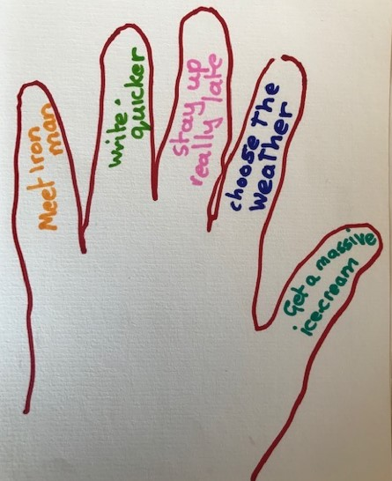

Follow these instructions
- Draw round your hand
- On each finger something you would like to magically make happen!
You can’t wish for anything permanent
But remember…
It will just happen once!

It can’t hurt or harm someone else!

Write your own spell
Now write your own spell in the style of Double Double…
___________________________________
____________________________________
______________________________________
_____________________________________________________________
_____________________________________________________________
_____________________________________________________________
_____________________________________________________________
Making a Magic Wand
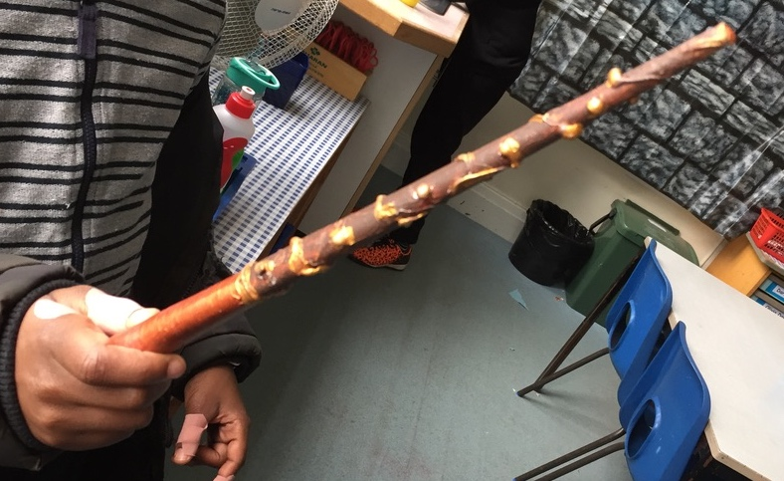
What you will need:

- Quite long, thick, straight twigs or sticks
(twigs, chop sticks, old pencils or dowelling rods)
- Newspaper torn up into small pieces
- White or neutral- coloured tissue paper
- PVA glue plus water or a nice sticky flour and water mix
- String and Paints

Instructions:
- Find a suitable twig or stick in your garden or at the park. It doesn’t need to be completely straight – in fact, slightly twisted wands look the best.
- Blend water with PVA glue (use a ratio of about 4 glue to 1 water) and dip your newspaper pieces into the mix.
- Wrap the gluey paper sections around your stick until the whole thing is covered. Do another layer after the first one so that the stick is thickly coated.
- If you want your wand to have a ‘bulb’ at one end, keep adding paper to this part until it bulges out like a ball.
- When you have the shape you really like, cover the whole stick with pieces of gluey white tissue paper.
- Dip a piece of string in the glue and then wrap the gluey string around your wand. You may need to add extra glue to hold it in place.
- Allow the stick to dry
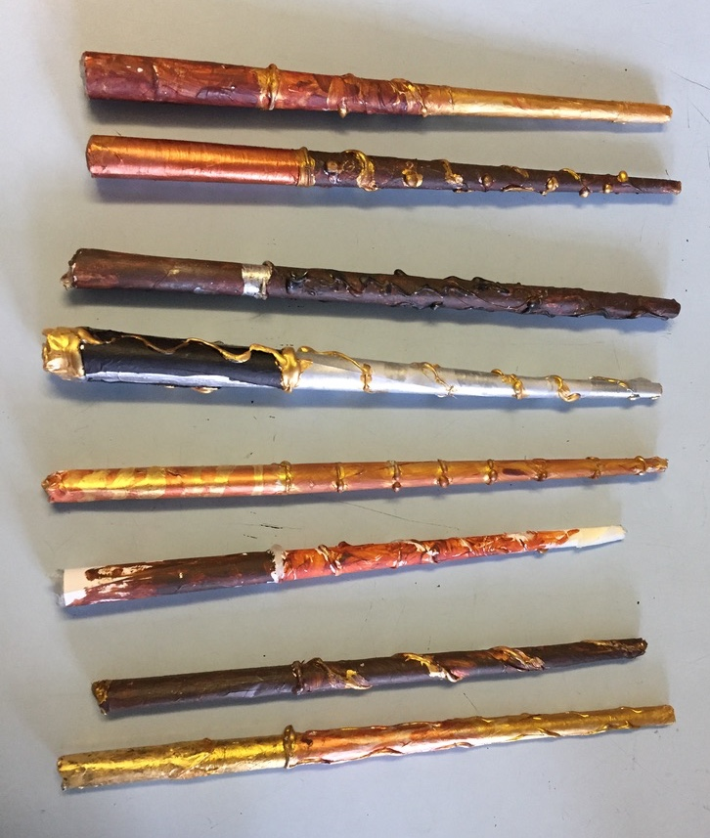
completely.
- Paint your wand any colour
you like and let the paint dry.
- You are done.
Ready for making magic!

