What to do today
IMPORTANT! Parent or Carer – Read this page with your child and check that you are happy with what they have to do and with any weblinks or use of the Internet required.

1. Reading riddles
A riddle is a word puzzle. You have to think carefully and look for clues in the riddle to work out its ‘hidden’ answer.
- Read each of the Riddles.
- Were you able to figure them all out? Check with the Answers.

2. Writing riddles.
What were your favourite riddles?
- Copy out the riddles you liked most on My Favourite Riddles.
- Learn them off by heart.
- Try them out on your friends and family.
- See if you can make up your own riddles!

3. Finding Words
You can use the letters in the letter boxes to spell out lots of words.
- Read the instructions on Square Spellings and see how many words you can spell.

Now try this Fun-Time Extra
- Challenge other people to see if they can beat Ian the Owl.
- Use the empty letter boxes to make up your own 9-letter challenge.
Did you find that some letters were really hard to make any words from? Which vowels will you use in your selection?

Riddles

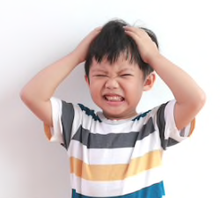

I slither on the ground. I often scare people. I can bite. I hiss when I am frightened. Who am I?

What has a bottom right at the top?

What is so fragile that even whispering breaks it?

What has a face and two hands, but no arms or legs?

What has a thumb and four fingers but no arm?

What gets wetter the more it dries?

You can catch me, but you can’t throw me. What am I?

What is black and white and read all over?

I run right round a garden without moving. What am I?

There is a bungalow where everything is yellow. The carpets are yellow, the curtains are yellow, the sheets and the pillowcases are yellow. The cups and saucers are yellow, the toys are yellow, the walls are yellow. All the clothes are yellow and so are the chairs and the lampshades. What colour are the stairs?

You are driving a bus with 10 people on it. At the first stop 3 more people get on and no one gets off. At the next stop 4 people get on and 2 get off. At the next stop 7 people get on but 3 people get off. What is the name of the bus driver?

Riddle Answers

I slither on the ground. I often scare people. I can bite. I hiss when I am frightened. Who am I? A snake!

What has a bottom right at the top? Your legs!

What is so fragile that even whispering breaks it? Silence!

What has a face and two hands, but no arms or legs? A clock!

What has a thumb and four fingers but no arm? A glove!

What gets wetter the more it dries? A towel!

You can catch me, but you can’t throw me. What am I? A cold!

What is black and white and read all over? The page of a book!

I run right round a garden without moving. What am I? A fence or hedge!

There is a bungalow where everything is yellow. The carpets are yellow, the curtains are yellow, the sheets and the pillowcases are yellow. The cups and saucers are yellow, the toys are yellow, the walls are yellow. All the clothes are yellow and so are the chairs and the lampshades. What colour are the stairs? There are no stairs – it’s a bungalow!

You are driving a bus with 10 people on it. At the first stop 3 more people get on and no one gets off. At the next stop 4 people get on and 2 get off. At the next stop 7 people get on but 3 people get off. What is the name of the bus driver? It’s you! ‘You are driving a bus...’ says the first line.
My Favourite Riddles

Letter Boxes

c | t | o | p
r | a | n | i
d | e | s | n
u | m | b | a

Square Spellings

You are going to use the letters in the Letter Boxes for a spelling game.
Either play with another person or play against Ian the Owl.
Rule
The next-door letters in the word must touch by a side or a corner

Game for two players
1. Look at the letters. Choose 2 or more letters to make a word, e.g. cat.
- c touches a and a touches t so you can have cat.
- You cannot have son because s does not touch o.
- Letters can go in any direction – forwards, backwards, upwards or down, just so long as they are always touching in the right order.
2. Take it in turns to make a word.
3. Write the words you have made down on your Words sheet.
The loser is the first person not to be able to create a new word.
So, the person who makes the last possible word is the winner!
4. Check Ian the Owl’s Words to discover words you could have made. You might have found others, as long as you both agree they are valid they can count!

Rules for playing against Ian the Owl
1. Look at the letters and choose 2 or more letters to make a word.
- c touches a and a touches t so you can have cat.
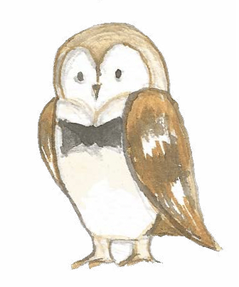
- You could not have son, because s does not touch o.
- Letters can go in any direction – forwards, backwards,
upwards or down, just so long as they are always
touching in the right order.

Ian the Owl has gone first and made 30 words.
Can you make even more than him?

Make as many words as you can and then compare them
with Ian the Owl’s Words.

Ian the Owl’s Words

Ian the Owl found 54 words

An, art, to, ta, car,
ton, can, cat,
cart, dean, seat, sat, sea, tan,
ran, rant, dear,
tone, tones, toner, toned, tread,
act, dart, den, snot, not,
snare, carton, cartons, sad,
dumb, mud, due, meat, men,
mean, meant, means, in, ban, bans,
bases, pot, pin, pins, pint, pine, pined, nine,
nines, nip, nab, nabs

Words

Empty Letter Box

