What to do today
IMPORTANT! Parent or Carer – Read this page with your child and check that you are happy with what they have to do and with any weblinks or use of the Internet required.

1. Reading time
Read the short poem Four Ducks on a Pond by William Allingham.
- In what ways is the poem like Sam’s Duck?
- The poet says, ‘to remember with tears’. Do you think he means tears of joy or sadness?
- What could make him so happy about what he saw? What could make him so sad?

2. Comparing poems
Read Night Cat by Helen Dunmore, a poem about an animal – like Sam’s duck – that goes away and leaves a person behind.
- Answer the Questions about the poem.

3. Writing time
Where do you think the cat in Night Cat went to after it vanished? What sort of things did it do? Who did it meet and play with – or fight?!
On The Further Adventures of the Night Cat, write all about what it got up before dawn.

Now try this Fun-Time Extra
Have you ever got close to a shy or nervous animal? Maybe in a zoo or a safari park? Maybe in school when someone brought an animal in? Maybe it was just in your garden?!
- On My Animal Experience draw the creature and say what happened.

Four Ducks on a Pond

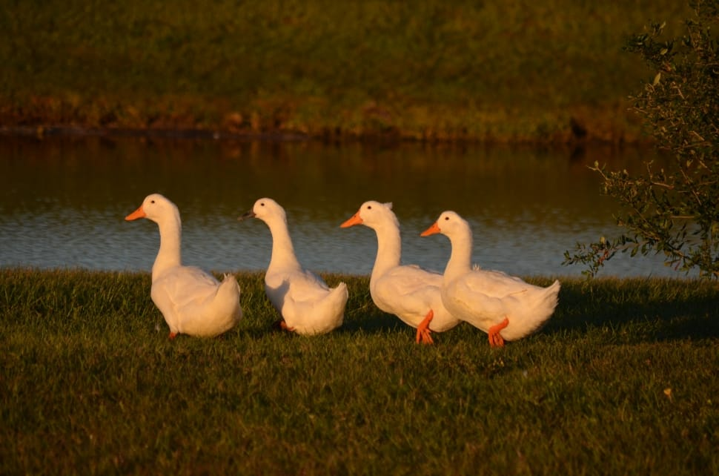

Four ducks on a pond,
A grass bank beyond,
A blue sky of Spring,
White clouds on the wing*;
What a little thing
To remember for years –
To remember with tears.

by William Allingham

From Read Me First, Poems for Younger Readers for Every Day of the Year,
Louise Bolongaro,
Macmillan Children’s Books, 2003

* on the wing – flying past in the breeze, as if they were birds

The Night Cat

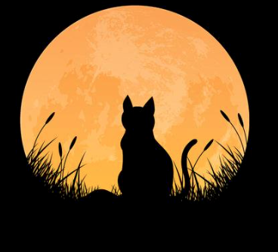

She’s there by the fence
but you mustn’t call out,
like a scoop of night
or a water shadow
tense for flight
she’ll twist and go,
don’t open your mouth –
the moon’s so close
that the stars blow out –
you turn she’s gone
leaving that patch
where the moon shone
leaving the empty dress of night
with the stars picked out
and you alone.

by Helen Dunmore

From Read Me First, Poems for Younger Readers for Every Day of the Year,
Louise Bolongaro,
Macmillan Children’s Books, 2003

Questions about The Night Cat

1. Which of the words below describe the cat in the poem?
Circle any of the words that you think describe the cat well.

bold cautious wary boisterous excited timid

2. What colour do a scoop of night and a water shadow make you think of?

_______________________________________________________________________

3. Why is that a very appropriate colour for this poem?

_____________________________________________________________________________________________________________________________________________________________________________________________________________________

4. Rhyming verse features sets of words at the end of lines that rhyme with one another and has a strong, singsong rhythm when you say it out loud.

Free verse is poetry where there are no or very few rhymes and where the rhythm is not so regular.

Which term best describes The Night Cat, rhyming verse or free verse?

_______________________________________________________________________

5. The gap between you turn and she’s gone on line 10 is not a mistake. The poet deliberately put it there. Why do you think she wanted a gap between those words?

______________________________________________________________________________________________________________________________________________

6. How does the person in the poem feel at the start of the poem? How do they feel at the end? What has caused the change?

_____________________________________________________________________________________________________________________________________________________________________________________________________________________

The Further Adventures of the Night Cat

My Animal Experience

____________________________________________________________________________________________________________________________________________________________________________________________________________________________________________________________________________________________________________________________________________________________________________________
__________________________________________________________________________________________________________________________________________________________________________________________
Answers - Questions about The Night Cat

1. Which of the words below describe the cat in the poem?
Circle any of the words that you think describe the cat well.

bold cautious wary boisterous excited timid

2. What colour do a scoop of night and a water shadow make you think of?
Answers may vary – maybe dark blue or another dark colour

3. Why is that a very appropriate colour for this poem?
Answer should reflect what the children said above, e.g. dark blue because the sky is very dark blue at night-time.

4. Rhyming verse features sets of words at the end of lines that rhyme with one another and has a strong, singsong rhythm when you say it out loud.
Free verse is poetry where there are no or very few rhymes and where the rhythm is not so regular.
Which term best describes The Night Cat, rhyming verse or free verse?
Free verse, there are some rhymes but there isn’t a regular rhythm.

5. The gap between you turn and she’s gone on line 10 is not a mistake. The poet deliberately put it there. Why do you think she wanted a gap between those words?
Answers will vary but might indicate something like: to show that there’s a pause as the watcher of the cat turns round very slowly.

6. How does the person in the poem feel at the start of the poem? How do they feel at the end? What has caused the change?
At the beginning the person is fascinated by the cat and excited to see it. At the end they seem to be sad and lonely. They might be feeling like this because the cat has gone.

