What to do today
IMPORTANT! Parent or Carer – Read this page with your child and check that you are happy with what they have to do and with any weblinks or use of the Internet required.

1. Reading time
Go back to https://youtu.be/ZDT8WUNMjOk.
Listen again to the section of Sam’s Duck that details how Sam smuggles Francis back to his home city after he rescues him from the red-faced man.
- Do you think Sam was lucky to get away with it? What sort of things might have given him away?

2. Baby animals
Read the text about Baby Farm Animals.
If you rescued an animal like Sam did, imagine which one it would be. Choose the baby farm animal you would rescue. Use Getting my Animal Home to make brief notes about how you would:
- disguise or hide your animal on the journey
- cover up any stinky smells it created
- make up an excuse for any noises it made

3. Story writing
On The Day I Smuggled Home a Baby ______ , write a short story about how you smuggled your baby animal home.
- Use all your ideas from Getting My Animal Home to help you.

Now try this Fun-Time Extra
- If, in the end, you had to release your animal, where would you take it? To a farm or to a friend’s house? To the park or to one of your relatives?
- Why do you think that would be the best place for your animal?
Baby Farm Animals

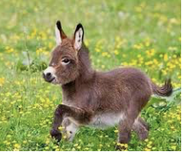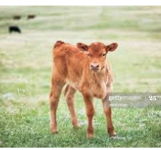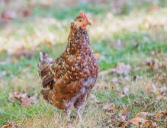

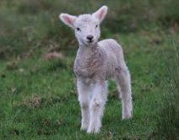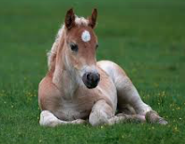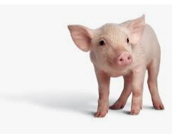

In the picture above you can see a baby donkey, a calf, a young chicken, a lamb, a foal and a piglet.

Which one would you choose to try to smuggle home?

You have to think about these problems though or you might get caught!

Even baby farm animals are quite big – and they move around a lot. How will you disguise or hide your animal? How will you keep them from moving about all the time? (Sing them a lullaby, feed them so they are full and happy, etc.)

Let’s face it, baby farm animals look adorable but they do smell... quite a bit! What will you do to cover up the icky odour while you are smuggling them? You’ll need a very nice smell to block out their pong. (Spray perfume, have a bunch of flowers, use a room spray, etc.)

Baby farm animals also make plenty of noise. They neigh, moo, cluck, bleat, whinny and oink all the time to get their mums’ attentions and let everyone know they are HUNGRY! What excuses could you make for their noises?
(It’s coming from a toy, it’s on my phone or my i-pad, etc.)

Getting my baby farm animal home

How I would disguise or hide my animal | How I would cover up its pong | What I would say was making all the noise

The day I smuggled home a baby _________________

