What to do today
IMPORTANT! Parent or Carer – Read this page with your child and check that you are happy with what they have to do and with any weblinks or use of the Internet required.

1. Story time
Go back to https://youtu.be/ZDT8WUNMjOk.
Listen again to the whole of Sam’s Duck.
- Does Sam know how to look after a duck properly?
- Do you think that Sam’s Grandad is right to say Sam should let the duck go?

2. Reading an information text
Read the information sheet on Farm Ducks and their care. Read it through twice and talk to a grown up about all the things you have to do.
- Do ducks sound easy or hard to look after?

3. Writing instructions
Imagine you have brought a duck back to live at your house. Your Grandad (who lives far away) is not sure that you really know what to do to look after it. Using the letter paper, write your Grandad a message.
- Say what sort of duck you’ve got and what its name is.
- Explain all that you will do to take good care of it.
- Tell your Grandad not to worry.
- Sign off affectionately from you and your duck!

Now try this Fun-Time Extra
- In the book it is Sam’s Grandad’s birthday. A duck might not be a great idea, but what else could Sam have brought back from the farm for his Grandad? List your ideas on Gifts for Grandad.

Farm Ducks and their Care

There are lots of different sorts of farm ducks in Britain, but all of them need the same sort of care if they are to be happy and healthy.

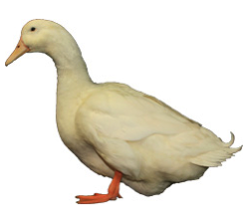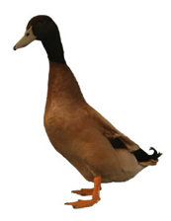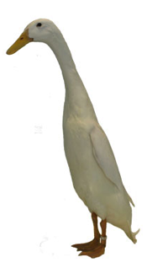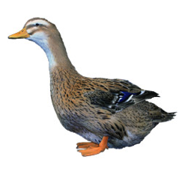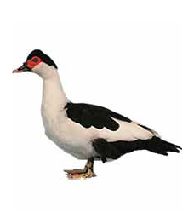

Aylesbury Khaki Campbell Indian Runner Rouen Clair Muscovy

What a duck needs

- Lots of water to play and splash about in. This can be a proper stream or pond, or just an old bath or paddling pool filled up with fresh water each day. Be warned – ducks make their water very dirty and usually splash most of it out of a bath or tub!
- A sturdy house or enclosure for night time to protect them from predators.
- Clean straw to sleep on and keep them warm.
- A hopper (a special feeding bucket) of pellets or corn to eat.
- Drinking water.
- Access to grass and soil so that the duck can eat insects and bugs such as slugs and snails. This might be a big field or just a normal garden but ducks can't live inside all the time.
- Company! Ducks don't like to live on their own so you should always have at least two ducks living together so they stay cheerful.

___________________________________
___________________________________
___________________________________
___________________________________

___________________________________

______________________________________

____________________________________________________________________________________________________________________________________________________________________________________________________________________________________________________________________________________________________________________________________________________________________________________
__________________________________________________________________________________________________________________________________________________________________________________________
__________________________________________________________________________________________________________________________________________________________________________________________
__________________________________________________________________________________________________________________________________________________________________________________________

______________________________________

