What to do today
IMPORTANT! Parent or Carer – Read this page with your child and check that you are happy with what they have to do and with any weblinks or use of the Internet required.

1. Story time
Go back to https://youtu.be/ZDT8WUNMjOk.
Listen to the rest of Sam’s Duck, from, ‘No quacking,’ Sam whispered, ‘Please!’ to the end of the book.
- Who nearly revealed that Sam had the duck on board the coach?
- How do you think the duck would have felt at being smuggled home by Sam? Consider two different emotions it might have had.

2. Reading about characters
Think about the characters in the story. How many can you list?
- Name one character that is sympathetic (that you like and feel warmly about) and one that is unsympathetic.
- Is there a character you particularly like or dislike? Explain why.
Read the profiles of The Gardener and The Red-Faced Man.

3. Writing a character profile
Using the profiles of the gardener and the red-faced man as models, write a profile of Sam.
- Use the Profile sheet to record your sentences on.
- Don’t forget: in your profile you need to focus on Sam’s personality and how he behaves.

Now try this Fun-Time Extra
- Have you ever been away from home like Sam in the story? On Staying Away, write about what it was like or what you think you would feel about it if you were doing it for the first time.

The Gardener

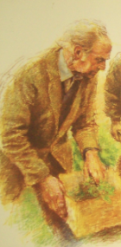

The gardener at Nethercott Farm is cheerful, kind and friendly. He is quite tall, with a long brown work coat and a jersey and a tie. He is a bit bald but has silver hair just like Sam’s Grandad. The gardener is in charge of the vegetable patch at the farm, sowing seeds and picking all the fruit, salads and vegetables that Sam and the other children help plant, and which they get to eat in the farmhouse kitchen at teatime. He likes teaching Sam things about the countryside and knows all about animals too. He helps Sam take care of Francis. Although he probably doesn’t think it’s a terribly good idea for Sam to actually take Francis home, he does understand how important the duck is to Sam and so he doesn’t try to stop him.

The red-faced man at the market

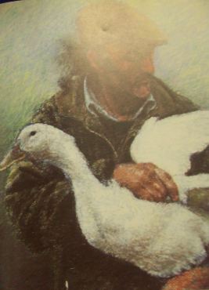

The red-faced man that Sam meets at the market is not a very nice character at all. He wears an old cloth cap over long, straggly grey hair and has a battered and dirty country jacket. His face is red from being angry and a bit mean to the animals. Unlike the gardener who Sam meets on the farm, the red-faced man is really unfriendly and cruel. He sneers at Sam and tells him to get out of his way. He is very rough with the animals at the market, pulling their tails to make them move and even kicking out at them. Sam realises that the man is thoughtless and uncaring so he buys the duck to stop the him taking it home and killing it for his dinner.

______________________________

____________________________________________________________________________________________________________________________________________________________________________________________________________________________________________________________________________________________________________________________________________________________________________________________________________________________________________________________________________________________________________________________________________________________________________________________________________________________________________

Staying Away

