What to do today
IMPORTANT! Parent or Carer – Read this page with your child and check that you are happy with what they have to do and with any weblinks or use of the Internet required.

1. Story time
Go to https://youtu.be/ZDT8WUNMjOk .
Listen to the reading of Sam’s Duck, written by Michael Morpurgo and illustrated by Keith Bowen.
Stop when you get to, ‘No quacking,’ Sam whispered, ‘Please!’
- Explain one thing you have really liked in the story so far.
- What do you think Sam will do with the duck?

2. Answering comprehension questions
Nethercott Farm is a real farm in Devon. It is run by a charity called Farms for City Children.
Read all about Farms for City Children.
- Answer the Questions about the text.

3. Writing about your average day
Read the text of An Average Day at Nethercott Farm.
- Say one way in which your average day is different to that on the farm, and one way in which it is quite similar.
- On My Average Day, set out a normal day for you in the same way.
- Mention at least four different things for each part of your day.

Now try this Fun-Time Extra
- Think about all the farm animals in Sam’s Duck. On My Favourite of the Farm Animals, draw the one you like the best and explain why it appeals to you the most.

Farms for City Children

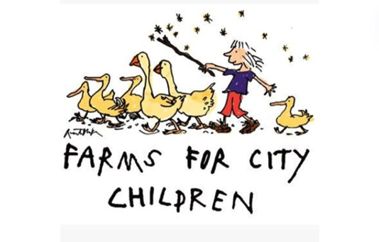

Farms for City Children started in 1974, when Michael Morpurgo – who wrote Sam’s Duck – and his wife Clare started a charity (an organisation set up to help other people) to make it possible for children who live in towns and cities to spend time on farms out in the countryside.

Farms for City Children own three farms – Nethercott Farm in Devon (which is where Sam goes in the story), Lower Treginnis in Pembrokeshire and Wick Court in Gloucestershire.

Children come from schools in cities all over Britain to live and work on the farms. They learn how to look after farm animals and grow vegetables, use tools and go looking for wild animals and birds. Although the children come with their teachers, Mums and Dads stay at home, so coming to the farms also gives children a chance to feel what is like being away from their families for a few days in a safe and exciting place.

There is loads of lovely food to eat (some of which the children grow and pick and prepare themselves) and at night time, everyone sleeps in dormitories with their friends. But you have to go to sleep nice and early as you get woken up at the crack of dawn to do all the farm jobs that need tackling, from feeding lambs and grooming | 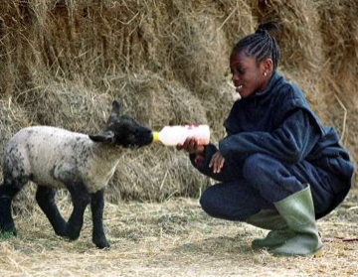
horses to mucking out pig sties and picking potatoes in the fields.

Questions

Which two people started Farms for City Children?

______________________________________________________________

Which of these definitions of what ‘charity’ means is the most accurate

a farm for children to visit _____________________
a club for children’s authors ___________________
a group that try to assist people in some way ________
a place in Pembrokeshire ______________________

Why do you think the farm trips are for city children and not for children who live in the country?
___________________________________________________________________________________________________________________________

Find and copy the line in the text that says you do not get your own bedroom when you stay on one of the farms.

______________________________________________________________

What does the expression ‘the crack of dawn’ mean?

______________________________________________________________

Look at the photograph at the bottom of the Farms for City Children page. Explain what you think is going on in the photograph.
__________________________________________________________________________________________________________________________________________________________________________________________

Why do you think the girl is wearing the clothes she is in?

____________________________________________________________________________________________________________________________

How does she seem to be feeling about her time at one of the farms?

__________________________________________________________________________________________________________________________________________________________________________________________

‘I would not want to stay at one of the farms as you have to work too hard and everything is muddy and smelly’. How much do you agree with this? Explain why you agree or disagree with the statement.
__________________________________________________________________________________________________________________________________________________________________________________________
__________________________________________________________________________________________________________________________________________________________________________________________
____________________________________________________________________________________________________________________________

An Average Day at Nethercott Farm

Morning  6am  7am  7.30am  8.00am  8.30am  12.00pm | Take the cows to the milking parlour and milk the whole herd.  Give the horse, calves and pigs their first feed of the day.  Have breakfast in the kitchen – porridge, scrambled eggs and lots of toast.  Let out the ducks, hens and geese so that they can forage for food around the farmyard.  Collect eggs from the nest boxes.  Muck out the animals’ sheds and put down clean straw.  Go in for lunch: hot soup, crusty rolls and slices of cheese.
Afternoon  1.30pm  3.00pm  5.00pm  6.00pm | Pick up stones from the fields so that they can be sown for crops.  Visit the livestock market to buy new animals for the farm and to collect feed, straw and other useful things.  Milk the cows again.  Have a tea of steaming hot stew with potatoes and vegetables grown on the farm.
Evening  7.00pm  9.00pm | Bring the lambing sheep into the barn for the night.  Groom the horses.  Close up the hen coops and get the ducks and geese back into their pens.  Have a hot chocolate and get an early night, ready for tomorrow!

My Average Day

Morning

Afternoon

Evening

My Favourite of the Farm Animals
Answers - Questions

Which two people started Farms for City Children?
Michael Morpurgo and his wife Clare.

Which of these definitions of what ‘charity’ means is the most accurate
A group that try to assist people in some way.

Why do you think the farm trips are for city children and not for children who live in the country?
Children who live in the country are more likely to see farms and farm animals as they go about their daily lives, they might be able to grow vegetables in their gardens. For some children living in the inner city (where there are no fields for animals to live in or crops to grow) it won’t be something they’ve experienced before.

Find and copy the line in the text that says you do not get your own bedroom when you stay on one of the farms.
‘at night time, everyone sleeps in dormitories with their friends’

What does the expression ‘the crack of dawn’ mean?
It means really early in the morning just as the sun is coming up.

Look at the photograph at the bottom of the Farms for City Children page. Explain what you think is going on in the photograph.
The girl is feeding a lamb from a bottle.

Why do you think the girl is wearing the clothes she is in?
She’s wearing overalls so that it doesn’t matter if she gets dirty. She’s wearing wellies so she can walk through muddy fields.

How does she seem to be feeling about her time at one of the farms?
The girl is smiling and she looks happy to be there feeding the lamb.

‘I would not want to stay at one of the farms as you have to work too hard and everything is muddy and smelly’. How much do you agree with this? Explain why you agree or disagree with the statement.
Answers will differ but children should give reasons for why they agree or disagree.

