What to do today
IMPORTANT! Parent or Carer – Read this page with your child and check that you are happy with what they have to do and with any weblinks or use of the Internet required.

1. Solving a crossword
Have you ever completed a crossword puzzle? Go to…
http://www.whenwecrosswords.com/crossword_puzzles/kids_crosswords.jsp or, if you can’t print at home, try https://lovattspuzzles.com/kids/childrens-online-puzzles/
- Select a crossword from the list and have a go.

2. Creating a crossword
Go to http://puzzlemaker.discoveryeducation.com/CrissCrossSetupForm.asp or http://www.printablecrosswordmaker.com/crossword_maker/crossword_maker.jsp
to make your own crossword for other people to solve.
- Look at the example My Puzzle.
- Follow the instructions.
- Chose a subject for your crossword that you know lots about – an animal you are really interested in or your favourite book, a TV character you know or the sport you like the most.

3. Palindromes
Look at the words on Palindromes. They often come up in crosswords.
- What do you notice about all the words?
Hint: try reading them backwards!
- Can you find more palindrome words? Write them in the box.

Now try this Fun-Time Extra
- Have a go at more of the puzzles from
https://lovattspuzzles.com/kids/childrens-online-puzzles/

My Puzzle

This is the puzzle I made using
http://www.printablecrosswordmaker.com/crossword_maker/crossword_maker.jsp

Pets
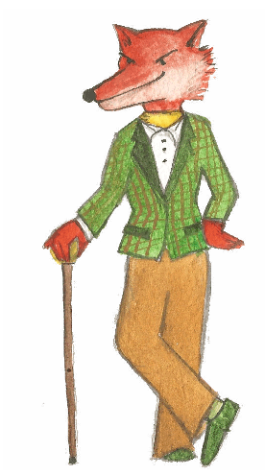

Go slowly and carefully and you'll definitely succeed
 |  |  |  | 1
2
 |  |  |  |  |  |  | 3 |  | 4
 |  |  | 5
 |  | 6

Across | Down
1 A pet that swims and lives in water in a bowl  2 Soft cuddly pet with silky ears  5 A small animal that likes to run in a wheel  6 Pet that needs lots of walks | 1 Smaller than a rabbit and larger than a hamster  3 Very clever pet that purrs  4 Clever bird that can learn to say words

Palindromes

Palindome words spell themselves properly both ways round!
Read them properly from left to right but also read them from right to left!
eye
pup
mum

dad
peep
toot

did

Look at the palindrome words at https://kids.kiddle.co/Palindrome .
Write down your favourites in the box below. Can you think of any others?

