What to do today
IMPORTANT! Parent or Carer – Read this page with your child and check that you are happy with what they have to do and with any weblinks or use of the Internet required.

1. Reading jokes
Do you know any good jokes?
- Read the Joke Collection, looking at the Punch Lines if you need to.
- Which one made you laugh the most? Which one made you groan the most!?
- Start to learn three of your favourite jokes off by heart.

2. Telling jokes out loud
Some people are very good at telling jokes.
- Go to https://www.youtube.com/watch?v=NMIjkqZFN9o and watch some children telling jokes.
- Think about what made some of the children such good joke tellers.
- Use what you learned by watching the children and from the suggestions on Telling Jokes to tell your family and friends the best jokes you read earlier.

3. Acrostics
An acrostic is a poem where the first letter of each line spells out a word.
- Read two jokey acrostics, Laugh and Groan.
- On My Acrostic, write an acrostic of your own for the word Joker.

Now try this Fun-Time Extra
- On A funny thing happened the other day, draw and write about a time something really funny happened to you.
Joke Collection

What is a glow-worm’s favourite food?

Why did the toilet paper roll down the hill?

What did the cruel chef do?

Why are giraffes happy to have long necks?

How do monkeys make toast?

Why don’t bugs have bad breath?

What is the biggest mouse in the world?

What does the word ‘minimum’ mean?

On which day do giants eat people?

What do you call a donkey with only three legs?

How do you stop a dog digging in your garden?

What did the nose shout out at the auditions for the school play?

What did one toilet say to the other toilet?

What do you get if you cross a spider and an elephant?

Why wasn’t there any food left after the witch’s party?

What do you get if a giant steps on Batman and Robin?

Why did the banana go to the doctors?

Punch Lines

What is a glow-worm’s favourite food?
Anything, so long as it is a light snack!

Why did the toilet paper roll down the hill?
To get to the bottom!

What did the cruel chef do?
He beat the eggs and whipped the cream!

Why are giraffes happy to have long necks?
Because they’ve got horribly smelly feet!

How do monkeys make toast?
They put the bread under the gorilla!

Why don’t bugs have bad breath?
Because they use moth-wash every day!

What is the biggest mouse in the world?
The hippopotomouse!

What does the word ‘minimum’ mean?
It means really small mother!

On which day do giants eat people?
Chewsday!

What do you call a donkey with only three legs?
A wonkey!

How do you stop a dog digging in your garden?
Take away his spade!

What did the nose shout out at the auditions for the school play?
Pick me! Pick me!

What did one toilet say to the other toilet?
Are you alright? You look flushed!

What do you get if you cross a spider and an elephant?
I have no idea, but if you see one on the ceiling move out of the way in case it lands on you!

Why wasn’t there any food left after the witch’s party?
Because everyone there was a goblin!

What do you get if a giant steps on Batman and Robin?
Flatman and Ribbon!

Why did the banana go to the doctors?
He wasn’t peeling very well!
Telling Jokes
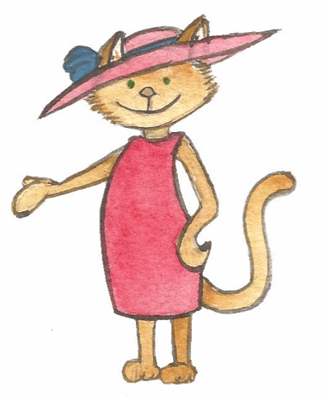

1. Make sure you know your jokes and their punch lines off by heart. Keep saying your jokes to yourself until you know them all really well.

2. You can begin a joke with a stock joke teller’s phrase such as, ‘I say, I say, I say...’.

2. Speak slowly and clearly so that the person you are telling the joke to can hear all the words. Even when you really want to get to the part where you let someone know the punch line, don’t rush!

3. Give the person you are telling the joke to time to think of an answer. Pause dramatically before you let them know the punch line.

4. Be smiley when you tell your joke but try not to burst into laughter while you are actually telling the joke! People can’t hear you if you are having a fit of the giggles and – even though your jokes are the best in the world (obviously!) – it’s better to let the person you are speaking to do the laughing (or groaning) first.

5. When you have finished telling your jokes, you can take a bow. You can also use a joke teller’s sign off line such as, ‘Thank you ladies and gentlemen, I’ve been (say your name) and you’ve been amazing. Goodnight!’ or, ‘Thank you ladies and gentlemen, I’m here all week.’

Two Acrostics

Laugh
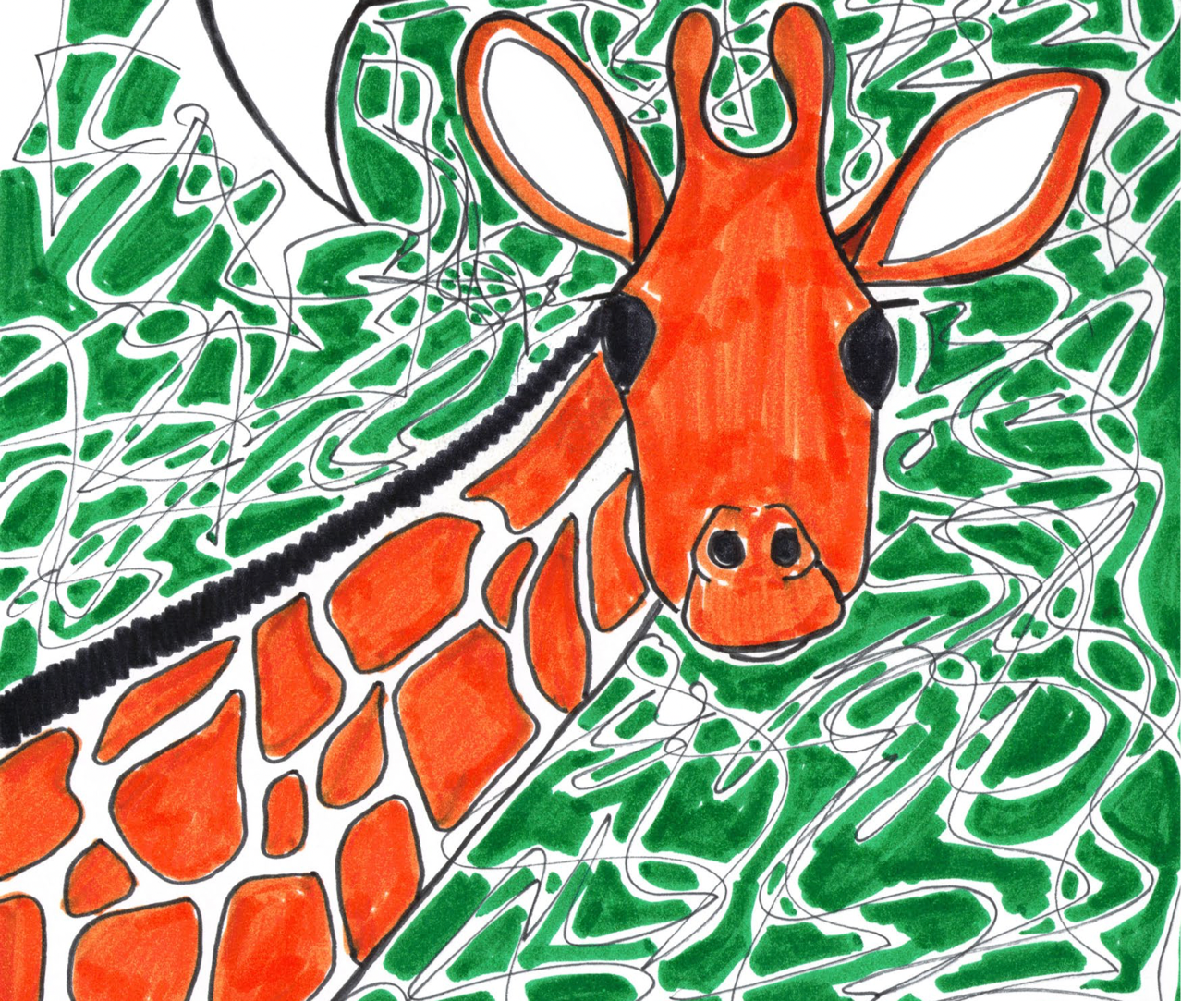
L eopards chuckling
A ntelopes giggling
U nicorns sniggering
G iraffes chortling
H aving fun with animal jokes!

Groan

G one and done it again.
R e-told a terrible joke.
O nly wish I could have stopped myself.
A fter all, I know lots of others but
N o-one wants to hear any of them now!
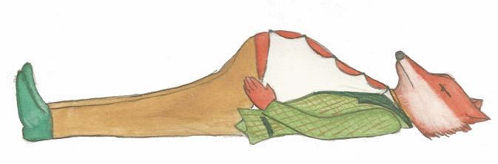

My Acrostic - Joker!

J_______________________________________________
O_______________________________________________
K_______________________________________________
E_______________________________________________
R_______________________________________________

A funny thing happened the other day

