What to do today
IMPORTANT! Parent or Carer – Read this page with your child and check that you are happy with what they have to do and with any weblinks or use of the Internet required.

1. Reading magic spells
Do you know any magic spells?
- Read the Magic Spells, sounding out each of the words carefully.
- Which ones do you recognise? Where have you heard them before?

2. Spelling spells
Look at the Abracadabra Triangle.
Starting at the bottom, what happens each time you go up a line?
- Choose your favourite magic spell from the set.
- Make a triangle for your spell. Make sure you get the spelling right!

3. Magic wands
Every good magician must have a wand.
- Follow the instructions on Making a Magic Wand to create your very own wand.

4. It’s magic!
You are now ready to make some magic.
- Make up a magic spell of your own or use one on the list.
- Swish your wand through the air.
- Cry out your spell and add a magic command: Bring..., Make..., Give..., Build..., Tidy..., etc. (Make sure your magic spell is kind!)

Now try this Fun-Time Extra
- Be amazed! Watch the magic tricks at https://www.youtube.com/watch?v=uA7BxSrhjw4

Magic Spells

Abracadabra!
Hocus pocus!
Bibbidi-bobbidi-boo!
Sim Sala Bim!

Alikazam!

Hey presto!
Shazam!

Kimota!

Expelliarmus!

Abracadabra Triangle

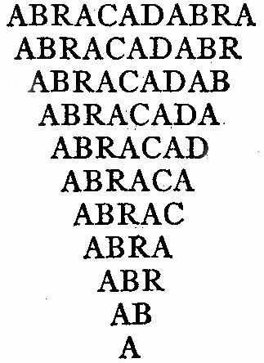

My Magic Spell Triangle

Making a Magic Wand
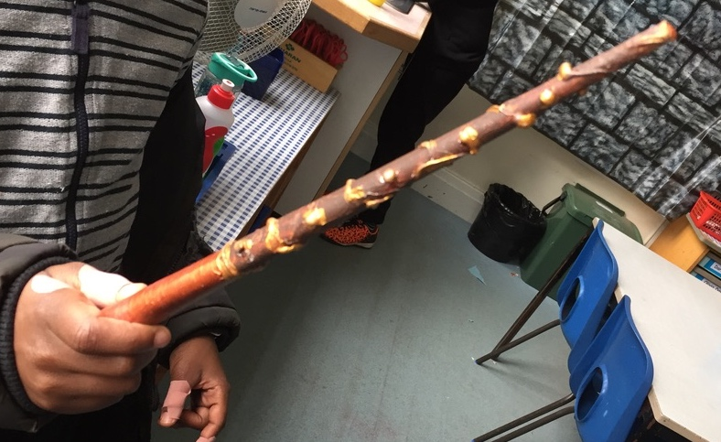
What you will need:

- Quite long, thick, straight twigs or sticks
(twigs, chop sticks, old pencils or dowelling rods)
- Newspaper torn up into small pieces
- White or neutral- coloured tissue paper
- PVA glue plus water or a nice sticky flour and water mix
- String and Paints

Instructions:
- Find a suitable twig or stick in your garden or at the park. It doesn’t need to be completely straight – in fact, slightly twisted wands look the best.
- Blend water with PVA glue (use a ratio of about 4 glue to 1 water) and dip your newspaper pieces into the mix.
- Wrap the gluey paper sections around your stick until the whole thing is covered. Do another layer after the first one so that the stick is thickly coated.
- If you want your wand to have a ‘bulb’ at one end, keep adding paper to this part until it bulges out like a ball.
- When you have the shape you really like, cover the whole stick with pieces of gluey white tissue paper.
- Dip a piece of string in the glue and then wrap the gluey string around your wand. You may need to add extra glue to hold it in place.
- Allow the stick to dry
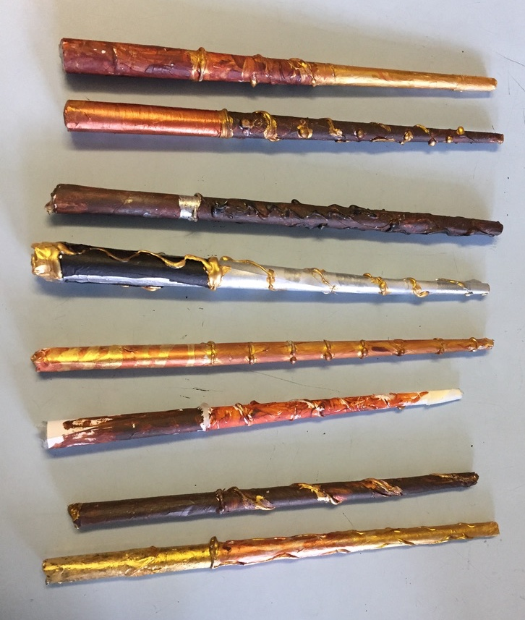
completely.
- Paint your wand any colour
you like and let the paint dry.
- You are done.
Ready for making magic!

