What to do today
IMPORTANT! Parent or Carer – Read this page with your child and check that you are happy with what they have to do and with any weblinks or use of the Internet required.

1. Story time
Go back to the Hamilton Storybook: Hickory Dickory Dock.
Re-read this version – you should know some of it by heart!

2. New animals for Hickory Dickory Dock
With a grown up, read the Instructions for writing two new verses for Hickory Dickory Dock.
- Record all your ideas for animals, numbers and rhymes on your Planner.

3. Producing a best copy of your new verses
- Copy out your new verses on the special paper.
- Use your very best handwriting.
- Make sure each sentence starts with a capital letter and ends with a full stop or exclamation mark.
- Leave neat, regular spaces between your words.

Now try this Fun-Time Extra
- Decorate your page of new verses
Instructions for writing new verses for Hickory Dickory Dock

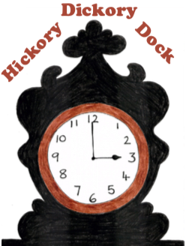

You are going to write two new verses for Hickory Dickory Dock.

What to do:
1. Think of a new animal to be in your first verse.
2. Double-check with the Hickory Dickory Dock Creatures to be sure they are not already in the rhyme!
3. Add your animal’s name in the space on the Planner.
4. Decide on an ‘o’clock’ number from one to nine to go with your animal. Write this number in the space on the Planner too.
5. Write in a line that ends in a word that rhymes with your number. Look at the Number Name Rhymes you collected yesterday to help you decide what word your line could end with.
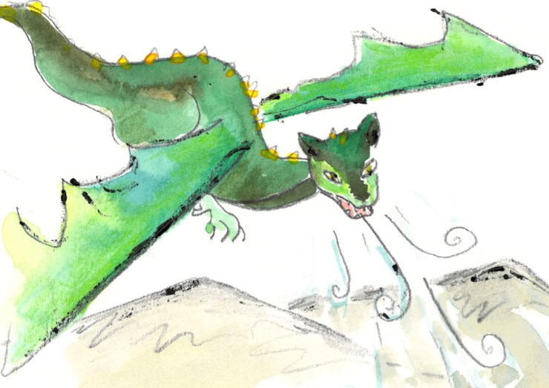
Hickory Dickory Dock!
The dragon flew up the clock.
The clock struck four,
Dragon flew through the door,
Hickory Dickory Dock!

6. Now do the same thing for your next animal and number.

Hickory Dickory Dock Creatures

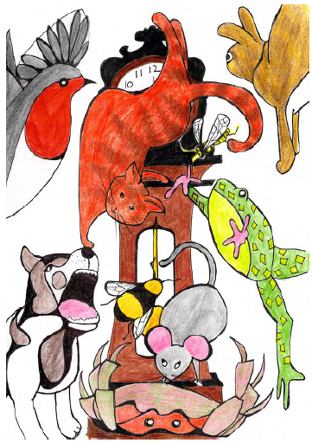

Planner
Hickory Dickory Dock!
The ran up the clock.
The clock struck
The
Hickory Dickory Dock!

Hickory Dickory Dock!
The ran up the clock.
The clock struck
The
Hickory Dickory Dock!

_____________________________________________________

__________________________________________________________________________________________________________________________________________________________________________________________________________________________________________________________________________________________________________________________________________________________________________________________________________________________________________________________________________________________________________________________________________________________________________________________________________________________________________________________________________________________________________________________________________________________________________________________________________________________________________________________________________________________________________________________

