What to do today
IMPORTANT! Parent or Carer – Read this page with your child and check that you are happy with what they have to do and with any weblinks or use of the Internet required.

1. Story time
Read the longer version of Hickory Dickory Dock in the Hamilton storybook.
- Name one thing that is the same as and one thing that is different to the version of the rhyme you heard yesterday. Record your thoughts on the sheet Comparing Hickory Dickory Docks.

2. Hearing a new version of Hickory Dickory Dock
Go to https://hamiltontrust-live-b211b12a2ca14cbb94d6-36f68d2.divio-media.net/documents/GR_Hickory_Dickory_Dock.mp3
Listen to the recital of the longer version of Hickory Dickory Dock.
- Did you like the way the rhyme was recited? What did you like?
- Do you prefer reading the illustrated version or listening to the oral recital? Say why.

3. Sequencing the animals from Hickory Dickory Dock
Look at the Hickory Dickory Animal Picture Cards.
- Cut out the cards.
- Lay the cards down in the correct ‘story order’.
- Read the rhyme again if you get stuck.

Now try this Fun-Time Extra
What is the best bit in this version of the rhyme?
- On My Favourite Moment from Hickory Dickory Dock, draw that scene.
- Underneath, write out the lines that go with just that part of the rhyme (The clock struck seven, Wasp flew to Devon, etc.).
- Use your best handwriting and word spacing for the lines.

Comparing Hickory Dickory Docks
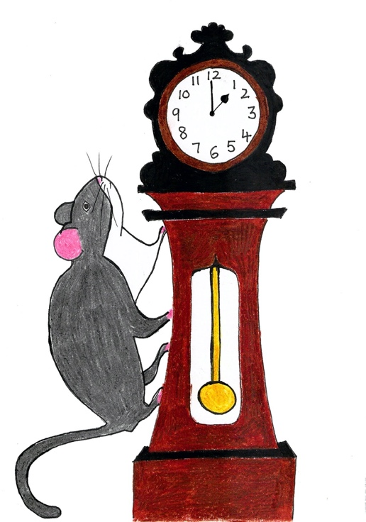

What is the same? | What is different?
The clock does strike 1… | The clock strikes different hours…

Hickory Dickory Dock Animal Picture Cards

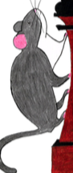  mouse | 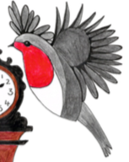  robin
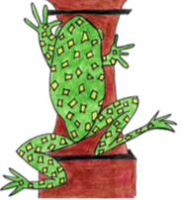  frog | 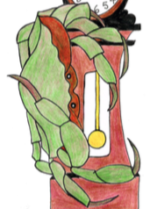  crab
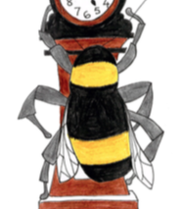  bee | 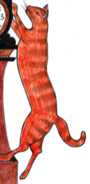  cat
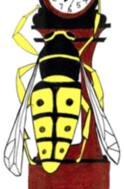  wasp | 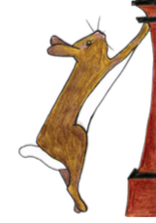  rabbit
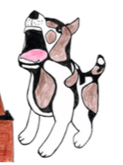  dog | 1. Cut up the cards  2. Lay the down in the correct story order  3. Re-read the rhyme if you get stuck

My Favourite Moment from Hickory Dickory Dock

__________________________________________________________________________________________________________________________________________________________________________________________

