What to do
IMPORTANT Parent or Carer –
Please check that you are happy with any weblinks or use of the internet.

1. Counting practice
- Lay cards with numbers on in a line 1 to 20.
  - Ask your child to turn around or else blindfold them!
  - Remove four numbers.
  - Ask the child to turn around, and then to lay those four cards in order, smallest to largest.
  - Check that they have done this correctly by looking at the ‘gaps’ in the 1-20 line.
  - Repeat this, three times. They can challenge you to do it too.

2. Play the game

- Play Shapey Trail as outlined below
  - You need some tiny soft toys or small plastic animals/people. In all it would be good to have about 12. You also need a coin to spin, and a counter each to move round the track.
  - Move round the track following the instructions.

Try these Fun-Time Extras

- Go on a Shape Hunt around your house. What circles can you find? (clock faces, dials on the cooker, plates…) What squares can you find? (cushions, window panes, pieces of kitchen towel…) What rectangles can you find? (books, magazines, table tops…) Are there any triangles?

Shapey Trail

You need:
- the track below printed out
- about a dozen small plastic animals/people or really tiny soft toys
- a coin to spin
- a counter each to move round the track

How to play

- Place the toys in the middle of the track.
- Place your counters on start.
- Take turns to spin the coin.
- If it lands ‘heads’, move two places forward.
- If it lands ‘tails’, move one space forward.
- When you have moved, say the name of the shape you have landed on.
- If you are correct, you take a small toy.
- If you are incorrect, discuss what shape it is, and then move back one space.
- Keep playing.
- When you both get back to the start, count your toys. The person with the most toys is the winner.
- Play again, timing yourselves. How fast can you get around the track, saying the correct shape names each time.

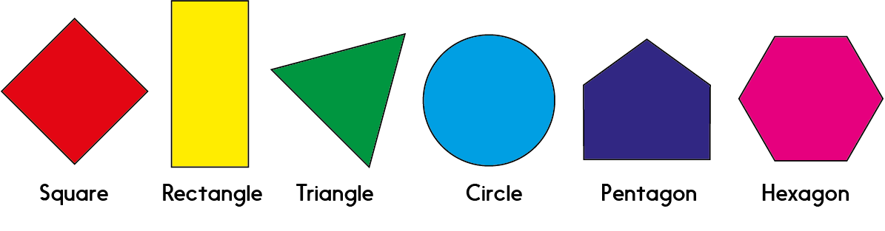

Shapey Trail
