What to do today
IMPORTANT Parent or Carer – Read this page with your child and check that you are happy with what they have to do and any weblinks or use of internet.

1. Find out about a true story
- Watch the trailer for A Street Cat named Bob.
https://www.youtube.com/watch?v=s13Fnj8LzD8
* This film is rated 12 and the trailer and extract (included in the resources from the associated book) make passing reference to substance addiction – please watch / read first to check suitability specifically for your child.
- How does this true story seem similar to Way Home? How does it feel different? Try to think of three different ways.
- Read the Extract and answer the Questions.

2. Learn about homelessness in Britain
- Visit this Newsround website about homelessness. Read all the information and take notes about the five things that most stand out to you. https://www.bbc.co.uk/newsround/50631620
- Watch Natasha’s story on this website. How is it similar to Way Home? How is it different?
- Make a poster that shows the five things that you chose as most important from this website. What do you want to tell people about homelessness?

3. Read poems about home
- Read the two poems about home: A Home Song and There’s No Place Like Home. Read each twice: once in your head and once out loud.
- Choose your favourite poem and practise reading it out loud. Use the Top Tips to help you.

Well done. Talk to a grown-up about three things you have learned today.

Try the Fun-Time Extra
Write a poem about the place you feel most at home.
Extract
﻿There’s a famous quote I read somewhere. It says we are all given second chances every day of our lives. They are there for the taking, it’s just that we don’t usually take them.
I spent a big chunk of my life proving that quote. I was given a lot of opportunities, sometimes on a daily basis. For a long time, I failed to take any of them, but then, in the early spring of 2007, that finally began to change. It was then that I befriended Bob. Looking back on it, something tells me it might have been his second chance too.
I first encountered him on a gloomy, Thursday evening in March. London hadn’t quite shaken off the winter and it was still bitingly cold on the streets, especially when the winds blew in off the Thames. There had even been a hint of frost in the air that night, which was why I’d arrived back at my new, sheltered accommodation in Tottenham, north London, a little earlier than usual after a day busking around Covent Garden.
As normal, I had my black guitar case and rucksack slung over my shoulders but this evening I also had my closest friend, Belle, with me. We’d gone out together years ago but were just mates now. We were going to eat a cheap takeaway curry and watch a movie on the small black and white television set I’d managed to find in a charity shop round the corner.
As usual, the lift in the apartment block wasn’t working so we headed for the first flight of stairs, resigned to making the long trudge up to the fifth floor.
The strip lighting in the hallway was broken and part of the ground floor was swathed in darkness, but as we made our way to the stairwell, I couldn’t help noticing a pair of glowing eyes in the gloom. When I heard a gentle, slightly plaintive meowing I realised what it was.
Edging closer, in the half-light I could see a ginger cat curled up on a doormat outside one of the ground-floor flats in the corridor that led off the hallway.
I’d grown up with cats and had always had a bit of a soft spot for them. As I moved in and got a good look I could tell he was a tom, a male.
I hadn’t seen him around the flats before, but even in the darkness I could tell there was something about him, I could already tell that he had something of a personality.
He wasn’t in the slightest bit nervous, in fact, completely the opposite. There was a quiet, unflappable confidence about him. He looked like he was very much at home here in the shadows and to judge by the way he was fixing me with a steady, curious, intelligent stare, I was the one who was straying into his territory. It was as if he was saying: ‘So who are you and what brings you here?’
I couldn’t resist kneeling down and introducing myself. ‘Hello, mate. I’ve not seen you before, do you live here?’ I said. He just looked at me with the same studious, slightly aloof expression, as if he was still weighing me up.
I decided to stroke his neck, partly to make friends but partly to see if he was wearing a collar or any form of identification. It was hard to tell in the dark, but I realised there was nothing, which immediately suggested to me that he was a stray. London had more than its fair share of those.
He seemed to be enjoying the affection, and began brushing himself lightly against me. As I petted him a little more, I could feel that his coat was in poor condition, with uneven bald patches here and there. He was clearly in need of a good meal. From the way he was rubbing against me, he was also in need of a bit of TLC.
‘Poor chap, I think he’s a stray. He’s not got a collar and he’s really thin,’ I said, looking up at Belle, who was waiting patiently by the foot of the stairs.
She knew I had a weakness for cats.
‘No, James, you can’t have him,’ she said, nodding towards the door of the flat that the cat was sitting outside. ‘He can’t have just wandered in here and settled on this spot, he must belong to whoever lives there. Probably waiting for them to come home and let him in.’
Reluctantly, I agreed with her. I couldn’t just pick up a cat and take him home with me, even if all the signs pointed to the fact it was homeless. I’d barely moved into this place myself and was still trying to sort out my flat. What if it did belong to the person living in that flat? They weren’t going to take too kindly to someone carrying off their pet, were they?
Besides, the last thing I needed right now was the extra responsibility of a cat. I was a failed musician and recovering drug addict living a hand-to-mouth existence in sheltered accommodation. Taking responsibility for myself was hard enough.
James Bowen A Street Cat Named Bob: How one man and his cat found hope on the streets

Questions

- Where does James first meet the cat?

- What tells him that the cat might be a stray?

- Why does James think about taking the cat?

- Why does he decide that he shouldn’t take the cat?

- How would you describe the mood of this extract?

- What do you think might happen next?

A Home Song

I read within a poet’s book
A word that starred the page:
“Stone walls do not a prison make,
Nor iron bars a cage!”

Yes, that is true; and something more
You’ll find, where’er you roam,
That marble floors and gilded walls
Can never make a home.

But every house where Love abides,
And Friendship is a guest,
Is surely home, and home-sweet-home:
For there the heart can rest.
by Henry Van Dyke
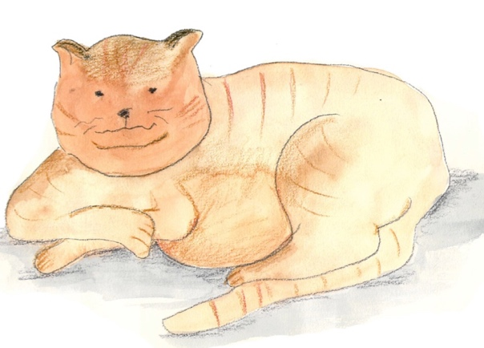

There’s No Place like Home

Mid pleasures and palaces though we may roam,
Be it ever so humble, there’s no place like home;
A charm from the sky seems to hallow us there,
Which, seek through the world, is ne’er met with elsewhere.
Home, home, sweet, sweet home!
There’s no place like home, oh, there’s no place like home!

To thee I’ll return, overburdened with care;
The heart’s dearest solace will smile on me there;
No more from that cottage again will I roam;
Be it ever so humble, there’s no place like home.
Home, home, sweet, sweet, home!
There’s no place like home, oh, there’s no place like home!

by John Howard Payne

Top tips for reading a poem aloud

- Work on the tricky words. Find out what they mean and how they are said. Practise saying them.
- Look for the full stops. Make sentences flow to the full stop, even when there’s a new line.
- Slow down. Speak slowly when you’re reading a poem, so that others can hear the words.
- Project your voice. Imagine someone on the other side of the room and speak to them.
- Practise. Read and read and read your poem, so that you get better each time.

