What to do today
IMPORTANT Parent or Carer – Read this page with your child and check that you are happy with what they have to do and any weblinks or use of internet.

1. Track emotions through a story
- Look carefully at the Emotions Graph – Example.
- Listen to the story again and make an Emotions Graph for Shane https://www.youtube.com/watch?v=rjzP18bsSdQ .
Try to find 4 or 5 key events and imagine his emotions.
- Now make an Emotions Graph for the cat. Compare your two graphs. Are there points when they both have similar emotions? When are their emotions most different?

2. Read two ‘cat-narrator’ extracts
- Read Cat Speaks 1 and 2.
- Complete Cat Speaks questions.

3. Now for some writing
- Write Way Home as though it is told by the cat.
- Use your Emotions Graph and some of the ideas that you saw in Cat Speaks 1 and 2.

Well done. Show your writing to a grown-up. Explain to them how you have used your Emptions Graph and the ideas in Cat Speaks
1 and 2.

Try the Fun-Time Extras
Write a diary for a pet that you know well. Try to imagine how they would see and understand the activities of the humans around them.

Emotions Graph – Example

Above the neutral line for positive emotion, below for negative. Give short reason.
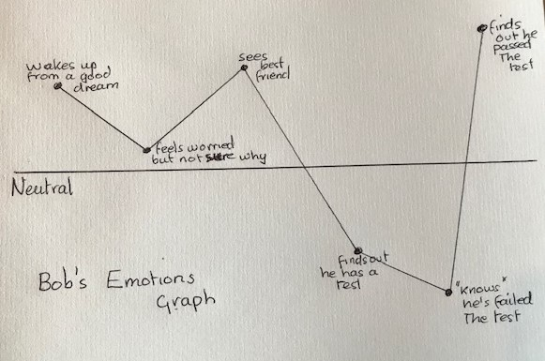

Emotions Graph - Shane

Emotions Graph - Cat

Cat Speaks 1
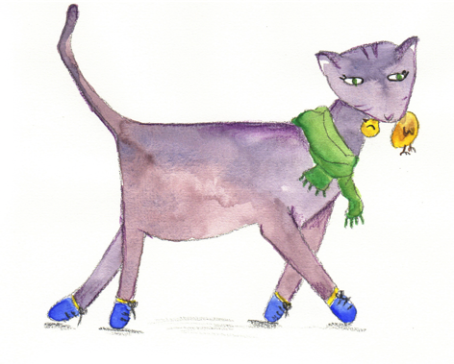

Okay, okay. So hang me. I killed the bird. For pity’s sake, I’m a cat. It’s practically my job to go creeping round the garden after sweet little eensy-weensy birdy-pies that can hardly fly from one hedge to another. So what am I supposed to do when one of the poor feathery little flutterballs just about throws itself into my mouth? I mean, it practically landed on my paws. It could have hurt me. Okay, okay. So I biffed it. Is that any reason for Ellie to cry in my fur so hard I almost drown, and squeeze me so hard I almost choke? ‘Oh, Tuffy!’ she says, all sniffles and red eyes and piles of wet tissues. ‘Oh, Tuffy. How could you do that?’ How could I do that? I’m a cat. How did I know there was going to be such a giant great fuss, with Ellie’s mother rushing off to fetch sheets of old newspaper, and Ellie’s father filling a bucket with soapy water?

By Anne Fine. The Diary of a Killer Cat

Cat Speaks 2
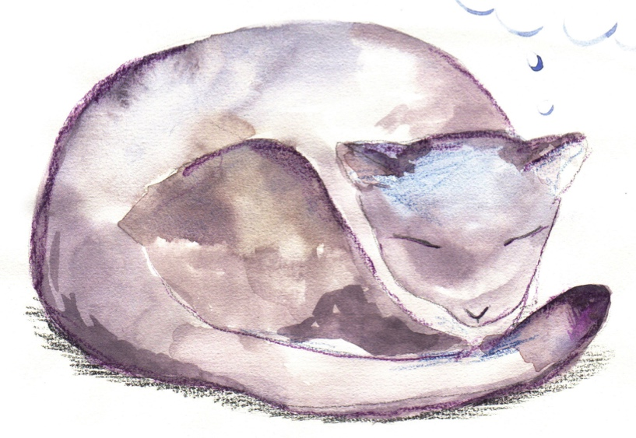

I AM A cat. As yet, I have no name. There’s a famous cat in our country who once made this very statement.
I have no clue how great that cat was, but at least when it comes to having a name I got there first. Whether I like my name is another matter, since it glaringly doesn’t fit my gender, me being male and all. I was given it about five years ago – around the time I came of age.
Back then, I used to sleep on the bonnet of a silver van in the parking lot of an apartment building. Why there? Because no one would ever shoo me away. Human beings are basically huge monkeys that walk upright, but they can be pretty full of themselves. They leave their cars exposed to the elements, but a few paw prints on the paintwork and they go ballistic.
At any rate, the bonnet of that silver van was my favourite place to sleep. Even in winter, the sun made it all warm and toasty, the perfect spot for a daytime nap.

I stayed there until spring arrived, which meant I’d survived one whole cycle of seasons. One day, I was lying curled up, having a snooze, when I suddenly sensed a warm, intense gaze upon me. I unglued my eyelids a touch and saw a tall, lanky young man, eyes narrowed, staring down at me as I lay prone.
‘Do you always sleep there?’ he asked.
I suppose so. Do you have a problem with that?
‘You’re really cute, do you know that?’
So they tell me.
‘Is it okay if I stroke you?’
﻿No, thanks. I batted one front paw at him in what I hoped to be a gently threatening way.
‘Aren’t you a stingy one,’ the man said, pulling a face.
Well, how would you like it if you were sleeping and somebody came by and rubbed you all over?

By Hiro Arikawa. The Travelling Cat Chronicles
Cat Speaks – Questions

How would you sum up the character of these cats?
Diary of a Killer Cat | The Travelling Cat Chronicles

How are these cats similar?

How are they different?

What do you think is the most memorable thing that each of these cats say?
Diary of a Killer Cat | The Travelling Cat Chronicles

What do you think their owners might say about these cats?
Diary of a Killer Cat | The Travelling Cat Chronicles

Way Home – the cat’s story
Write Way Home as though it is told by the cat.

