What to do today
IMPORTANT Parent or Carer – Read this page with your child and check that you are happy with what they have to do and any weblinks or use of internet.

1. Read the start of a book
- Look closely at the Front Cover of Way Home.
- Make brief notes about five things that you notice and what you think might happen in the book.
- Read First Page Text. Is this how you expected it would be from the front cover. What do you think about Shane? What do you think might happen?
- Listen to the Reading of the first part of the book, stop the video at 6.14, https://www.youtube.com/watch?v=rjzP18bsSdQ.

2. Answer questions
- Read Book Questions. Think carefully about your answers.
- Write your answers as sentences making a paragraph for each section.

3. Make predictions
- Use Development/Resolution to note down with words and pictures what you think will happen in the rest of the book.
- Write about your predictions. What will happen to Shane? What will happen to the cat? How might the story end?

Well done. Show your predictions to a grown-up. Explain to them how the story has started, what has happened and why you are making these predictions.

Try the Fun-Time Extra
Write your own story about meeting a stray cat. What would you call it? Where would you take it? What would you show it?

Front Cover
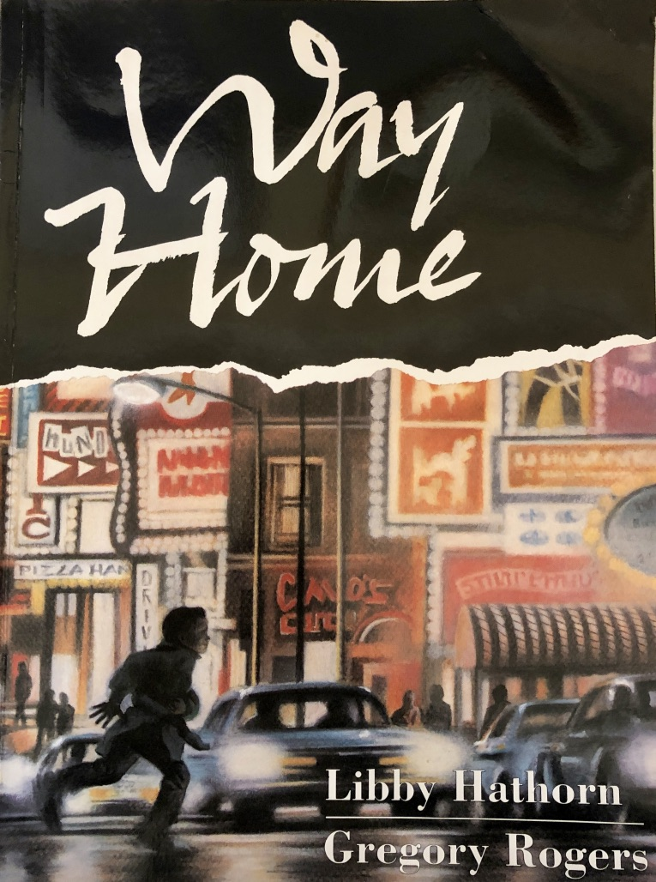

First Page Text

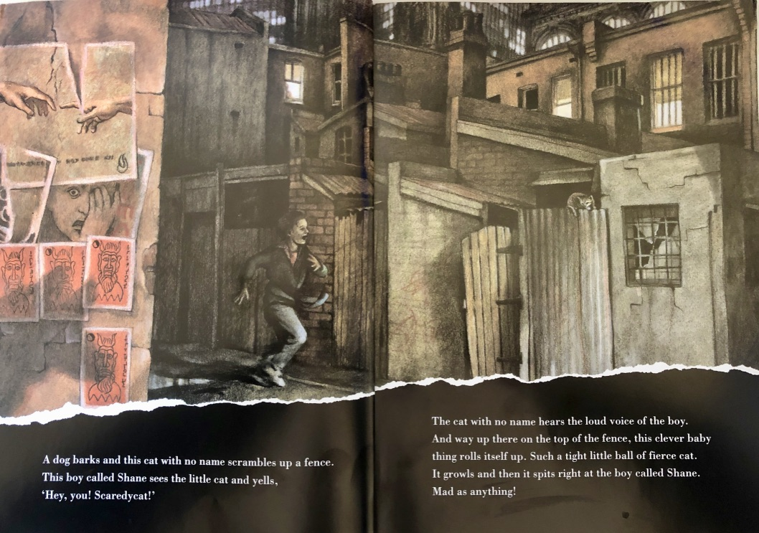

A dog barks and this cat with no name scrambles up a fence.
This boy called Shane sees the little cat and yells,
‘Hey, you! Scaredycat!’

The cat with no name hears the loud voice of the boy. And way up there on the top of the fence, this clever baby thing rolls itself up. Such a tight little ball of fierce cat. It growls and then it spits right at the boy called Shane.
Mad as anything!

Book Questions
What do you like about the book? Is there anything that you dislike? Why? | What does the book make you think about?  Anything you have read or seen? Anything that people have talked about? Anyone you know?
What makes the book striking? Which page particularly caught your eye? What is your favourite phrase, sentence or paragraph so far? | What issue and questions does the book raise?

Development/Resolution

What do you predict will happen next? How will the story end? Use words and pictures to show your ideas.

Your Predictions
Write about what you think might happen in the story.

