What to do today
IMPORTANT Parent or Carer – Read this page with your child and check that you are happy with what they have to do and any weblinks or use of internet.

1. Find out about alchemy
- Read the non-fiction History of Alchemy. What are three new things that you have learnt from reading this article?
- Read Alchemy Questions. Think about your answers and then write them in clear sentences.

2. Listen to a story
Listen to the reading of The Last Alchemist https://youtu.be/rlRh0qqKPyI
- What did you like about the story? Was there anything that you disliked? What did it remind you of? Why do you think Colin Thompson decided to write this book?
- Write 2 or 3 sentences to describe what is happening in each of the three Illustrations.

3. Compare two stories
- Read the version of the Greek Myth, King Midas.
- Complete the Comparison Table.

Well done. Show your Comparison Table to a grown-up and explain to them about the two stories. You can check your answers to Alchemy Questions at the end of this pack.

Try the Fun-Time Extras
- How do you think Colin Thompson would illustrate the story of King Midas? Try making an illustration of one scene from the story in his style.
- Research these alchemists. Try to find out five facts about each. Albert Magnus, Geber, Isaac Newton.
History of Alchemy

Alchemy is an ancient area of study. Alchemists attempted to purify and change certain materials. It is believed to have begun in Egypt and was developed in Ancient Greece.

It was introduced to western Europe in the eighth century when Arab settlers brought it to Spain. From here it quickly spread to the rest of Europe.

Alchemists believed that all metals were made up of a mix of mercury and sulphur. Gold was seen as the perfect metal and all other metals were seen as less perfect. Some alchemists believed that other metals could be changed into gold by using a substance that they called the Philosopher’s Stone.

They believed that the stone could make people live for ever. The Chinese name for the stone was the
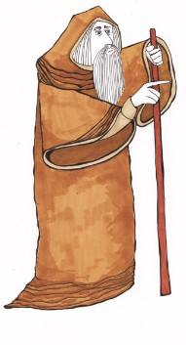
‘Pill of Immortality’.

The study of alchemy continued for
hundreds of years. By the sixteenth
century there were two groups of
alchemists.

The first group focussed on the discovery of new materials and their reactions. Their work led to what is now the science of chemistry.

The second group continued to look at the more mysterious and strange side of alchemy. They searched for immortality and the change (transmutation) of lower metals into pure gold.

Famous alchemists include: Geber, Albertus Magnus and Isaac Newton.

Alchemy Questions
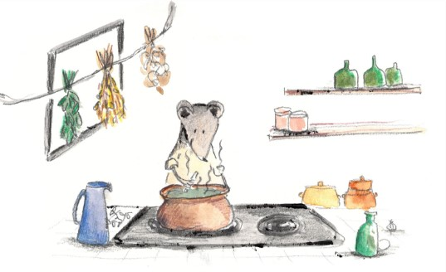

- Where is alchemy believed to have begun?
- What did alchemists believe about all metals?
- What did alchemists believe about gold?
- What did alchemists believe about the ‘Philosopher’s Stone’?
- What word means living for ever/never dying?
- Which of the sciences did alchemy develop into?
- What word do alchemists use for changing lower metals into pure gold?
- Which famous alchemist first stated the law of gravity?
(You may need to do some research to answer this question)

Illustrations

Write 2/3 sentences about what is happening in each of these illustrations.
You could watch the video again to help you.
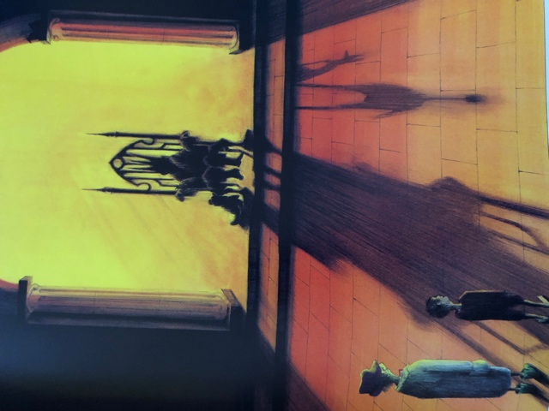
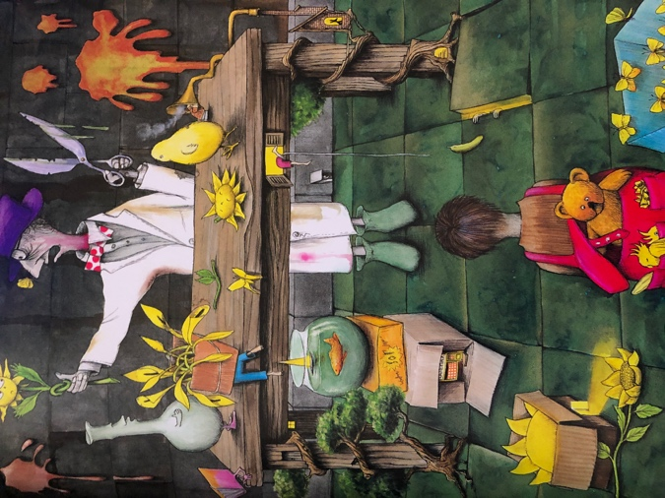
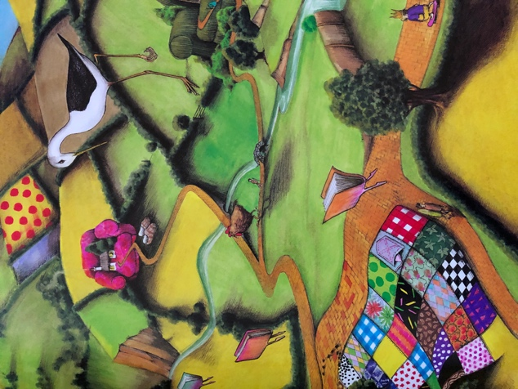

King Midas and the Golden Touch

Once upon a time, a long time ago in ancient Greece, there lived a king named Midas. King Midas loved three things more than anything else in the world - his little daughter, his rose garden, and gold. Nothing gave him more pleasure than seeing his little daughter picking roses in the garden, roses she placed in a golden vase to decorate the castle.

One night, while strolling through his rose garden, the king stumbled over a satyr. A satyr was half man, half goat. This satyr looked half-starved and very ill. King Midas brought the satyr into his castle. He made sure the satyr was washed and fed and tucked into bed for a good night's sleep. When the satyr woke up the next morning, his fever was gone. The king and the satyr had quite a nice chat over breakfast. King Midas was surprised to hear that the satyr belonged to the powerful god Dionysus, the god of wine and truth. That very day, the king personally took the satyr home in his very best chariot.

Dionysus told the king he would grant any one wish the king made to thank him for taking such good care of his friend. The king did not wish anything for his daughter because he had given her everything she wanted and a whole lot more besides. He did not wish anything for his rose garden because everyone knew he grew the finest roses in all the world. That left gold. King Midas wished that everything he touched would turn to gold.

When the king arrived back at his castle, he pulled out a chair to sit down at his table. The minute he touched it, the chair turned to gold. He touched the table. He touched a vase. As soon as he touched them, they turned to gold. King Midas raced through his castle. Everything he touched turned to gold! He was so happy. He shouted to his servants to cook him a feast in celebration!

His servants served him a feast. That's when the trouble started. Everything looked and smelled so good that King Midas did not wait for his daughter to show up for lunch. He reached out and grabbed a fistful of food. The food made quite a clatter when he dropped it back on the table in shock. It had turned to gold in his fist. He touched other food. Whatever he touched turned to gold. He tried leaning over and ripping a piece of meat with his teeth, but that did not help. The meat turned to gold in his mouth. The king's eyes filled with fear. | 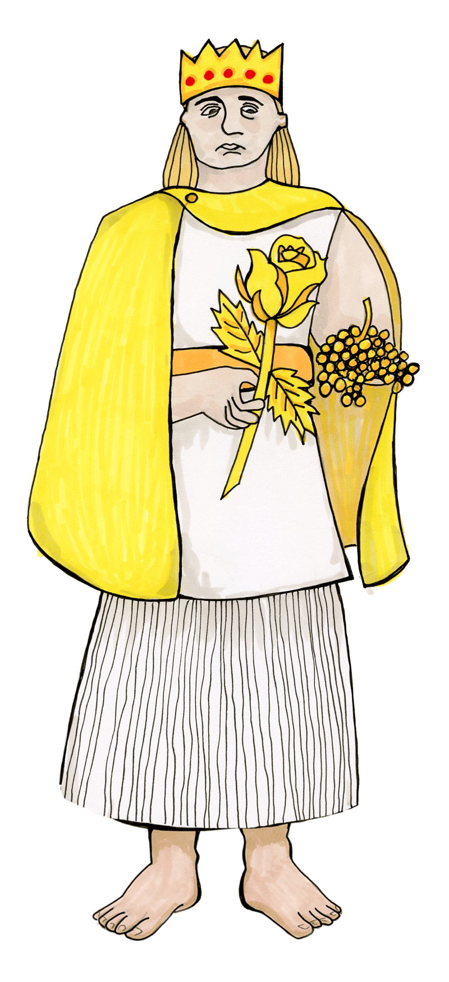
He knew if he could not eat, he would starve. This was terrible. The king did not know what to do.

King Midas wandered sadly out to his rose garden. His little daughter was in the garden, picking roses. When she saw her father, she ran into his arms for a hug and turned to gold. King Midas hung his head and cried. As his tears fell on his precious roses they turned to gold, but the king did not care. He did not care about his roses or his gold or himself. Dionysus, hear my prayer, the king begged. Take my wish back! Please, take my wish back and save my daughter!

One last time, the king's wish was granted.

Adapted from: https://greece.mrdonn.org/greekgods/kingmidas.html

Comparison Table

How are the stories of King Midas and The Last Alchemist similar and how are they different?

Explain your answers

Similarities | Differences

Alchemy Possible Answers

- Where is alchemy believed to have begun?
Alchemy is believed to have begun in Ancient Egypt.
- What did alchemists believe about all metals?
Alchemists believed that all metals are a mixture of mercury and sulphur.
- What did alchemists believe about gold?
Alchemists believed that gold was the purest metal.
- What did alchemists believe about the ‘Philosopher’s Stone’?
Alchemists believed that the Philosopher’s Stone would change lower metals into gold.
- What word means living for ever/never dying?
Immortality means never dying and living forever.
- Which of the sciences did alchemy develop into?
Alchemy developed into chemistry.
- What word do alchemists use for changing lower metals into pure gold?
Alchemist describe the change from lower metals into gold as transmutation.
- Which famous alchemist first stated the law of gravity?
Isaac Newton first stated the law of gravity.

