What to do today
IMPORTANT Parent or Carer – Read this page with your child and check that you are happy with what they have to do and any weblinks or use of internet.

1. Examine illustrations
- Look at Images 1-4. How would you describe what they show? What can you notice that maybe someone else wouldn’t? Where in the story do they come?
- Watch the story being read again. Watch out for Images 1-4. Were they where you remembered them to be?
https://www.youtube.com/watch?v=KQtRXXj08Sw
Which of the two readings did you prefer? Why?

2. Remind yourself about the Perfect and Progressive Form
- Use the PowerPoint on the Perfect and Progressive form of past tense, or remind yourself using the Revision Cards.
- Write Four Sentences for each of the Images. Make one in the past perfect, one in the present perfect, one in the past progressive and one in the present progressive.

3. Reflect on the story
- Read Reflection Points and think about your answers.
- Choose the five points that interest you most and write your answers in sentences.
- Challenge yourself to write about the other points too.

Well done. Show a grown-up your answers to the Reflection Points.

Try the Fun-Time Extras
Can you make a set of four illustrations that would tell something about a day in your life?
Image 1
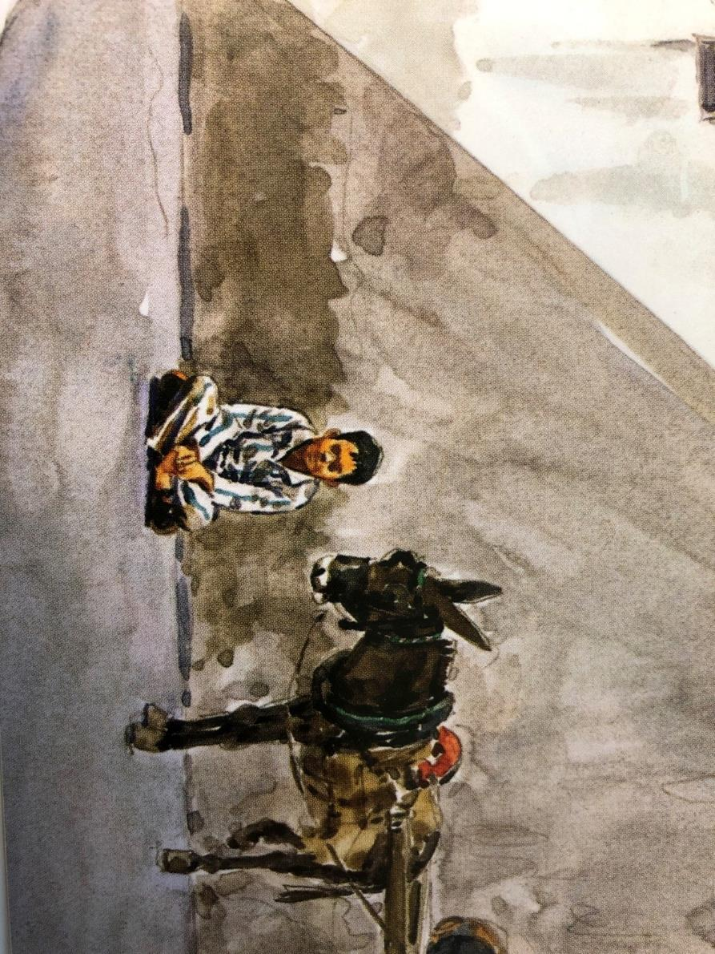

Image 2
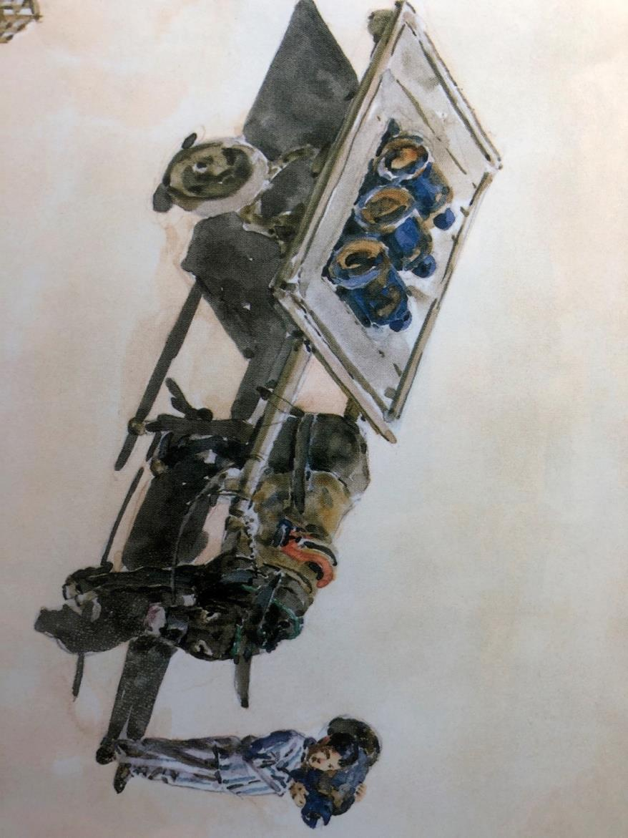

Image 3
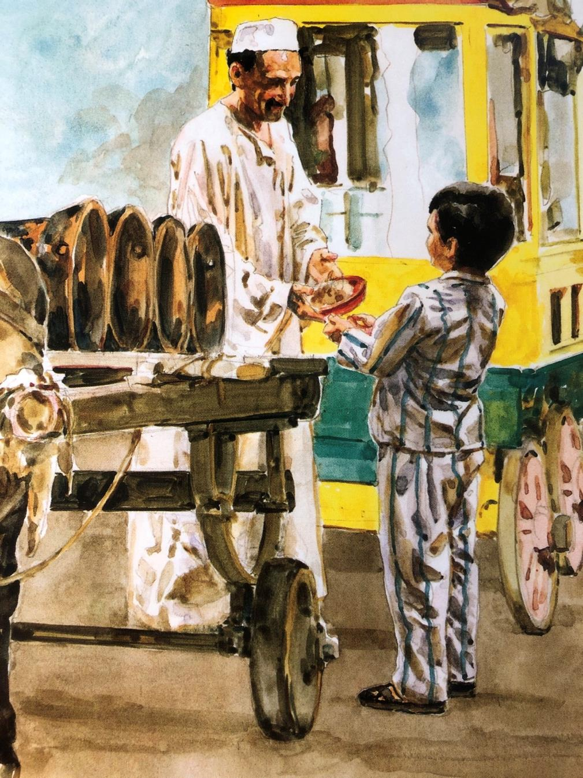

Image 4
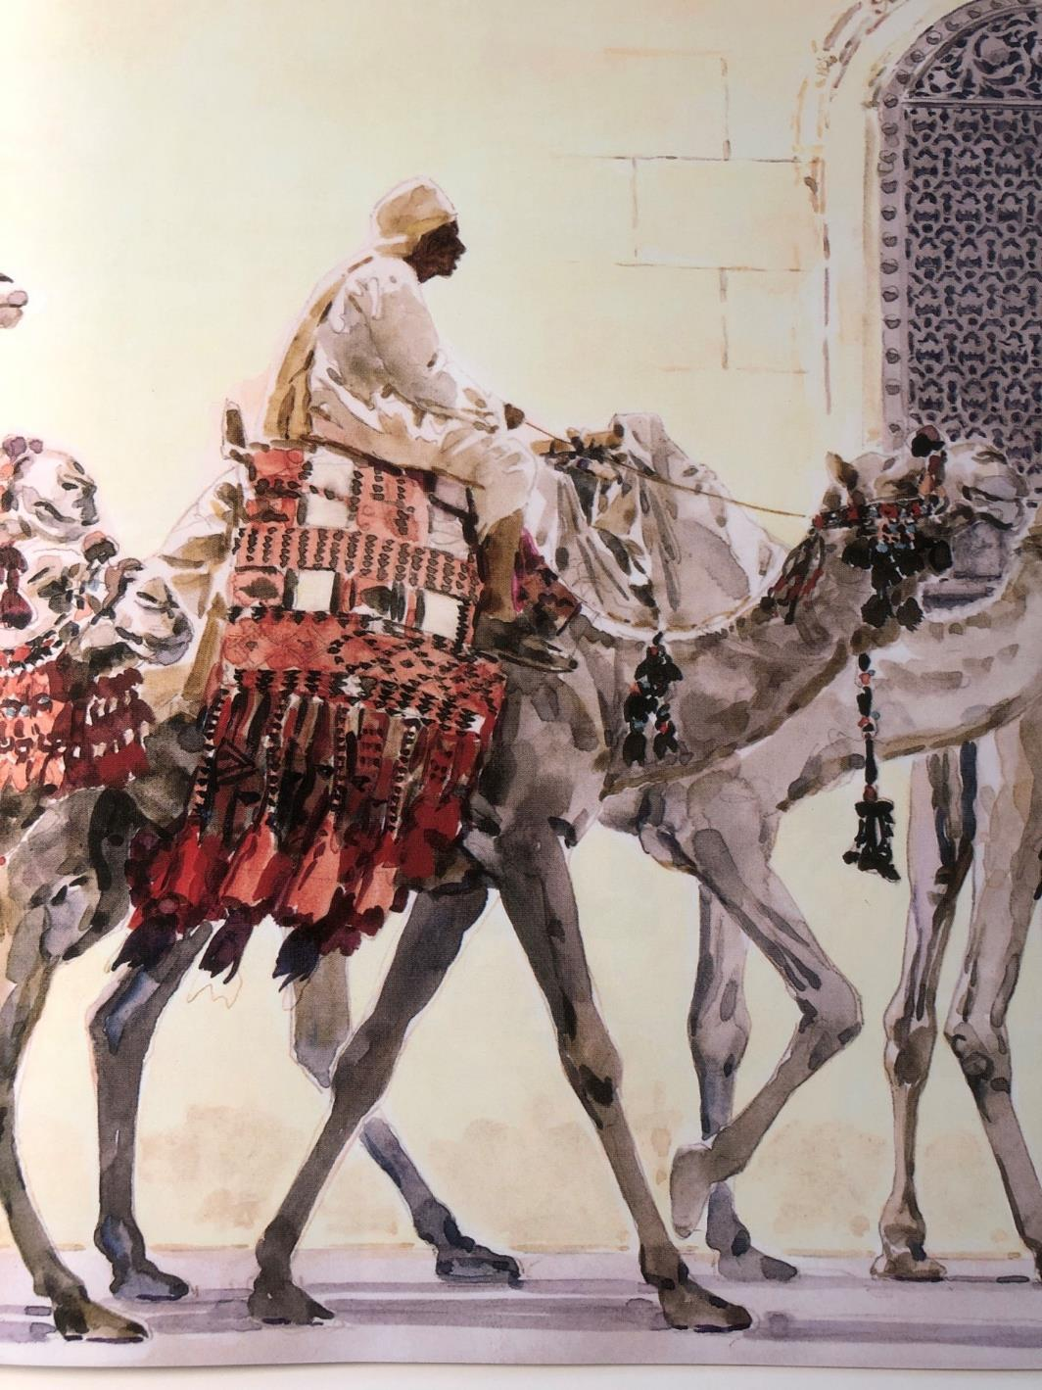

Revision Card – Perfect and Progressive
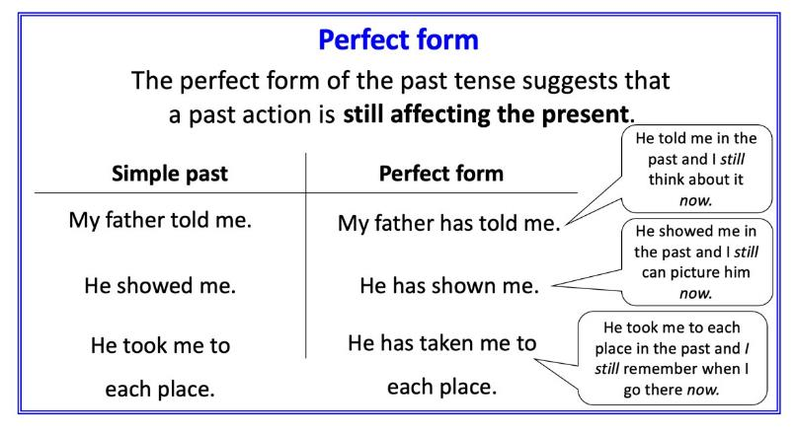 | 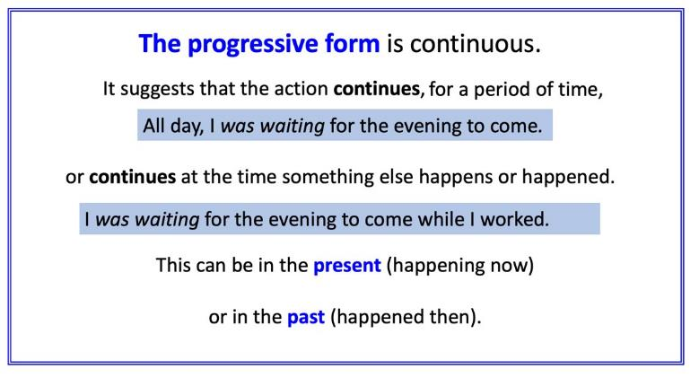
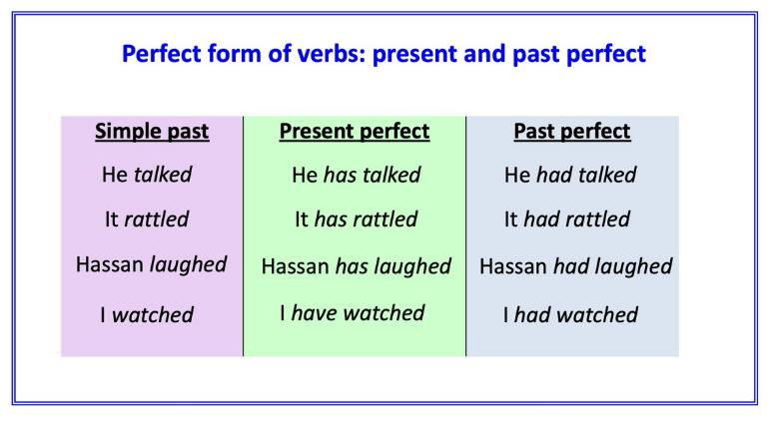 | 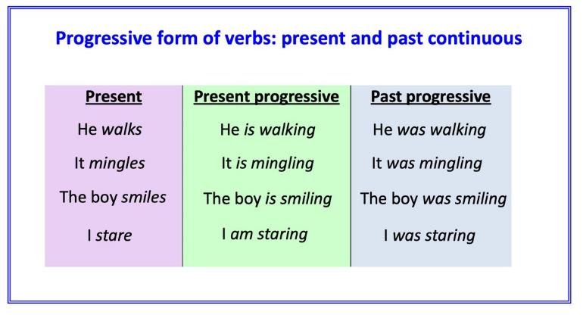

Four Sentences

Image 1  Write your own sentences under these demonstration ones.  He is sitting quietly. (Present Progressive)  He was resting in the middle of the day. (Past Progressive)  His father has told him to do this. (Present Perfect)  His donkey had pulled the cart for the whole morning. (Past Perfect) | Image 2
Image 3 | Image 4

Reflection Points

In what ways is Ahmed’s life similar to your own? In what ways is it different?

Which part of his life do you find most surprising?

What do you think that you know about Ahmed that the book does not tell you directly? Why do you think this? What would you most like to ask Ahmed more about?

Do you think Ahmed is lonely? Why might someone say that he is? Why might someone say that he isn’t?

Which of the other characters would you say is most important to Ahmed? How do you know that? Are there any missing characters?

What other books or stories do you know that you could say are similar to this one? How would you say that they are similar?

Which of the images in the book do you think is most vivid? Why?

How could the publisher make this part of a series of books? What would the other titles be?

