What to do today
IMPORTANT Parent or Carer – Read this page with your child and check that you are happy with what they have to do and any weblinks or use of internet.

1. Listen to a story
- Listen to the reading of The Day of Ahmed’s Secret.
https://www.youtube.com/watch?v=FrDkGA_wRZc
What did you like about the story? Was there anything about it that you disliked? Did it remind you of anything else that you have read or seen?

2. Revise verb tenses
- Use the Revision Card to remind yourself about the past tense.
- Rewrite Extracts 1 and 2 so that they are in the past tense. Decide what is best to do about the last paragraph in Extract 2.

3. Think about the themes of the story
- Read Possible Themes. Pick the three of these that you think are most clearly shown in The Day of Ahmed’s Secret.
- Write 3-5 sentences about each of those themes. How are they shown in the story? What do you know about them from your life? (Watch the story again, if it helps to remind you).

Well done. Show your writing about themes to a grown-up. Tell them about the story of The Day of Ahmed’s Secret. You can check your answers to Extracts 1 and 2 at the end of this pack.

Try these Fun-Time Extras
Can you research more about modern-day Egypt? (You could start with the FactFile. What else could you find out?)
Can you write about a day in your life in the same style as The Day of Ahmed’s Secret? (It could be a day from lockdown or from before.)

Revision Card – Past Tense
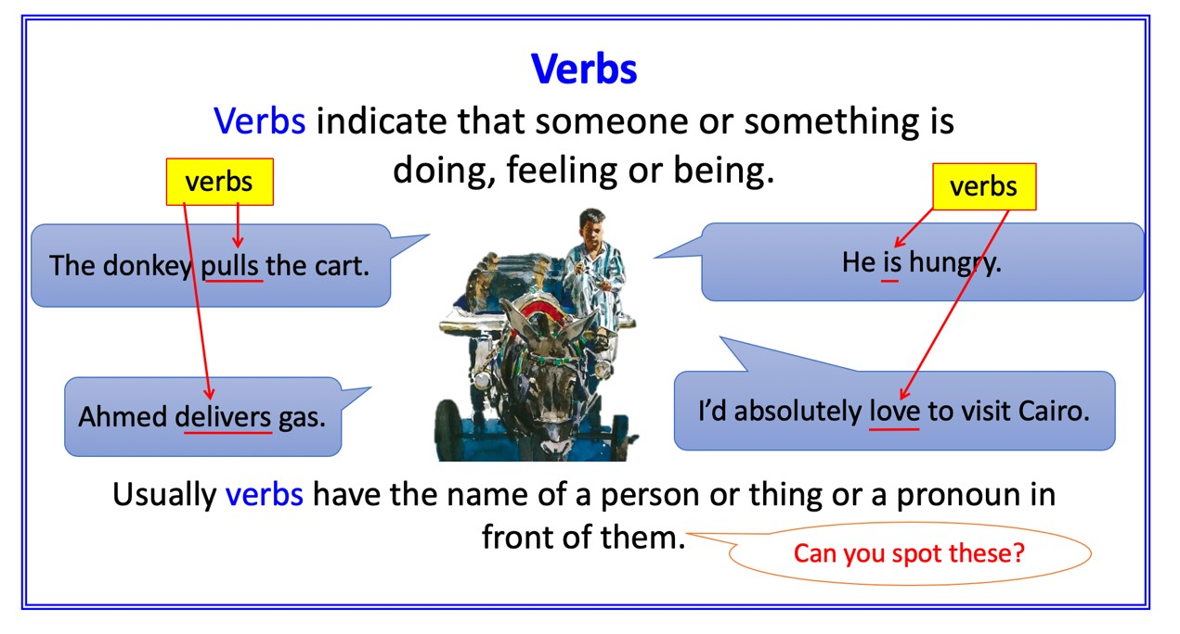
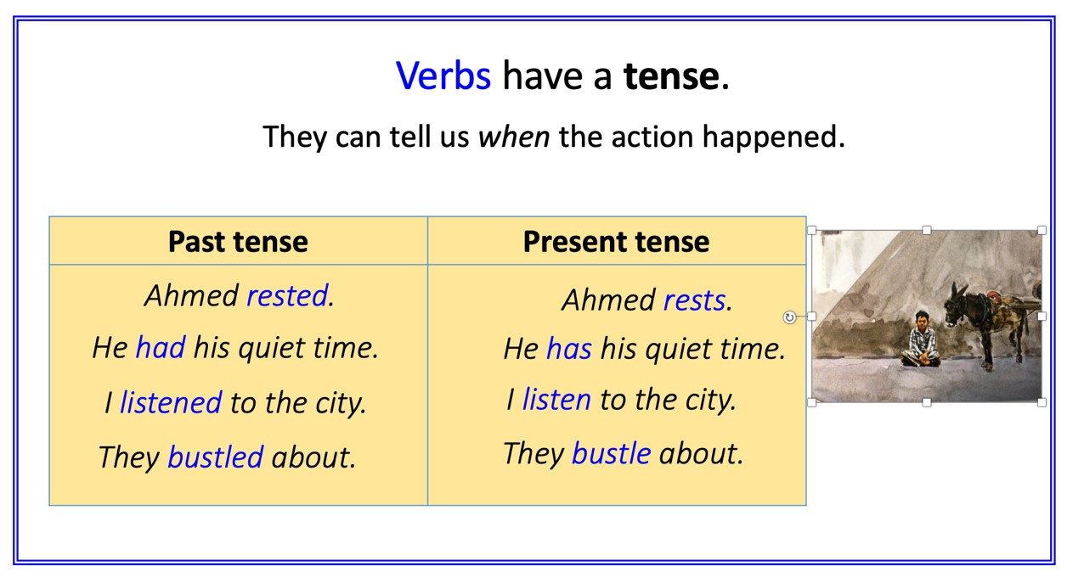
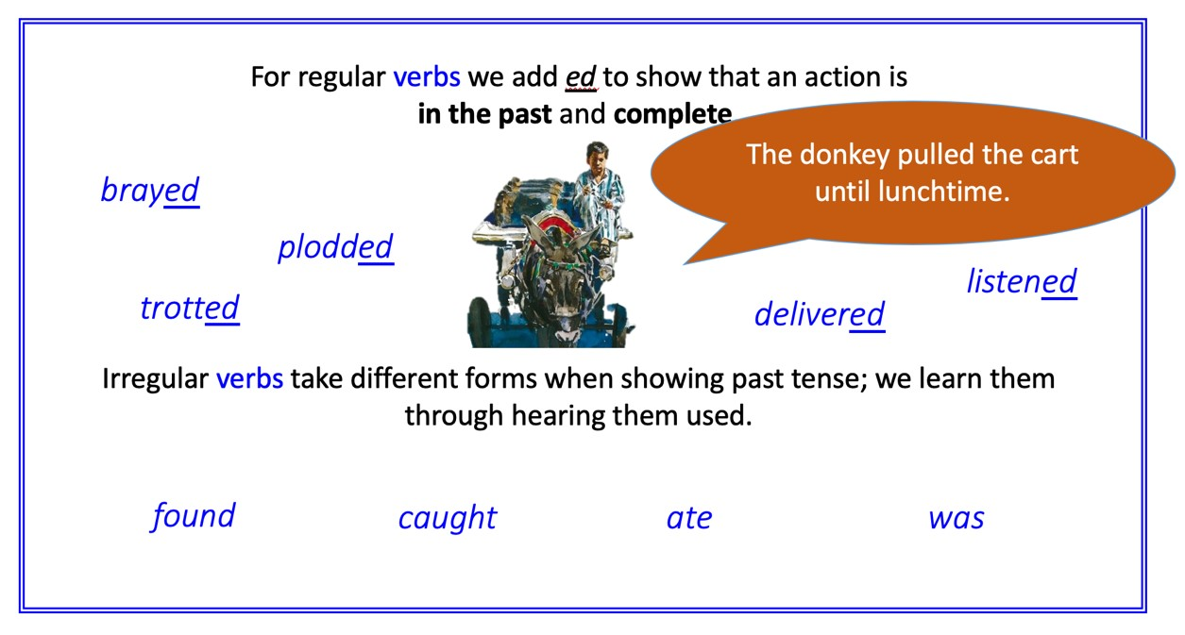

Extract 1
Re-write this extract so that it is in the simple past tense.

I am proud that I can carry these big heavy bottles all the way up the steps to the floor where she lives. I am proud that I can do this work to help my family.

I make more stops, and then I am hungry again. I look for the bright red and yellow cart where I can buy my lunch, and I find it in its usual place near the old building.

You will need these words:
- was
- could
- lived
- made
- looked
- could
- found

e.g. I was proud that I could carry…

Extract 2
Re-write the first four paragraphs into simple past tense.
Decide which verbs to change in the final paragraph.
(The modal verbs in the final paragraph might sound better if changed for others and some of the present tense might sound better unchanged.)

I hear the rose-water man before I see him. He clicks two cups together as he walks along the street so people hear him and come to him for a drink.
I give him my smile. He does not give me his, but our eyes meet and we know we are connected to the same day and to the city.
I do not buy his rose-water, but seeing him reminds me how hot and thirsty I am. I take a drink from the bottle of water I always carry in my cart.
There are more stops to make, and more times up and up narrow steps with my heavy load, and then I am back in my cart.
It is a long day. I think the moment will never come when I may share my secret, but of course I know that each day ends and that every moment has its time to be.

Possible Themes

- the importance of literacy

- the blessing of achievement

- the delight of family

- the strength that flows from hard and honest work

- the happiness that comes with a fulfilled life

- the feelings of togetherness that we share regardless of our culture

Extract 1 - Answers
I was proud that I could carry these big heavy bottles all the way up the steps to the floor where she lived. I was proud that I could do this work to help his family.

I made more stops, and then I was hungry again. I looked for the bright red and yellow cart where I could buy my lunch, and I found it in its usual place near the old building.

Extract 2 - Answers
I heard the rose-water man before I saw him. The man clicked two cups together as he walked along the street so people heard him and came to him for a drink.
I gave the man his smile. He did not return it, but our eyes met and we knew we were connected to the same day and to the city.
I did not buy the rose-water, but seeing the man reminded me how hot and thirsty I was. I took a drink from the bottle of water I always carried in his cart.
There were more stops to make, and more times up and up narrow steps with my heavy load, and then I was back in my cart.
It was a long day. I thought the moment would never come when I might share my secret, but of course I knew that each day ends and that every moment has its time to be.
(Underlined sounds better left in present tense, because that suggests it is always true, now as well as then)

Irregular Past - Examples from Extracts 1-3

becomes/became
lean/leant
go/went
are/were
says/said
eat/ate
come/came
tell/told
am/was
can/could
make/made
find/found
give/gave
do/did
take/took
think/thought

Fact File – Egypt

Population size | 82,056,378 | 15th
Population 0-14 | 33.4%
Landmass (km2) | 1,002,450 | 30th
Life Expectancy | 73.45 | 100th
Under-5 mortality rate | 24/1000

Did you know?
When the Pyramids in Egypt were built, woolly mammoths still roamed the earth. Many thousands of years ago, the sun was considered the one and only god – that is why Ancient Egyptians were fascinated with pyramids – the shape of the sun’s rays is like a pyramid.
Egypt’s Suez Canal links the Mediterranean to the Red Sea. Eight per cent of all the world’s ocean-going ships pass through it. Like the Panama Canal, it can save ships thousands of miles in the journey between east and west.

Children’s Rights
Poverty
Around twenty percent of the whole Egyptian population lives below the poverty line.
Education
Attendance at school is compulsory until the age of 14.
Child Labour
Numerous children work in Egypt; this is estimated at 7%. Children have jobs such as street vendors, cotton pickers and apprentice mechanics.
Discrimination
Girls are traditionally not expected to further their education.

