What to do today
IMPORTANT Parent or Carer – Read this page with your child and check that you are happy with what they have to do and any weblinks or use of internet.

1. Read instructions and an explanation about the same subject
- Read Skateboarding: how to get started and The Science behind the Ollie. What are the three pieces of information here that interested you the most?
- Annotate these two articles to show any Explanation Features and Instruction Features.

2. Answer some questions
- Read Articles 1 – 4.
- Choose one of the articles and answer the Questions about it.
- Challenge yourself to answer the questions about another of the articles.

3. Write your own explanation or instructions
- Decide about something you know about. It could be a game, a recipe, a hobby or a sport.
- Write an article with instructions or an explanation. Use Explanation Features or Instruction Features to help you.

Well done. Share your writing with a grown-up. Show them the features that you have used.

Try this Fun-Time Extra
Learn a new skill! Find out about something you haven’t done before. Read instructions and explanations and then practise to put it into action. Make sure that you share your skill with others.
You might find some useful instructions here: www.instructables.com

Skateboarding: how to get started
Parts of a Skateboard
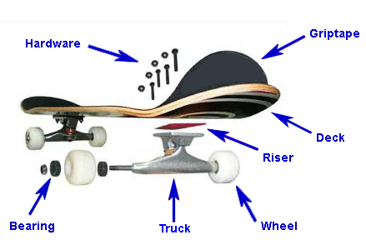
If you're an absolute beginner and you've never set foot on a skateboard before, then there are a few things you should know before you start.

1. Set Up Your Skateboard
Choose an inexpensive skateboard at first. Firstly, good skateboards are surprisingly expensive and, if you end up not wanting to skateboard, buying one is going to be a waste of money. Secondly, they are a lot faster which makes them harder to ride and less forgiving. Loosen your trucks because new skateboards tend to have them done up very tightly. Although this is very stable, you won't be able to turn your skateboard at all and if there is a natural lean to the board (there usually is) you'll end up riding in to a wall.

2. Work Out Your Stance
Work out how you stand on your board. If your left foot is forward, or you are facing to the right you are in the position called "regular". If your right foot is forward, or you are facing to the left you are in the position called "goofy". For most people, they stand with their writing hand facing backwards and their opposite foot forwards.

3. Push Off
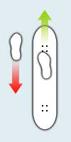
Push off up a shallow hill or on a level surface. You should imagine that pushing off is like walking; your pushing foot must step in front of the foot on the skateboard and then push back, just like taking normal steps. `Take a couple of long, smooth pushes to gain some speed. Getting on requires you to twist the foot that is on the board around to face sideways instead of forwards and step backwards onto the back fishtail. Step on firmly and confidently and don't mess about as this is when you are most vulnerable to falling off. Your feet should be behind the bolts in both cases, so if you don't get into this position straight away, try to quickly shuffle into the correct position.

The Science behind the Ollie
Invented in the late 1970s by Alan ‘Ollie’ Gelfand, the ollie has become the basis for many other more complicated tricks. In its simplest form, the ollie is a jumping technique that allows skaters to hop over obstacles and onto curbs. Have you ever wondered how an ollie works?

How Forces Act in an Ollie
There are three forces that come into play as the skateboarder rides forward on his or her skateboard. These forces are the weight of the rider pressing down on the board, the effect of gravity pulling down on the rider, and the forces of the ground pushing up.
- When a skateboarder decides to perform an ollie, the first step is to crouch down slightly. This helps the skateboarder jump and accelerate upward.
- Then the skateboarder presses down with his or her rear foot, sharply, on the tail of skateboard. This causes the skateboard to flip up. The ground pushes back against the board and results in a rotation movement.
- As the board is rotating, the skater drags his or her forward foot up along the board. This causes the board to tilt up higher.
- The skater then pushes down with his or her forward foot on the front of the board, while pulling up on his or her rear foot to get out of the way of the rotating board. The skater and the board are level at this point and because of this look stuck together.
- Finally, gravity pulls the skater and the board back to the ground.
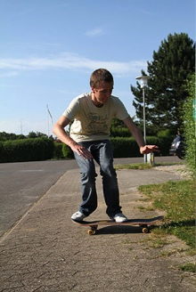 | 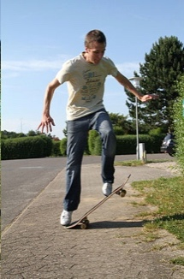 | 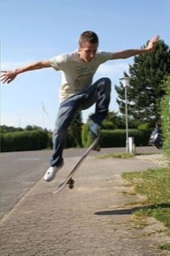 | 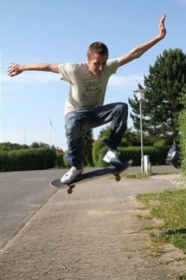
A | B | C | D
Skateboarding requires the manipulation of forces to achieve a range of moves and tricks. Who thought forces could be this much fun!
accelerate: begin to move more quickly
force: a push or pull
gravity: a force which pulls two objects together (the Earth's gravitational force pulls objects towards the ground)
ollie: a jump performed without the aid of a take-off ramp

Instruction Features

Purpose – tells how to do or make something

Range – Non-fiction book, recipe, science experiment, instruction on packaging, poster or sign, manual, craft patterns.

- Title which says what will be achieved
- List of ingredients or equipment needed
- Step by step actions
- Labelled illustrations
- Bullet points or numbered lists
- Clear, concise vocabulary and sentence structures
- Imperative verbs (e.g. Mix the flour, Cut along the line, Press the controller)
- Clear statements of quantities, measurement and other details
- Descriptive language used for clarity rather than vividness or effect
- Adverbials (numbers or time connectives) used to show stages in a process
Explanation Features

Purpose – tells why or how something happens

Range – Non-fiction book or article, encyclopaedia entry, write-up of a science experiment, technical manual.

- Title telling what needs to be explained
- Introduction (often making a link to the reader)
- Clear layout e.g. sections or paragraphs
- Bullet points or sub-headings
- Diagrams and illustrations
- Technical vocabulary (often with definitions)
- Present-tense verbs
- Causal language (e.g. because; ‘if…then…’; the reason that; when; so; this results in; this causes; therefore)
- Passive verbs
- Formal connectives (e.g. however, therefore, consequently)
- Usually formal register
- Comparisons (similes, metaphors and analogies)
- Stories (to capture the reader’s interest)
- Closing sentence to round off the explanation

Article 1

Spotting
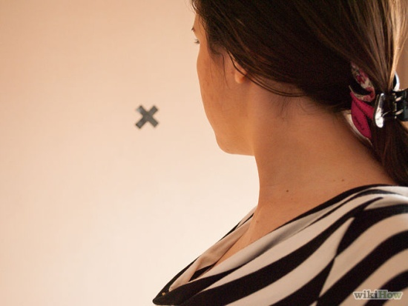
First, find a 'spot' on the wall in front of you, perhaps a mark, a fixture or you can even place some tape on the wall and make your own mark.
Next, stand up straight with your hands on your shoulders. Begin by slowly turning to the right whilst continuing to keep your head focused on the spot. Having your hands on your shoulders assists your balance, so later on when you have practised a lot you can bring your arms out to the side.
When you have turned your body as far as you can, your head will also need to turn; this is around the point where your chin is over the top of your left shoulder. You will also know when you have got to this point as you won't be able to keep your focus on the spot anymore and naturally your body will want to move your head.
As you continue to turn your body to the right, whip your head around and focus back on the spot again. Your head will now be facing more to the left then your body is and then just let your body follow your head back to your starting point.
Good luck!

Safety Considerations:
- Do not wear socks. If you are an amateur dancer and don't have the correct footwear then just do it barefoot to prevent injury;
- Do not do this on a rug as you will trip over. Use a hard floor; and
- Make sure you do not look at your spot for so long that your neck hurts.

Article 2

When you spin, why do you get dizzy?
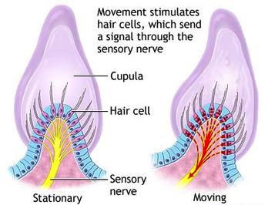
The ears have two functions. In addition to hearing, the ears have another important purpose. The inner parts of the ears give a sense of balance and this text will explain how.

The inner parts of the ear are open spaces filled with fluid; this fluid is called endolymph fluid. The inside walls of the spaces are covered with tiny hairs. Each hair is connected to a nerve cell that carries signals to the brain, along the sensory nerve.

When the head moves, this causes the fluid to slosh around and bend the hairs. As each hair bends, it makes its nerve cell send a signal, telling the brain about that movement.

When we spin around, the fluid starts spinning too. That gives us the sensation of spinning. When we stop, the fluid keeps moving (and bending tiny hairs and signalling the brain). Because the fluid is still moving, the nerve cell continues to send a 'movement signal'. This means that we feel that we are spinning, even though we are now still. We call that ‘feeling dizzy’.

Article 3 - The Hitch-Hiker Dance Movement
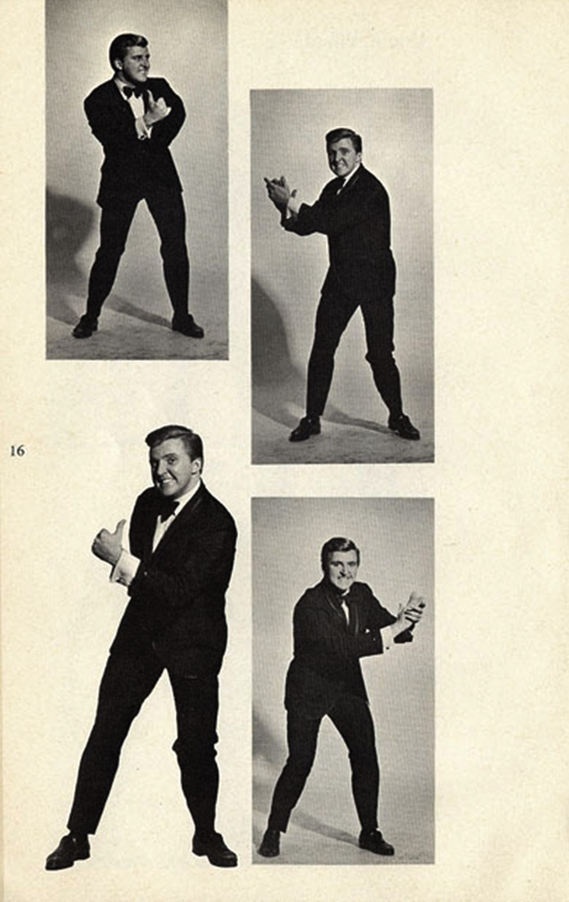 | - Stand in an upright position with feet apart, doing a slight rocking movement.  - Hitch-hike with right thumb on the count of 1-2-3 to your right side.  - Clap of the 4th beat on the right side of your body.  - Hitch-hike with left thumb on the count of 1-2-3 to your left side.  - Clap of the 4th beat on the left side of your body.  - Repeat over and over.  From a US Dance Manual 1960

Article 4 - What causes egg white to change when it is used in cooking?
Have you ever wondered how a small amount of runny egg white can be transformed into a large crisp meringue? This is how the process works.

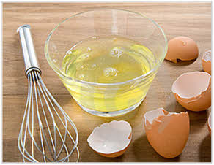
Making the meringue changes the structure of egg whites. Egg whites are made of water and proteins. When the egg is cracked, the proteins are in a tangled mess. This results in a runny, flowing texture.

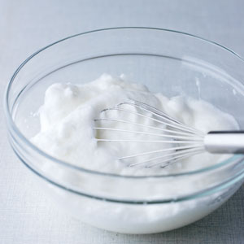
As the egg is beaten, the proteins are unfolded. The unfolded proteins form a net structure. Beating the egg whites adds lots of air, which gets trapped in the net of proteins. As a result, the combination of the new protein structure and lots of air causes the egg whites to form stiff peaks.

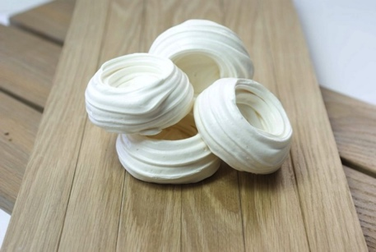
As the meringues are baked, the water in the mixture evaporates. The egg white and sugar mixture hardens, leaving a crispy shell of egg whites and sugar.

This is why egg white changes when it is used in cooking. Many recipes use this change to make crispy, peaked desserts, such as meringue pie, pavlova, baked Alaska and Eton Mess.

Desserts containing egg white as an ingredient
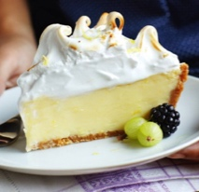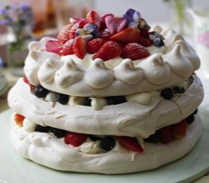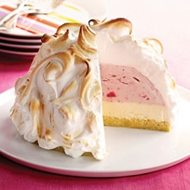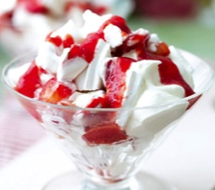

Questions

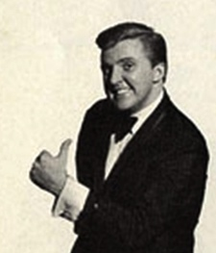  The Hitch-Hiker  How clear are these instructions? Try them.  What imperative verbs can you find?  What tense has the writer used? Why?  Find an example of precise language. Why is this important?  What features of these instructions help the reader follow them? | What causes egg white to change when it is used in cooking?  What is the purpose of this text?  What function does the first paragraph have?  What time adverbs/adverbials/conjunctions can you spot? [HINT: they can be phrases]  What causal language can you find?  What makes this a good explanation text?
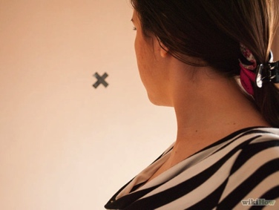  Spotting  What is the purpose of this text?  How has the writer separated the introduction from the main part of the text? Why?  What time adverbs/adverbials/conjunctions can you spot? How do they help the reader?  Why has the writer organised the safety considerations with bullet points? Is this a good use? Explain why.  How helpful is the title for the reader? What would make a better title? | When you spin, why do you get dizzy?  Why is this text written in present tense?  How does the writer help the reader understand the technical vocabulary?  How do the diagrams help the reader?  What causal language can you find?  Can you find an example of impersonal language? Why is this used?

Instructions/Explanation

Write your own instructions or explanation here

