What to do today
IMPORTANT Parent or Carer – Read this page with your child and check that you are happy with what they have to do and any weblinks or use of internet.

1. Write about pictures
- Look closely at the set of Images.
- Write on Sentences 1 and 2, to say what could be happening in each of these pictures.
- Can you think of a story that could connect all these images? Try making it up and telling it to someone else.

2. Read and listen to a poem
- Read the first page of The Great Realisation. Challenge yourself to read the next two pages as well.
- Highlight the poem to show your favourite lines and phrases.
- Watch the performance of the poem:
https://www.youtube.com/watch?v=Nw5KQMXDiM4&t=5s
- Was it as you expected it to be?

3. Write about the poem
- Read Poetry Questions and think about your answers.
- Write some of your answers in clear sentences.

Well done. Show the film of the poem to an adult. Ask them about it using Poetry Questions. How are their answers similar/different to yours?

Try this extra challenge
- Read ‘Lockdown’ by the poet laureate: Simon Armitage.
- Research to find out about what a yashka is and about Eyam, Emmott Sydall and Rowland Torre.
- Try to answer the Poetry Questions about this poem.
- This article might help you understand more about the poem

https://www.theguardian.com/books/2020/mar/21/lockdown-simon-armitage-writes-poem-about-coronavirus-outbreak
Images

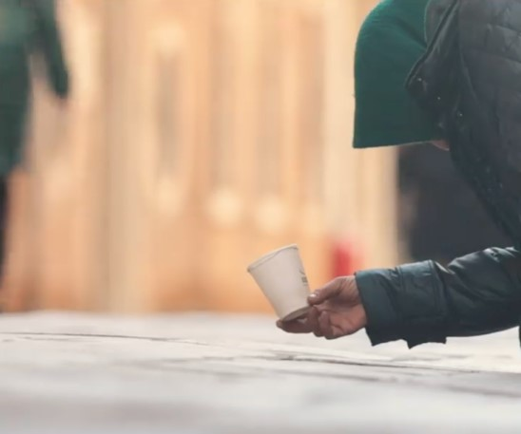 | 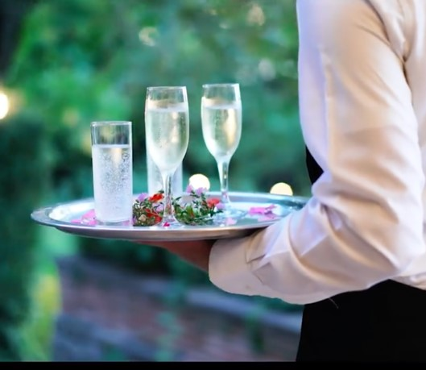
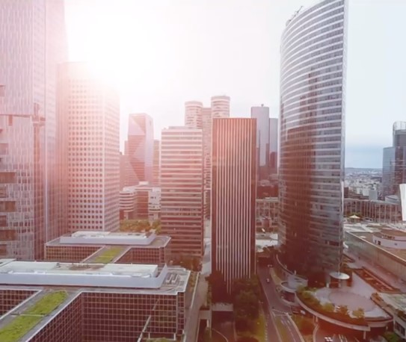 | 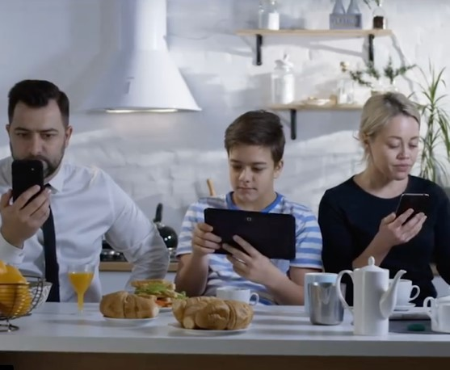
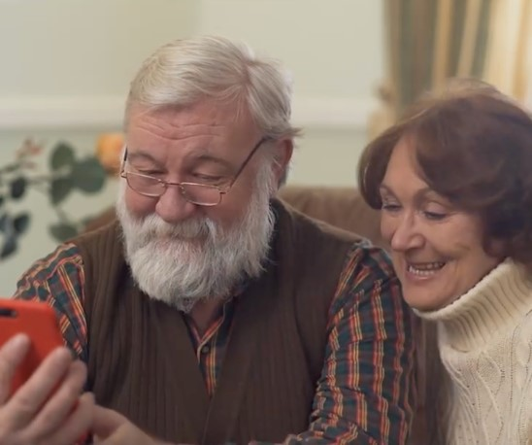 | 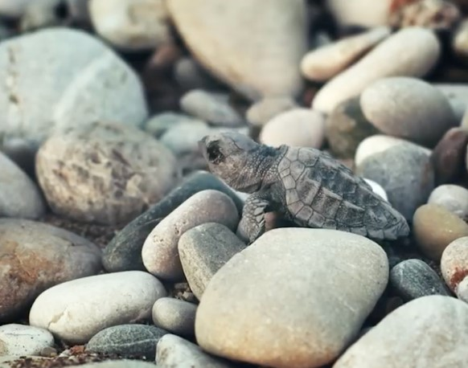
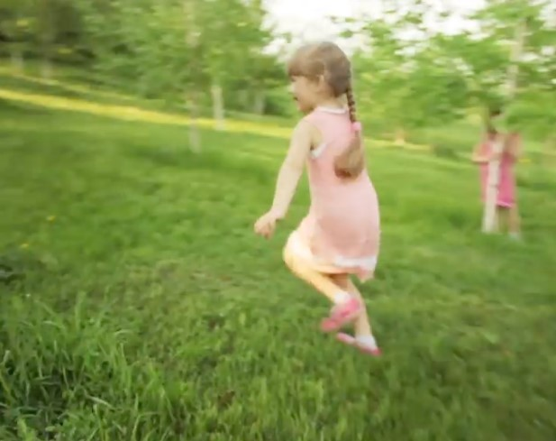 | 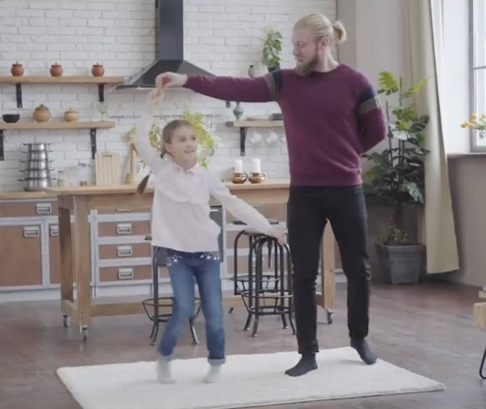

Sentences 1

What is happening? What could the story be behind this image?

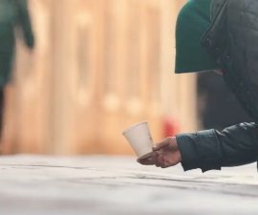
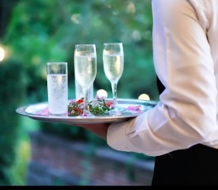
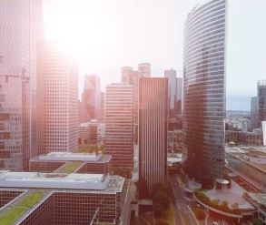
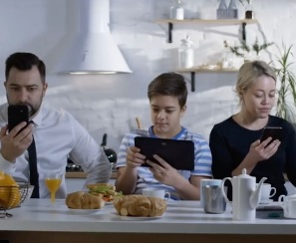

Sentences 2

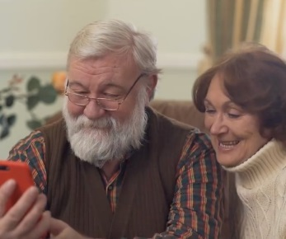
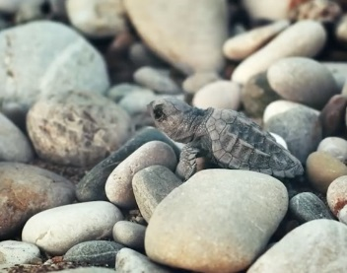
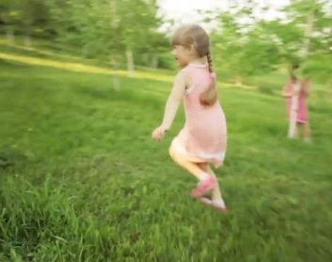
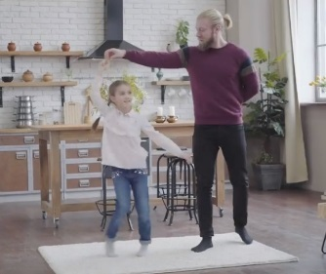

The Great Realisation

Tell me the one about the virus again  Then, I’ll go to bed  But my boy you’re growing weary,  sleepy thoughts about your head  Please that one's my favourite  I promise just once more  Okay, snuggle down my boy  though I know you know full well  the story starts before then  in a world I once would dwell.  It was a world of waste and wonder  of poverty and plenty  back before we understood  why hindsight's 2020.  You see the people came up with companies  to trade across all lands  but they swelled and got much bigger  than we ever could have planned.  We'd always had our wants  but now it got so quick  you could have anything you dreamed of  in a day and with a click. | We noticed families that stopped talking  that's not to say they never spoke  but the meaning must have melted  and the work-life balance broke.  And the children's eyes grew square  and every toddler had a phone,  they filtered out the imperfections  but amidst the noise; they felt alone.  and every day the skies grew thicker  till we couldn't see the stars  so we flew in planes to find them  while down below we filled our cars.  we’d drive around all day in circles  we'd forgotten how to run  we swapped the grass for tarmac  Shrunk the parks till there were none.  we filled the sea with plastic  because our waste was never capped  until each day when you went fishing  you'd pull them out already wrapped  and while we drank, smoked and gambled  our leaders taught us why  it's best to not upset the lobbies  or convenient to die.

but then in 2020  a new virus came our way  the governments reacted  and told us all to hide away.  But while we all were hidden  amidst the fear and all the while  people dusted off their instincts  they remembered how to smile.  they started clapping to say thank you  and calling up their mums  and while the car keys gathered dust  they would look forward to their runs.  and with the skies less full of voyagers  the earth began to breathe  and the beaches bore new wildlife  that scuttled off into the seas.  some people started dancing  some were singing some were baking  we'd grown so used to bad news  but some good news was in the making.  and so when we found the cure  and were allowed to go outside  we all preferred the world we found  to the one we'd left behind | old habits became extinct  and they made way for the new  and every simple act of kindness  was now given its due .  but why did it take a virus  to bring the people back together?  sometimes you've got to get sick my boy  before you start feeling better  now lie down and dream of tomorrow  and all the things that we can do  and who knows if you dream hard enough  maybe some of them will come true  we now call it the great realization  and yes since then there have been many  but that's the story of how it started  and why hindsight's 2020.  The Great Realisation  By Tom Roberts

Poetry Questions

What do you like about the poem? Is there anything that you dislike? | What does the poem make you think about? Does it remind you of anyone? Does it remind you of anything you have ever read or seen?
What patterns can you find in the poem? | What puzzles and questions does the poem leave?

Lockdown

And I couldn’t escape the waking dream
of infected fleas

in the warp and weft of soggy cloth
by the tailor’s hearth

in ye olde Eyam.
Then couldn’t un-see

the Boundary Stone,
that cock-eyed dice with its six dark holes,

thimbles brimming with vinegar wine
purging the plagued coins.

Which brought to mind the sorry story
of Emmott Syddall and Rowland Torre,

star-crossed lovers on either side
of the quarantine line

whose wordless courtship spanned the river
till she came no longer.

But slept again,
and dreamt this time

of the exiled yaksha sending word
to his lost wife on a passing cloud,

a cloud that followed an earthly map
of camel trails and cattle tracks,

streams like necklaces,
fan-tailed peacocks, painted elephants,

embroidered bedspreads
of meadows and hedges,

bamboo forests and snow-hatted peaks,
waterfalls, creeks,

the hieroglyphs of wide-winged cranes
and the glistening lotus flower after rain,

the air
hypnotically see-through, rare,

the journey a ponderous one at times, long and slow
but necessarily so.

Simon Armitage

