What to do today
IMPORTANT Parent or Carer – Read this page with your child and check that you are happy with what they have to do and any weblinks or use of internet.

1. Read a poem
- Read Certainty. Read the poem twice: once in your head and once out loud. What did you like about the poem? Was there anything that you disliked? What patterns can you find? What would you like to ask the poet?
- Watch the poem being performed:
https://www.youtube.com/watch?v=3IUIymdLjK4
- Was it as you expected? What did you notice in the performance?

2. Remind yourself about adverbs of possibility
- Use the PowerPoint on Adverbs of Possibility or if this is not possible then remind yourself using the Revision Cards.
- Complete Adverbs of Possibility Sentences.

3. Now for some writing
- Think about your life in six months’ time. What possibilities could be there? What can you be sure about? Record your ideas on the Table of Certainty.
- Try turning some of your ideas into a poem. You could use some of the patterns from Matt Abbott’s poem.

Well done. Show your poem to a grown-up. Show them the patterns that you have included.

Try these Fun-Time Extras
- Make a recording of your poem and share it with someone else.
- Use the Table of Certainty to interview others about their ideas of the future. What will they possibly, maybe and certainly be doing?

Certainty

Amongst the chaos and confusion,
the only certainty I’ve got,
is that in six-month’s time,
we’ll be tying the knot.

Our honeymoon might be a beer garden.
Our wedding meal, a bag of crisps.
But we’ll count our smiles as favours,
and high-fives as wedding gifts.

Our band might be karaoke.
Our cake, from corner shop.
Our first dance in our kitchen
with flutes of fizzy pop.

Decorations made out of pasta
and toilet rolls galore.
Whatever changes in the next few months,
of one thing I am sure.

In six-month’s time,
we’ll be husband and wife,
And none of this will feel real.
In six-month’s time: it’s the rest of our lives,
and our love will be stronger than steel.

By Matt Abbott
Adverbs of Possibility – Revision Card

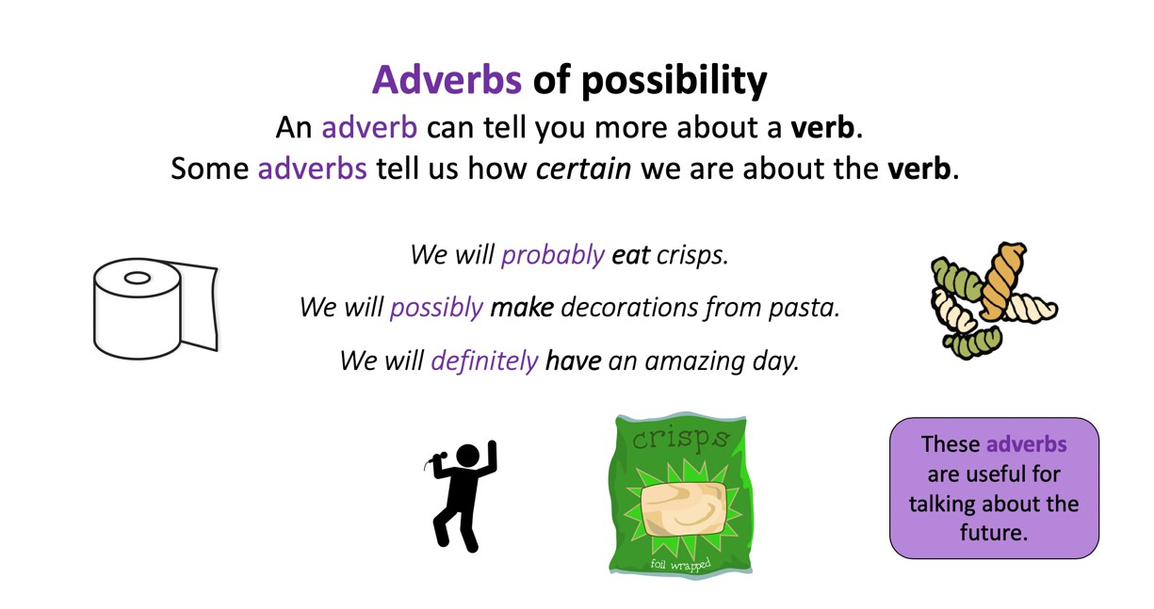
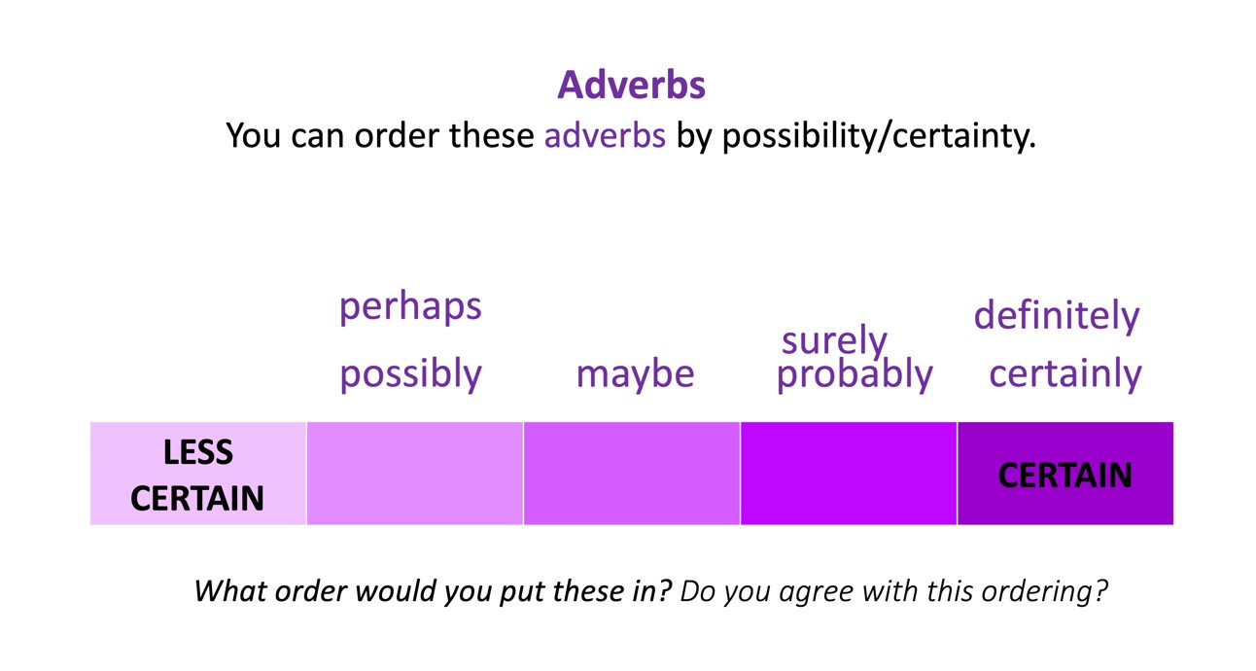
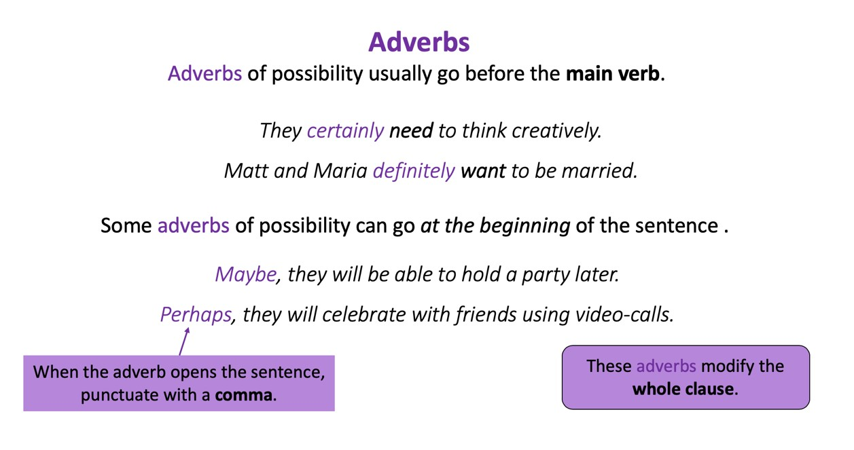

Adverbs of Possibility

perhaps
maybe
possibly
probably
surely
definitely
certainly

Adverbs of Possibility Sentences

Read these sentences. Find and mark the verbs, then find and mark the adverbs of possibility.

Try changing the adverbs of certainty. Can you find one that will work just as well? Can you find any that change the meaning? Can you find any that sound awkward or unnatural?

Try changing the word order. Listen to the difference. How does it sound?

1. Probably, Maria and Matt are looking forward to their wedding.

2. A wedding party in lockdown would certainly be a challenge.

3. They are surely unlucky to have to plan a wedding in lockdown.

4. If you want to have a memorable time, you should definitely think creatively.

5. Perhaps, Matt thought that his poem would make people smile.

6. Maybe, people can identify with the situation that they are in.

Table of Certainty

Perhaps  Possibly | Maybe  Surely | Certainly  Definitely

In Six-Month’s Time

Try writing your ideas as a poem here.

