What to do today
IMPORTANT Parent or Carer – Read this page with your child and check that you are happy with what they have to do and any weblinks or use of internet.

1. Learn about Colin Thompson
- Read Colin Thompson Autobiography.
- Answer the Autobiography Questions.
- Is there anything in Colin Thompson’s life that reminds you of The Paradise Garden or The Last Alchemist?

2. Compare the two books
- Listen again to both Colin Thompson books being read:
The Last Alchemist: https://youtu.be/rlRh0qqKPyI
The Paradise Garden: https://youtu.be/6pzhlQ_cupg
- Read the Six Compare and Reflect Tasks. Write your answers in clear sentences.

3. Now for some writing.
- Look at New Illustration. This is for a new book Colin Thompson is writing.
- Imagine a story that would fit this illustration. Note your ideas on Story Planner and then write all or some of your story.

Well done. Share your story with a grown-up. Show them the illustration and explain how you have used it in your story.

Try the Fun-Time Extra
- Can you make some more illustrations for your new story?
- Find more examples of Colin Thompsons illustrations online (including his designs for jigsaws). Can you find your own Colin Thompson top three? Share it with someone else and explain to them what you like about these illustrations.
Colin Thompson Autobiography

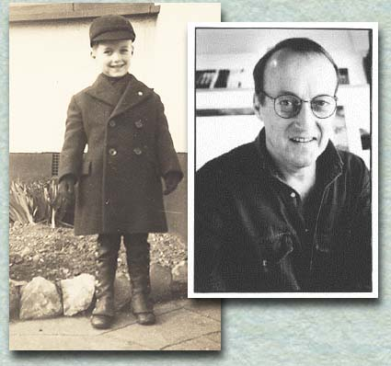

I was born in Ealing, London on October 18th 1942. Until I was eleven my name wasn't Colin Thompson it was Colin Willment. Willment was my father's name and my mother changed it to Thompson when she married my stepfather. Looking back I wish she hadn't. She cut my father off completely and I only met him once when I was nineteen. Now he's dead so it's too late, though I recently made contact with his family through searching on the internet and found a first cousin, Robert Willment, who lives in America. So now I have a whole new family.

I went to boarding school in Yorkshire, grammar school in West London and spent two years at art school in Ealing and Hammersmith where, to my dismay, I met people who could draw much better than I could. I met my first wife at art school and not long after, met my first daughter, Charlotte.

I have worked as a silk-screen printer, a graphic designer, a stage manager in the theatre but never as a lumberjack in Canada or a sailor on a tramp-steamer in the South Seas. I studied film-making for a year, got married for the second time and worked for a while making documentaries at the BBC.

In my early twenties I suffered with terrible depression and, on three different occasions, spent three months in three different hospitals. For no reason I have ever been able to explain, my depression went when I was 25 and has never returned.

If you suffer with depression ALWAYS REMEMBER it is NOT something you should ever be ashamed of and try to hide. I CAN'T EMPHASISE THIS ENOUGH. IT IS NOT YOUR FAULT. It is a genuine illness just the same as breaking your arm or having a cold.

In 1968 I went to live in Majorca but less than a year later moved with, my second wife, to a tiny island in the Outer Hebrides off the north-west coast of Scotland where we spent seven years trying to stand upright in the wind and began twenty years working in ceramics. I also tried living off the land but all I got was an acre of weeds, backache, a pet chicken and two more daughters, Hannah and Alice, though not necessarily in that order.

In 1975 I moved to Cumbria where I lived and worked in an old farmhouse on the edge of a forest for twenty years. During this time, I planted hundreds of trees and made a lake that is now home to a family of mediaeval carp. At one time my house was home for five rescued dogs and three cats.

In 1990 I started writing and illustrating children's books and had my first book published in March 1991. Since then I've had over 65 books published.

In March 1995 I visited a school in Sydney, Australia and fell so much in love with the place that two weeks later I came back to live here. And on April 9th 1999 I married Anne, the teacher librarian who organised my visit to the school. In February 1999 we moved to Bellingen, inland from Coff's Harbour and about seven hours north of Sydney. It is probably the most beautiful place on earth.

I have always believed in the magic of childhood and think that if you get your life right that magic should never end. I feel that if a children's book cannot be enjoyed properly by adults there is something wrong with either the book or the adult reading it.

My favourite fruit is cherries and my favourite music is The Ramones and old Blues records and I am now an Australian citizen. I am left-handed and colour-blind.

Autobiography Questions

- When was Colin Thompson born?

- What regret does he have about his childhood?

- Which of his jobs do you think is most unusual?

- What message does he give about depression?

- When did he begin writing and illustrating children’s books?

- How did he meet his wife, Anne?

- What does he say about adults and children’s books?

- What is his favourite fruit?

Can you spot anything from Colin Thompson’s life that has gone into his books?

Six Compare and Reflect Tasks

1. Look at the Example Illustrations. Say which book has the best illustrations and explain why you think that. | 2. Which main character, Arthur or Peter do you identify with most? Which do you feel most sympathetic towards? Give reasons for your choice. | 3. When and where is each book set? Describe the settings of each story and say how these are different.
4. Say which book has the best ending and explain why you think that. | 5. Say which book has the best plot and explain why you think that. | 6. Think of a particular friend or relative. Which of the two books would you suggest they read? Why do you think that would the better book for them?

Example Illustrations
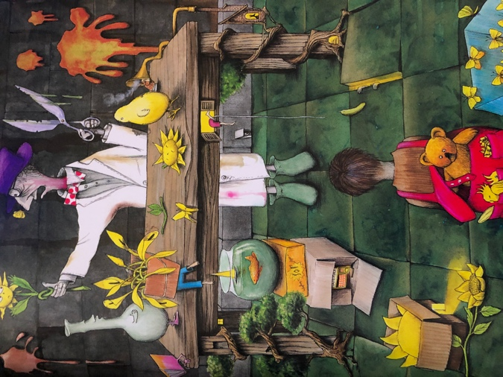 | 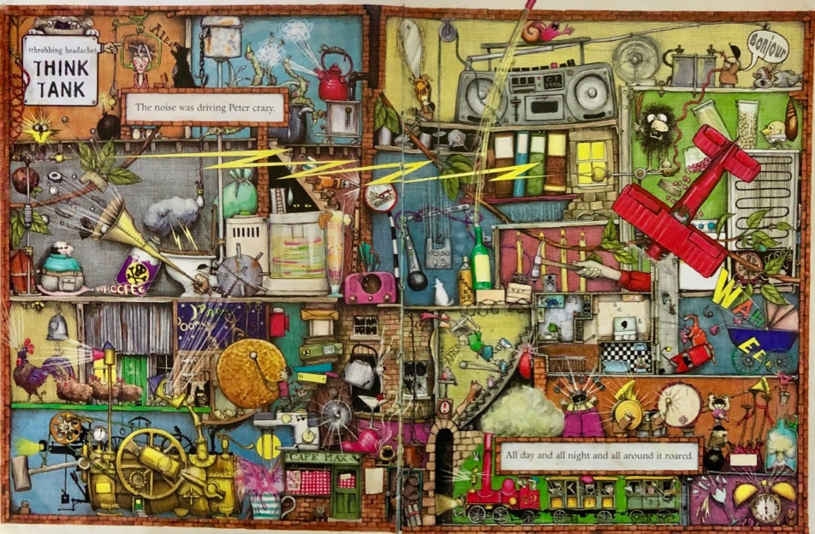
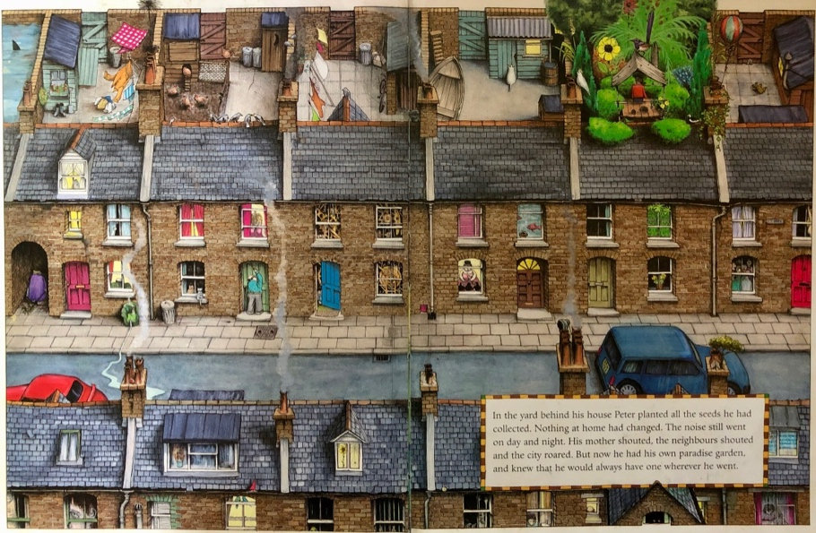 | 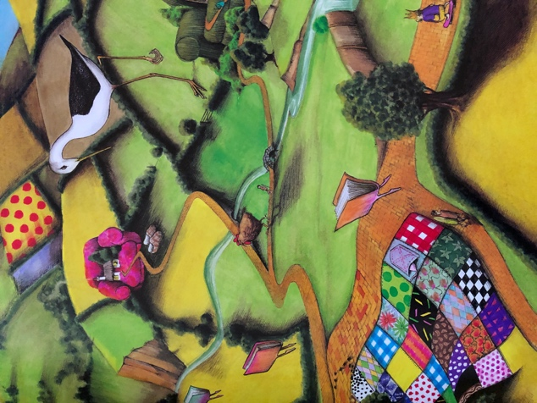

New Illustration

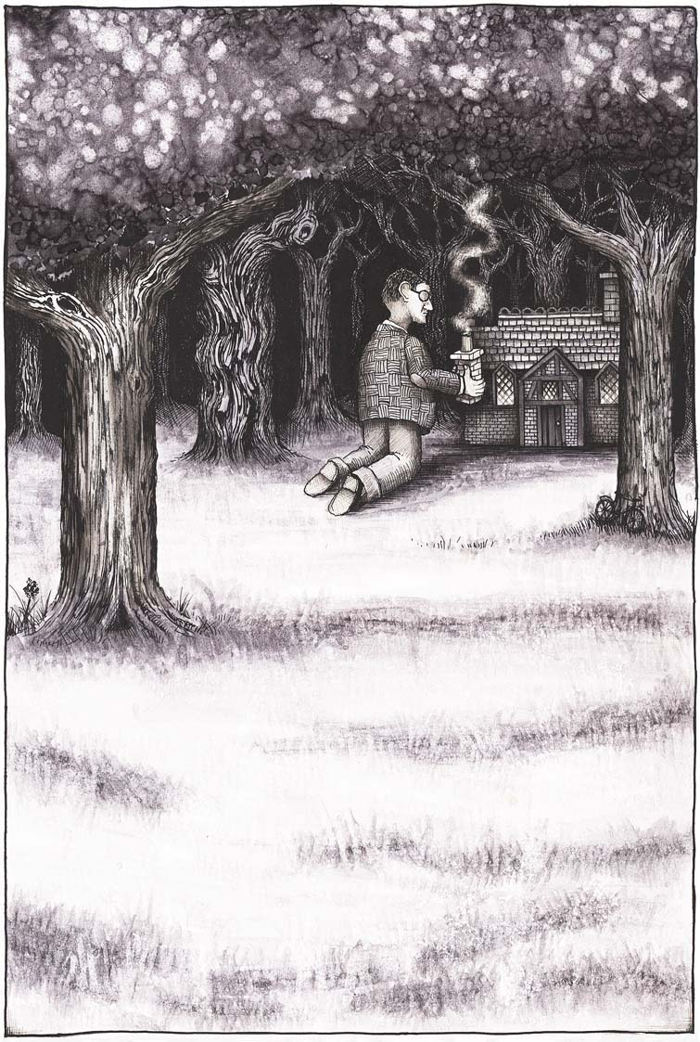

from: http://www.colinthompson.com/page14.htm
Story Planner

Characters  Who is the main character?  What is their name?  What other characters are there?  Is there a ‘baddy’ character or an evil character? |  | Setting  Where is the story set? Describe the setting.  When is the story set? Describe the times. |  | Illustrations  What sorts of things will need to be included in the illustrations?  How will the illustrations help us to understand:  - The characters?  - The plot?
The  story-line or plot | How does the story start? |  | What happens in the middle? |  | How does the story end?

Your Story
Write part or all of your new story here.

Autobiography Questions – Possible Answers

- When was Colin Thompson born?
Colin Thompson was born in 1942.
- What regret does he have about his childhood?
He regrets that his mother cut off contact with his father.
- Which of his jobs do you think is most unusual?
You decide!
- What message does he give about depression?
He explains that it is an actual illness and not something to hide or be ashamed or embarrassed about.
- When did he begin writing and illustrating children’s books?
He began writing and illustrating children’s books in 1991.
- How did he meet his wife, Anne?
He met Anne when she organised a visit to her school.
- What does he say about adults and children’s books?
He says that adults should enjoy children’s books.
- What is his favourite fruit?
His favourite fruit is cherries.

