What to do today
IMPORTANT Parent or Carer – Read this page with your child and check that you are happy with what they have to do and any weblinks or use of internet.

1. Read a poem
- Read The Tyger by William Blake. Practise reading it until you can read it fluently out loud.
- What do you notice new about the poem from reading it again? Can you find three new things?

2. Answer questions
- Read The Tyger - Questions. Think about your answers.
- Write your answers in clear sentences.

3. Present the poem
- Look at William Blake’s presentation of the poem. William Blake was a poet and artist who wrote this poem in 1794. What do you like about his presentation? Is there anything that you dislike?
- Choose at least one verse from the poem. Use your best handwriting and add illustrations to present the poem beautifully.

Well done. Show your presentation of the poem to a grown-up. You can check your answers to The Tyger - Questions at the end of this pack.

Try the Fun-Time Extra
Try learning the first verse of the poem off by heart. Challenge yourself to add other verses as well.

The Tyger by William Blake

Tyger Tyger, burning bright,
In the forests of the night;
What immortal hand or eye,
Could frame thy fearful symmetry?

In what distant deeps or skies.
Burnt the fire of thine eyes?
On what wings dare he aspire?
What the hand, dare seize the fire?

And what shoulder, & what art,
Could twist the sinews of thy heart?
And when thy heart began to beat,
What dread hand? & what dread feet?

What the hammer? what the chain,
In what furnace was thy brain?
What the anvil? what dread grasp,
Dare its deadly terrors clasp!

When the stars threw down their spears
And water'd heaven with their tears:
Did he smile his work to see?
Did he who made the Lamb make thee?

Tyger Tyger burning bright,
In the forests of the night:
What immortal hand or eye,
Dare frame thy fearful symmetry?

The Tyger - Questions

- What do you like most about this poem?
- Is there anything that you dislike about it? Why?
- What does the poem remind you of or make you think about?
- How many questions does the poet ask in the poem?
- What rhyme pattern can you find in this poem?
- What other patterns can you find?
- Why is ‘burning bright’ a good description for a tiger?
- Find two examples of alliteration in the poem.
- Why do you think that the poet asks about ‘the Lamb’?
- Do you think that the poet likes tigers? Explain your answer.

William Blake’s Presentation

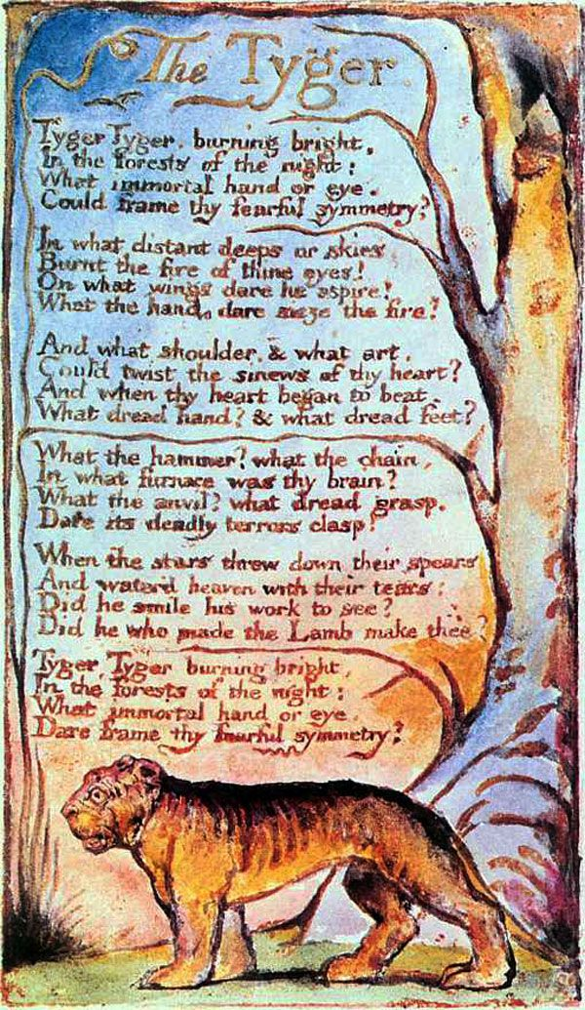
The Tyger – Questions – Possible Answers

- What do you like most about this poem? Why?
- Is there anything that you dislike about it? Why?
- What does the poem remind you of or make you think about?
- How many questions does the poet ask in the poem?
Between 10 and 14, depending on how you count them!
- What rhyme pattern can you find in this poem?
The rhyme pattern is: AABB
- What other patterns can you find?
Four-line verses; repeating questions; first verse/last verse repeat.
- Why is ‘burning bright’ a good description for a tiger?
This description captures the colour of a tiger, its brightness and also its danger.
- Find two examples of alliteration in the poem.
e.g. burning bright, distant deeps, frame thy fearful
- Why do you think that the poet asks about ‘the Lamb’?
The poet might want to make a contrast between the gentleness and softness of a lamb compared with the tiger.
- Do you think that the poet likes tigers? Explain your answer.
Yes, because he has chosen it as a subject for the poem and he seems awed and impressed by the tiger.
No, because he emphasises the danger of the tiger. He uses words like terrors, fear and dread.

